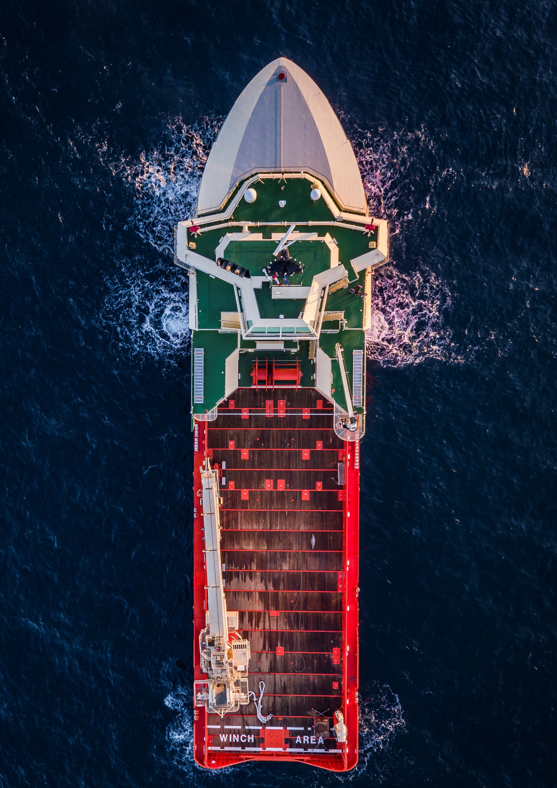



Ingmar Wever

November 2, 2018

Manoeuvrability and communication

requirements for safe operation when manned and unmanned vessels meet

MSc Thesis Report

This page is intentionally left blank.

(Except for the above line.)

Titels begeleiders, thesis number and graduation date

Thesis Report for the degree of

MSc Marine Technology and MSc Computer Science

Manoeuvrability and communication requirements for safe operation when manned and unmanned vessels meet

by Ingmar Wever at Damen Shipyards and TU Delft November 2, 2018

This thesis (THESISNUMBER) is classified as confidential in accordancewith the general conditions for projects performed by the TU Delft.

Student: Ingmar Wever 4161041 Project duration: September 2017 – November 2018

|  |  |  |
| --- | --- | --- |
| Supervisors: | Dr.ir. Robert Hekkenberg | TU Delft, Ship Design |
|  | Prof.Dr. Mark Neerincx | TU Delft, Interactive Intelligence |
|  | Toine Cleophas | Damen Shipyards, R&D |
| Committee members: | Peter de Vos MSc. | TU Delft, Marine Engineering |
|  | Dr.ir. Willem-Paul Brinkman | TU Delft, Interactive Intelligence |

# Notes

Titels begeleiders, thesis number and graduation date . . . . . . . . . . . . . . . . . . Schrijf voorwoord . . . . . . . . . . . . . . . . . . . . . . . . . . . . . . . . . . . . . v

Schrijf samenvatting vii

Wanneer is resultaat toepasbaar, gebruik case uit CS deel 58

Answer research question 59

Write final conclusion of report 105

Recommendations for future research 107

iii

# Preface

Schrijf voorwoord

v

vi *PREFACE*

# Abstract

Schrijf samenvatting

vii

# List of Figures

* 1. Steps from manned to autonomous ships 10
  2. Illustration of MUNIN vision 11
  3. Render of Electric Blue 14
  4. Render of Yara Birkeland 14

2.1 Decision model 18

* 1. Decision process 27
  2. Model for safety domain by Coldwell 31
  3. Generalized model for decision tree 31

4.1 Path description for situation identification 34

* 1. Example for closest point of approach (CPA) 37
  2. Example for crossing point and distance 39
  3. Turning circle test 45
  4. Zig-zag test 45
  5. Evasive manoeuvrer 46
  6. Direction for evasive manoeuvrer in crossing situation 50
  7. General curve for relation between distance till CPA and passing distance . . 52
  8. Relation between passing distance, distance till CPA and start speed 53
  9. Relation between distance till CPA, passing distance and advance distance by varying start speed and rudder amplification factor 55
  10. Classification of participants based on experience 83
  11. Ship-types operated by participants 85
  12. Simulation environment 85
  13. Situation sketch crossing situation North-Sea 88
  14. Situation sketch port of Rotterdam 90
  15. Estimation of relative start speed from memory for North Sea 94
  16. Estimation of relative start speed from memory for entering Maasgeul 94
  17. Response to color of vessels in situation when crossing at the North Sea . . . 95
  18. Response to color of vessels in situation when entering Maasgeul 95
  19. Protocol vs no-communication when crossing at the North Sea 97
  20. Protocol vs no-communication when entering Maasgeul 97
  21. Opinion of participants on SMCP 98
  22. Bridge system elements 111
  23. Very High Frequency radio (VHF) 114
  24. Automatic Radar Plotting Aid (ARPA) 115
  25. Electronic Chart Display Information System (ECDIS) 116
  26. Radar and ECDIS 119
  27. Various examples of bridge designs 119
  28. Basic crew structure organogram 122
  29. Endsley model for situational awareness 122
  30. Wrong AIS input when plotted on ARPA 126

B.1 Calculation of relative angle 133

viii

*LIST OF FIGURES* ix

* 1. Change time during evasive manoeuvrer for different ship types 139
  2. Simulation environment 139
  3. Illustration of collision MV AL ORAIQ and MV FLINTERSTAR 142
  4. Illustration of collision between MV ARTADI and MV ST-GERMAIN 143
  5. Approximate collision location USS FITZGERALD and MV ACX CRYSTAL . 144
  6. Approximate collision location USS JOHN S MCCAIN and MV ALNIC MC . 147
  7. Illustration of collision MV CONTI PERIDOT and MV CARLA MAERSK . . 147

# List of Tables

* 1. Description of phases in decision process 27
  2. Tags for different situations 28
  3. Criteria and result of evaluation to identify a problem 28
  4. Tags for different strategies 29
  5. Criteria to determine if action is possible 29
  6. Types of actions 29
  7. Time-domain for action 29
  8. Tags for safe situation criteria 30
  9. Tags for different situations 33
  10. Path definitions for different situations 34
  11. Validation of manoeuvring model 48
  12. Metrics for evasive manoeuvrer 51
  13. Interaction design patterns 71
  14. Envisioned technology 72
  15. Relevant information crossing at North-Sea 88
  16. Relevant information entering Maasgeul 90

A.1 Current relevant systems and technologies 127

* 1. Input for ship characteristics 132
  2. Ship details from simulation 132
  3. Rudder angle based on relative angle 133
  4. Input for manoeuvring model 136
  5. Dimensionless coefficients based on Artyszuk 136
  6. Different manoeuvring tests 140
  7. Different manoeuvring tests 140

x

# List of Abbreviations

**AIS** Automatic Identification System **AMS** Alarm Management System **ARPA** Automatic Radar Plotting Aid

**BNWAS** Bridge Navigational Watch Alarm System

**CAM-HMI** Central Alert Management - Human Machine Interface for presenting and handling of alerts

**COLREGs** Convention on the International Regulations for Preventing Collisions at Sea

**CPA** closest point of approach

**ECDIS** Electronic Chart Display Information System

**ENC** Electronic Navigational Chart **GNSS** Global Navigation Satellite System **GPS** Global Positioning System

**IDPs** Interaction Design Patterns

**IEC** International Electrotechnical Commission **IHO** International Hydrographic Organization **IMO** International Maritime Organization **HCI** Human-Computer Interaction

**Navtex** Navigational text Messages **no-UI** Non-visual User Interface **OoW** Officer of Watch

**sCE** situated Cognitive Engineering

**SMCP** Standard Maritime Communication Phrases

**SMNV** Standard Marine Navigational Vocabulary

**SOLAS** International Convention for the Safety of Life at Sea

**STCW** International Convention on Standards of Training, Certification and Watchkeeping for Seafarers

**TEU** Twenty foot Equivalent Unit

**UID** User Input Device

**VDES** VHF Data Exchange System

**VHF** Very High Frequency radio

xi

xii *LIST OF TABLES*

# Contents

#### Preface v

Abstract vii

Glossary vii

Introduction 1

I The problem of communication for autonomous vessels 5

1. Steps towards the future 9
   1. Why autonomous and unmanned shipping . . . . . . . . . . . . . . . . . . . 9
   2. Projects 11
   3. Stakeholders 15
   4. Challenges when combining unmanned and manned vessel 15
2. Decision model 17
   1. Decision process 17
   2. External factors 20

II Effect of manoeuvrability on decision making 23

1. Decision making process 27
   1. Decision phases 27
   2. Nodes in decision making tree 28
   3. Critical paths in decision trees 30
2. Identification of situation and scenarios 33
   1. Situation identification 33
   2. Situations which limit possible strategies 35
   3. Scenarios 36
3. Definition of criteria 37
   1. Calculations based on current systems 37
   2. Proposed algorithm based on planned path 39
4. Manoeuvers for tool validation and testing 43
   1. Manoeuvrer descriptions 43
   2. Tool validation 47
   3. Trial results for critical evasive manoeuvrer 51
   4. Relation between advance distance and passing distance 52
5. Evaluation 57
   1. General relation for critical evasive manoeuvrer 57
   2. Use case 58
6. Conclusion 59

xiii

III Necessity of a protocol to enable teamwork between manned and unmanned ships 61

1. Foundation 65
   1. Operational demands 65
   2. Human factors 68
   3. Envisioned technology 71
2. System design specification 73
   1. Design scenarios 73
   2. Functional requirements and claims 75
   3. Use case 76
   4. Ontology 78
3. Design evaluation 81
   1. Evaluation method 81
   2. Evaluation results 93
   3. Lessons learned 99

|  |  |  |  |
| --- | --- | --- | --- |
| **12** | **Conclusion** |  | **101** |
| **IV** | **Wrap-up** |  | **103** |
| **13** | **Final conclusion** |  | **105** |
| **14** | **Recommendations for** | **future research** | **107** |
| **V** | **Appendices** |  | **109** |
| **A** | **Current systems for safe navigation** | | **111** |
| **B** | **Simulation environment** | | **129** |
| **C** | **Accidents** | | **141** |

**Bibliography** **151**

*CONTENTS* xv

# Introduction

The Maritime industry is tapping into the world of automation and digitalization. The automation level of vessels is growing rapidly. Vessels are getting connected to the shore by different means. Operational data is becoming available and enriched with other data sets like design data, weather data and maintenance data. These technologies boost the development of autonomous and unmanned vessel designs [Blanke et al. (2017)]. At the same time is the Maritime Industry facing challenges when it comes to crewing and safety [Cappelle et al. (2018)]. Combined with an increasing competition it is hard to make healthy margins. These trends trigger Maritime Industry to embrace autonomous sailing technologies to secure a healthy future.

These business developments reflect in the significant amount of research and development projects [SMASH (2017)] [Eriksen (2017)] [MUNIN (2016)] [Sames (2017)] [Rolls-Royce (2015)] [Waterborne (2016)]. Each one of these projects tackle one or more challenges in the development of autonomous sailing. However, is the challenge of communication between unmanned and manned vessels not been tackled [Saarni et al. (2018)]. In chapter 1, these challenges and corresponding projects are discussed. Currently no solutions are available. However this is necessary to ensure the safety of all vessels: manned, unmanned, remote, automated and autonomous.

This report presents the results of my thesis on communication between unmanned autonomous sailing vessels and manned vessels. It presents a design philosophy which has been translated in a methodology for handling communication which is eventually translated in protocols which are derived based on theory and validated by means of simulations.

#### Context

In many situations is the Convention on the International Regulations for Preventing Collisions at Sea (COLREGs) sufficient to determine the intentions of other vessels [IMO (1972)]. They can be seen as ship separation rules, which guide all vessels to make early and correct alterations to their course. It will take more time to assess the situation when using VHF. Meaning there is less time to act, which limits the possible strategies. These rules do also apply to autonomous ships, and thus can be used when manned and unmanned vessels meet. Examples are to stay on starboard side of the shipping lane, and not to cross other ships with small relative angle. When this does not happen, communication is necessary. When this communication doesn’t happen correctly, accidents will occur (appendix C). Thereby are there also situations in which regulations are contradictory, such as the accident between

1

Artadi and St-Germain as described in appendix C.2. This occurs more often in complex situations, such as a harbor approach.

The risks when COLREGs are not sufficient can be mitigated by taking decisions, well in advance. What well in advance means, depends on the manoeuvrability of a vessel. A cargo vessel will follow common paths, while a small tug boat might move around much more. Which results in more false positives on potential collisions with other vessels, when using the same safety domain and evaluation system. The manoeuvrability means that it is necessary to think ahead several minutes with a large ship, while this is much shorter for a small tug boat. This time-domain for decision making depends not only on the ship characteristics, but also on the waterway characteristics. In chapter 2 this will be discussed in more detail, examples are the depth, traffic separation schemes and harbor entrances.

If it is not possible to take decision well in advance, it is often due to a lack of information. This can be solved by communicating. Communication between manned vessels happens in different ways. Most important is communication via VHF, thereby is information from the AIS used to identify vessels. Also can this information help to determine the intentions of the vessel, based on the type of vessel or destination. The used protocols for these systems are discussed in appendix A

#### Design philosophy

We developed a strategy to cope with the challenge of communication between manned and unmanned vessels, without introducing new systems to the bridge of manned vessels. First we will try to avoid the need for communication, by ensuring safe navigation. When this is not possible, there is a need for communication. For this communication a new communication protocol must be developed. This strategy can be used as a foundation to build a system for decision making which ensures safe operation of both manned and unmanned vessels. To implement this strategy, different steps must be taken.

First insights have been acquired on the decision model for safe navigation, to determine which factors are taken into account to make a decision. The next step is to determine how these factors influence the decision process. This can also be used to determine the critical situations. Showing when it isn’t possible to navigate without communicating. This leaves some specific situations for which a communication protocol must be developed. Using the situated Cognitive Engineering (sCE) method, the operational demands, relevant human factors and envisioned protocol can be defined. Where the current state of the maritime industry is taken into account.

*CONTENTS* 3

#### Research questions

Within the report, different research domains will be touched upon in more detail: Maritime Technology and Computer Science. Where the part on maritime technology focuses on the situation where manoeuvring is just enough. While the computer science part will focus on the development of the communication protocol. The following research questions will be answered for these domains:

*How do ship manoeuvrability characteristics influence the domain for decision making, to ensure that the chosen strategy will result in a passing distance which does not require communication?*

*Will a protocol based on existing maritime systems and communication protocols be sufficient to ensure safe navigation, while manned and unmanned vessels encounter each other?*

#### Report structure

This research will be separated into three parts. In those parts, the challenge of communication between manned and unmanned vessels is considered. The part I gives a more detailed context of autonomous shipping. Using this context and a decision-model, can be shown why communication is a challenge and how this challenge can be tackled.

Part II aims to determine how communication can be avoided. To determine this, it is important to first determine when communication is necessary. This is in case of critical situations. These situations are tested in a simulation environment. This means the time- domain for decision making can be determined to ensure safe operation. Which depends on the moment decisions made in critical situations. These situations are simulated, using a validated manoeuvring model in the simulation environment. Thereby is also evaluated if the time-domain can be improved to ensure that communication is needed in fewer situations.

Part III will focus on the critical situations where communication is a must. Currently there is not yet worked on a communication protocol between manned and unmanned vessels. Communication is necessary in cases where there is a lack of trust, missing information or the time-domain for decision making becomes critical. To ensure a fest implementation of the communication protocol between manned and unmanned vessels, will it be based on existing systems and protocols. The aim of this part, is to validate if it is possible to define a protocol using the situated Cognitive Engineering (sCE) method, which will be accepted by seafarers.

**Part I**

**The problem of communication for autonomous vessels**

*It is impossible for a man to learn what he thinks he already knows.*

– Epictetus [Adamson (2003)]

5

7

Safety at sea has been a relevant topic as long as ships exist. Nowadays communication has become very important to ensure the safety of all ships. Where communication can be all forms of sharing information. Before the invention of radio communication, ships literally lost all connection with the shore and other ships when setting sail. Flags were used when ships were close to others ships or to the shore. This form of communication was not complete as it only gave limited insight in the intentions of other vessels for example. To ensure the safety of ships, they agreed how to act in specific situations. These agreements became the foundation of the regulations as written down in the Convention on the International Regulations for Preventing Collisions at Sea (COLREGs) [IMO (1972)].

New technologies led to new ways for communication, such as radio communication. Which subsequently led to safer operation. This works very well between manned vessels, as human can work well with limited unstructured information compared to computers. For unmanned ships is this however a challenge. With autonomous ships getting closer, a solution must be found. Also because new technologies have led to more complex situations. As ships get bigger and perform more complex operations. Due to the limitations of unmanned vessels when it comes to communication, does it become even more important to make the right decisions well in advance. To avoid critical situations, or enable those ships to share the right information at the right time.

There are many projects working on unmanned autonomous ships. Chapter 1 starts to describe why steps are taken towards autonomous and unmanned shipping, including the economical and social incentives. Followed by a description of projects, showing the technological push factor. This will give more insight into the challenges as seen by others, for the introduction of unmanned vessels. Which shows the relevance of research into the communication between manned and unmanned vessels. A separation is made between the more exploratory projects aimed to form a vision of the future, and the applied projects aimed develop prototypes on the short term. Chapter 2 relates these challenges to the decision model for ships. This shows how the need for communication depends on the steps taken in the decision process, thus that it might be possible to avoid communication and ensure safe operation.

8

# *|* Steps towards the future

This research will focus on improving safety at sea by mitigating the risk which comes with communication between manned and unmanned vessels. This challenge was not yet in the scope of the major projects. This chapter will first show why this transition is happening, thus what the social or economical incentives are. Followed by the technological drivers in the form of projects who work on autonomous shipping. Thereby is shown how these projects address the problem of communication. To prove that the challenge of communication between manned and unmanned vessels is less explored and deserves attention.

## Why autonomous and unmanned shipping

Due to digitalization, ships will become more sophisticated. More data is generated by sensors, improved connectivity and new ways to visualize data. This enables ships to continuously communicate with managers and traffic controllers. At first, this can be used to analyze data and give better advice based on expected weather, fuel consumption and arrivals at bottlenecks like ports and bridges. But further ahead this might result in unmanned vessels, which might be operated remotely. In parallel there is the transition where people are taken out the chain of commands, which will result in automated or completely autonomous vessels. The main arguments heard for the transition towards autonomous or unmanned ships [Saarni et al. (2018)]:

* + - *Improved safety*, as most accidents are caused by human errors. Thereby will there be less crew at the ship, thus less crew is at risk when an accident occurs.
    - *Lower cost*, as insurance goes down due to improved safety. Thereby is manning a large portion of total cost. With more automation, less crew is needed, although they need to be schooled better.
    - *Higher productivity*, as the utilization rate of ships can improved, by using data more effective. Thereby comes that computers don’t have to work in shifts, to go home or take breaks.
    - *More comfort and attractiveness industry*, as people can have more regular hours to work and do not have to be away for many weeks when working remote.

Thereby are maritime trade volumes expected to increase in the future and accordingly the numbers of ships needed to transport the freight will grow, as will the number of seamen required to operate the vessels. At the same time European shipping faces a lack of seafaring

9

personnel already today [Cahoon et al. (2014)]. An often cited reason for this lies in the unattractiveness of seagoing professions, especially for youngsters. To some extend this is caused by seafaring’s inherent problem of lacking family friendliness and the high degree of isolation from social life that comes along with working on a seagoing ship. The current trend towards slower sailing speeds justified by ecologic and economic considerations increases the length of the ship’s voyage and with that the time seamen spend on sea even further [Finnsg˚ard et al. (2018)].

Here, the unmanned autonomous vessel represents a way out of the impasse of a shortage in the supply of seafarer due to the job’s perceived unattractiveness and a growing demand for seafarer caused by slow steaming and increasing transport volumes.On the one hand, it could reduce the expected pressure on the labor market for seafarer as it would enable, at least partly, to reduce the labor intensity of ship operation. On the other hand, routine tasks on board would be automated and only the demanding but interesting navigational and technical jobs transferred from ship to a shore side operation center. Making “seafaring” jobs more attractive and family friendly than today. Furthermore, economic and environmental benefits are also expected when implementing unmanned shipping. [MUNIN (2016)]

In the next sections are different projects around the world discussed, which work on the transition towards autonomous or unmanned vessel. Thereby should be considered that the projects are working on different levels of automation. These different levels are shown in figure 1.1a. Where can be seen that the higher the level of automation, the automated systems become more in control. The blue boxes show when a human is in control, while the orange boxes show when automated systems is responsible for the mentioned activity. Beside these levels of automation, are there also different types of automation, each with their own challenges. The types are shown in 1.1b.

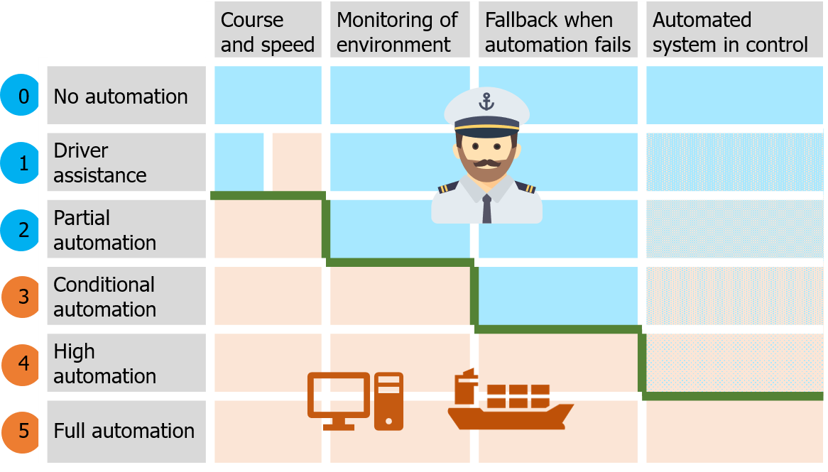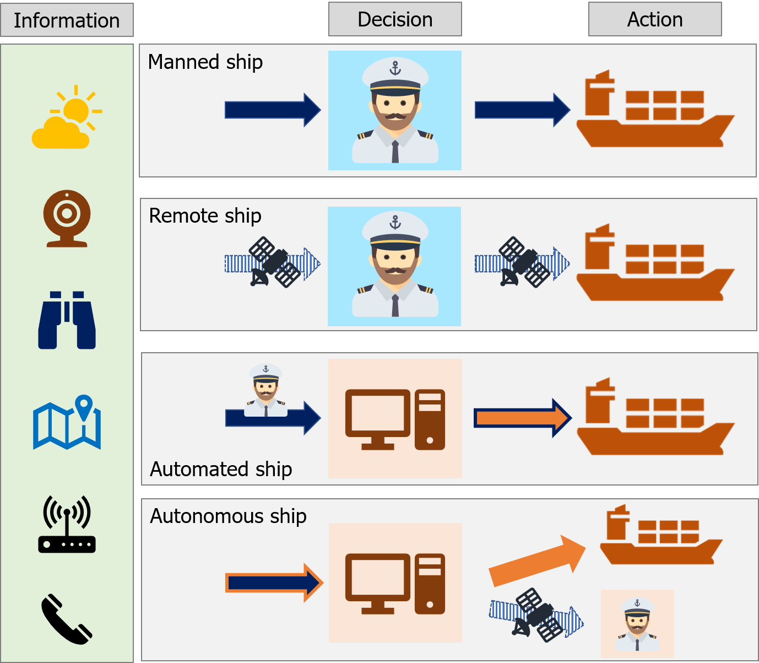

(a) Levels of automation (b) Types of automation on ships

Figure 1.1: Steps from manned to autonomous ships

## Projects

The vision of autonomous ships is not new, as it already occurred in a book on future ship concepts in 1973. The EU-funded research project MUNIN triggered the renewed interest for autonomous shipping [Saarni et al. (2018)]. The name is an abbreviation for Maritime Unmanned Navigation through Intelligence in Networks and originated from WATERBORNE. An initiative from the EU and Maritime Industries Forum, supporting cooperation and exchange of knowledge between stakeholders within the deep and short sea shipping industry. They did an initial research between 2013 and 2016. Focussing on different elements of an autonomous concept (figure 1.2):

* + - The development of an IT architecture.
    - Analysis tasks performed on today’s bridge and how this will be on an autonomous bridge.
    - Examining the tasks in relation to a vessel’s technical system and develop a concept for autonomous operation of the engine room.
    - Define the processes in a shoreside operation center, required to enable a remote control of the vessel.

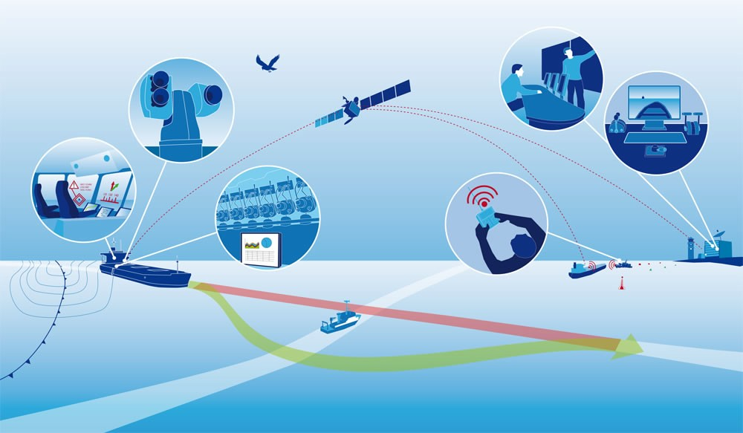

Figure 1.2: Illustration of MUNIN vision

Thereby taking into account the feasibility of the developed solution, including legal and liability barriers for unmanned vessels. They concluded that unmanned vessels can contribute to the aim of a more sustainable maritime transport industry. Especially in Europe, shipping companies have to deal with a demographic change within a highly competitive industry, while at the same time the rising ecological awareness exerts additional pressure on them. The autonomous ship represents a long-term, but comprehensive solution to meet these challenges, as it bears the potential to: Reduce operational expenses and environmental impact. A concept

was developed for a bulker vessel, enabling the consortium to do a financial analysis. Showing the viability, but admitting the limited scope of the project [MUNIN (2016)]. They have showed the importance of developing a method to determine intentions of other vessels and systems which are needed. But did not yet make the step towards developing such a method, which is the scope of this report.

### Exploratory projects

Different project worked on the vision about the future of shipping, often these projects have different phases in which the level of automation increases with every iteration. Examples of projects currently running all over the world are:

* + - * One Sea – Autonomous Maritime Ecosystem by DIMECC Ltd.
      * Advanced Autonomous Waterborne Applications
      * Unmanned Cargo Ship Development Alliance
      * ReVolt

Rolls-Royce Marine is involved in different projects, which are in some way follow-ups to the MUNIN project. The videos of the virtual bridge concept and the Electric Blue vessel have had many views, as this showed clearly their vision of how the shipping industry could look like in the future. Electric Blue is a concept ship, based on a standard 1000 TEU feeder and shown in figure 1.3. The ship is very adaptable, it can sail for example on both diesel and electricity. The modularity enables Electric Blue to adapt for specific routes and meet environmental requirements now, and in the future.

Keeping in mind that the way towards autonomous, will start with a virtual bridge, which is housed below the containers. Utilizing the opportunities for sensors during safe navigation. By using Radar, camera, IR camera, LIDAR and Automatic Identification System (AIS). The aim of this concept is to have partial autonomy by 2020, remote operation between 2025 and 2030, starting with a reduced passive crew on board. And be fully autonomous in 2035 [Wilson (2017)]. They pinpointed the control room, as the nerve center of remote operations. Using an interactive environment with a screen for decision support and improving situation awareness with augmented reality. With these developments does their vision look very promising. However there have not yet been successful prototypes.

Since June 2017 is Rolls-Royce also involved in the unmanned cargo ship development alliance, which is initiated by Asian companies and classification bureaus. Their aim is to develop unmanned cargo ships with independent navigational capacity and make market promotion

so as to promote the development of intelligent shipping. The alliance would not only promote changes in the ship design and operation, but also facilitate the establishment of technology, regulation and standard system involved in unmanned cargo ships. Combined with the accumulation of rules and standards as well as the field of intelligent ship.

### Industry projects

Where the exploratory projects work on the vision and far future of autonomous. Are some companies working towards prototypes, often funded by customers of shipping companies. The Yara Birkeland is one of the projects ahead of the pack, already building and testing a 120 Twenty foot Equivalent Unit (TEU) container ship (figure 1.4). This vessel will initially operate as fully electric manned vessel, but plans are that it will sail autonomously in 2020. Operating between different Yara facilities in Norway, transporting fertilizers and raw materials. Meaning the path and quay are always the same, which reduces the amount of challenges. Kongsberg is responsible for the development and delivery of all key enabling technologies. Including the sensors and integration required for remote and autonomous operations, in addition to the electric drive, battery and propulsion control systems [Sames (2017)].

Other smaller projects are the development of Norwegian ferries, which are likely to start sailing automated from 2018, just like an automated shuttle service for offshore installations. A partly Dutch project is the Roboat, where a fleet of small pontoons will be used to solve problems on urban waterways. Such as transportation of people and goods or creating temporary dynamic floating structures like bridges and stages. Which is a collaboration between AMS Institute and MIT.

Where most of the previous projects were focussed around developing a vessel which has to operate in the current environment. Does the smart shipping challenge (SMASH) focus on combining technological developments within different parts of the inland shipping industry in the Netherlands, such as bridges and terminals. This will help to steer ships remotely, enable intelligent exchange of information and the optimization of waterway maintenance. Good examples are the new vessels from Nedcargo and the Gouwenaar 3. These vessels will be able to transport more containers, while reducing the fuel consumption. This will not only be acquired by improving the hull shape and machinery, but also by sailing smarter. For example by optimizing the speed, based on opening times for bridges and availability of the quay [SMASH (2017)].

A future project from the Netherlands is a joint industry project, under the name Sovereign. The research conducted on communication and decision making will support the final result

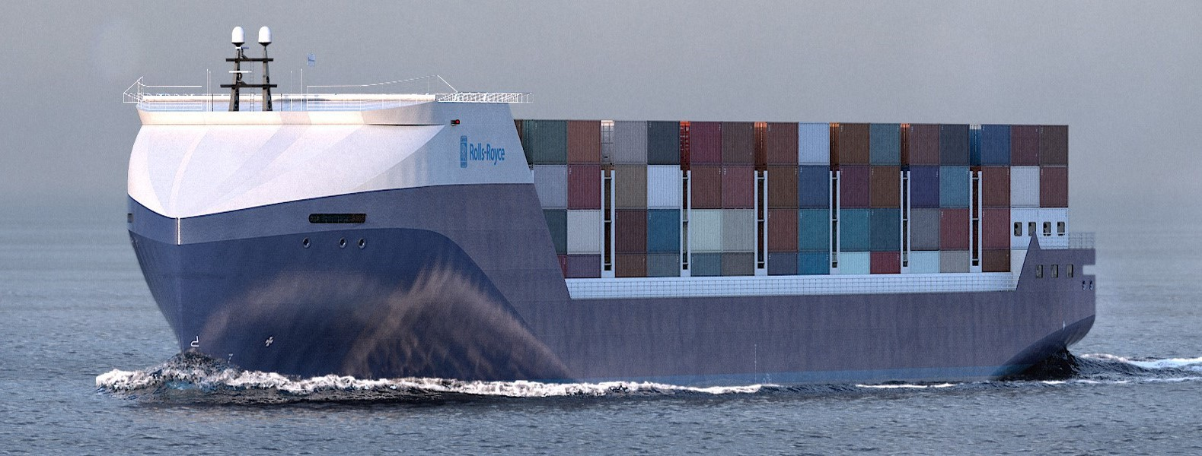

Figure 1.3: Render of Electric Blue

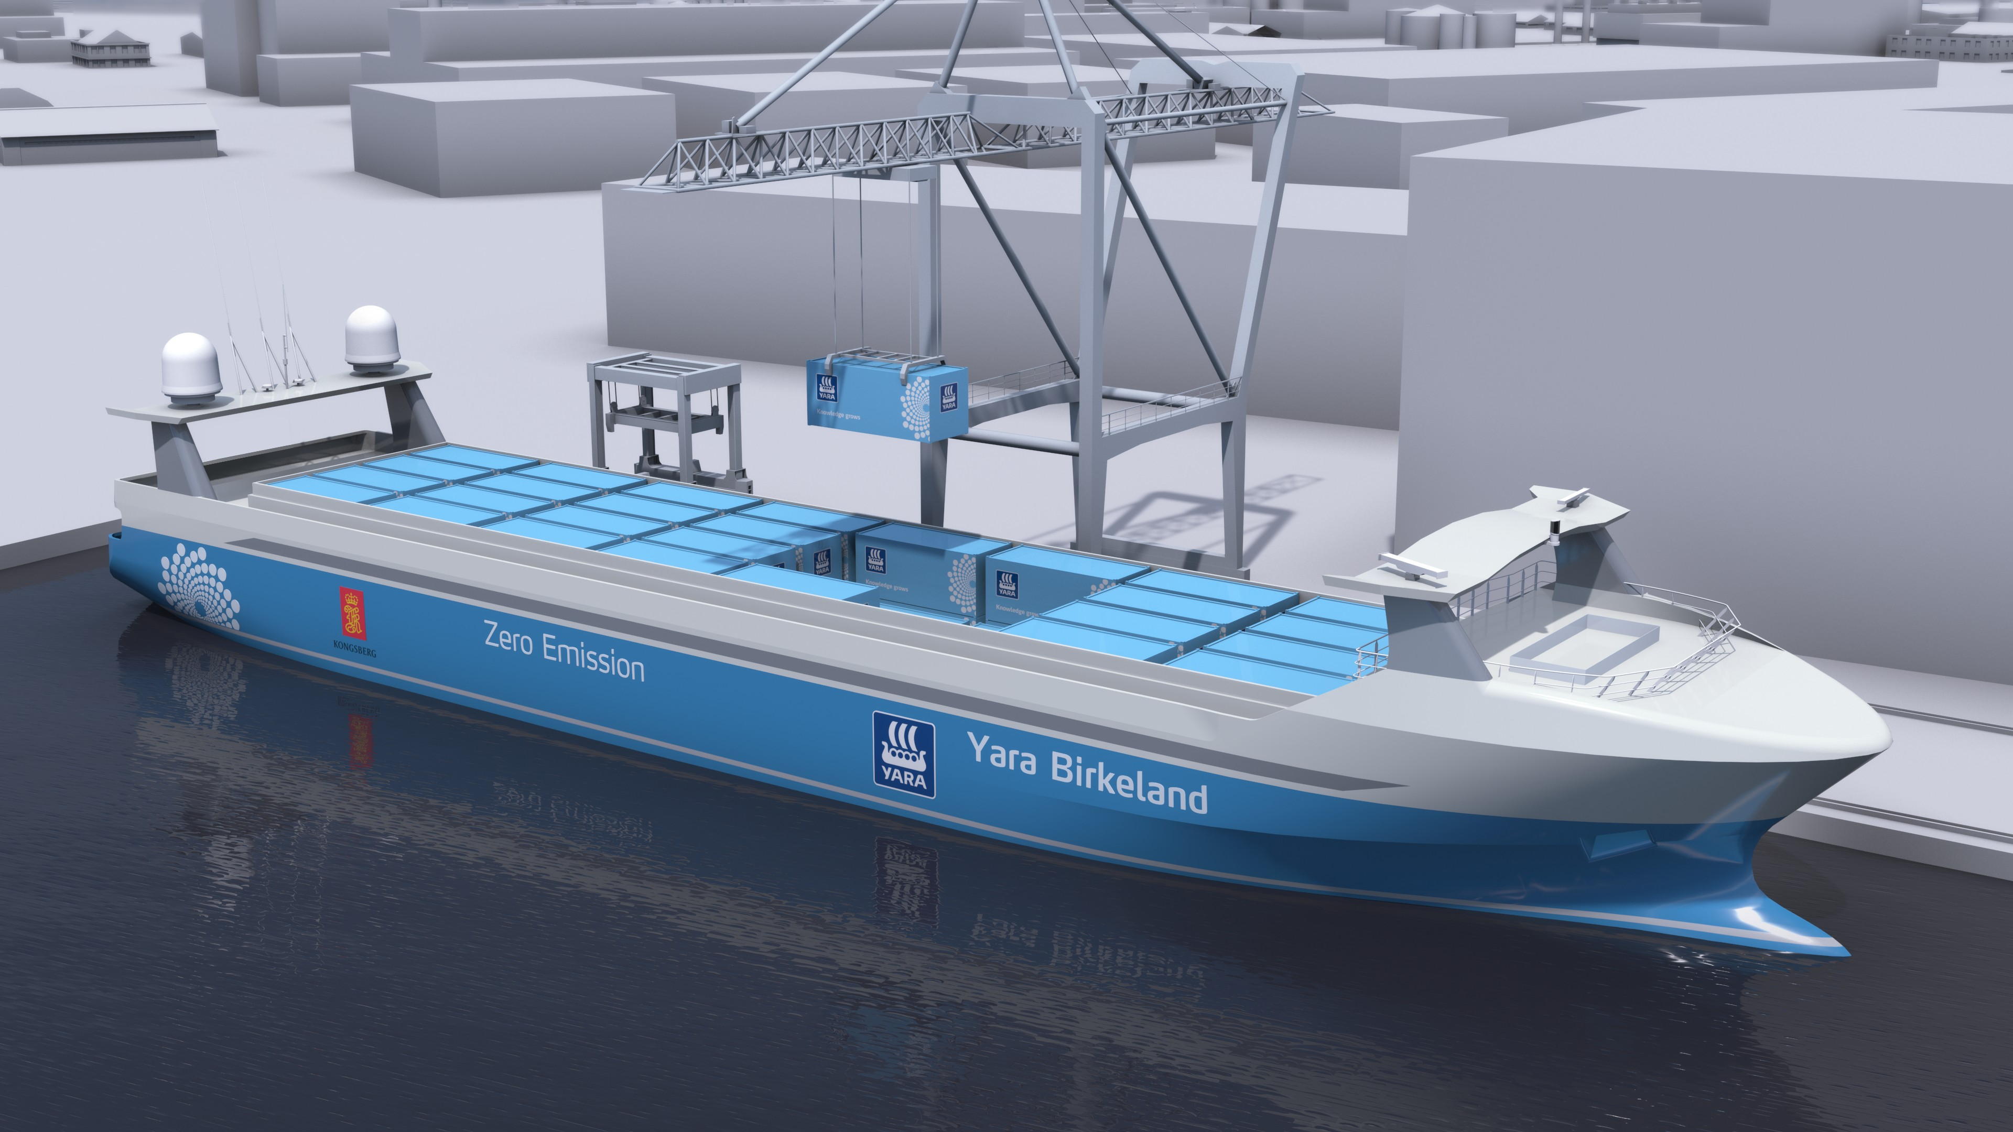

Figure 1.4: Render of Yara Birkeland

*1.3. STAKEHOLDERS* 15

of this project via Damen Shipyards and the Technical University of Delft. In this project did European companies, research institutes and the Technical University of Delft partner to develop a technology to deal with difficult environments and complex transport missions, within short sea and port traffic situations. Which is also applicable to other autonomous waterborne operations, such as inland waterways transport and coastal/inter-island short range ferry services. This should result in a ship for the shipping company Amasus.

Based on the above mentioned projects, are the most direct use cases: Local transport between factories and terminals and short sea shipping solutions. However there might be more in the future, such as the usage of tugs as extra actuator in dynamic positioning systems.

## Stakeholders

When these ships will sail, does not only dependent on the rate in which the technology can be developed. But there are also regulatory bodies, such as International Maritime Organization (IMO) and classification societies which need to incorporate autonomous vessels in their frameworks. The exploratory projects are very important, as this will help them to prioritize the codes for different ship types. These codes include information on autonomy levels and how to certify unmanned vessels.

Another group of stakeholders are the shipbuilders, system integrators and suppliers for subsystems. These are responsible for the technological development. More and more shipyards try to get involved, to gain knowledge on the development process. Also are there the companies from other industries, which see opportunities for products they already developed for planes or automotive, which could be used for unmanned vessel. For example using computer vision, protocols for classifying systems and connecting ships.

The last, but probably most important are the customers, as a technology will only be used if you can make money with it. More and more companies are convinced this is possible. This are not only the chartering companies, but also their customers, such as Heineken, Yara and BHP.

## Challenges when combining unmanned and manned vessel

Based on the above mentioned projects it is clear that many project work on different challenges. All challenges are related to the safe operation of unmanned vessels, while optimizing profit. One of the most critical cases is when manned and unmanned vessels

meet, in those cases is often ship-to-ship communication needed. Many of the projects so far, try to avoid these situations. As technologies for communication are costly to develop, is the aim to avoid communication when possible. To accomplish this, the first step is to adjust the operational strategies for unmanned ships to avoid complex situations. This means a strategy should be developed on how these ships can avoid communication. The most easy way is to operate only in area’s where all risks are known. But to enable a ship to operate everywhere, the best solution is to avoid the need for communication, by taking decisions well in advance and to make intentions clear. Still some challenges are open, as not all complex situations can be avoided. For these cases there must be a protocol which enables manned and unmanned ships to share the right information. Both of these issues have not been within the scope of the previously mentioned projects, or any other research [Kooij et al. (2018)].

*In the next chapter* are factors discussed which influence the decision making process. This is based on challenges from above mentioned projects and current research, where a decision model is used as stepping stone.

# *|* Decision model

In the previous chapter, several projects are discussed, which gave insight in the challenges towards unmanned and autonomous shipping. Using a model for decision making, insight is acquired how the challenge of communication can be tackled in a structured way. This model shows which factors influence the decision-making process and how this is supported by relevant research.

The decision process within the model is based on Boyd’s OODA loop, Endsley model for situational awareness, and combined with models used in the projects as mentioned in chapter 1. The OODA loop has different phases: Observe, orient, decide and act. Similar to Endsley’s model: Perceive, comprehend, project, decide and act. The combined model describes how this applies to, choosing the right strategy for safe operation, and relates to external factors and relevant theory. In figure 2.1 a visual of the decision model is shown. The first step describes what can be observed, to form a mental model. The next step is to orient, in which the situation and hazards are identified. This will result in a set of strategies, which will be evaluated using different criteria, resulting in a decision. After this decision, an action is executed. This chapter will discuss these phases in more detail and how they relate to the challenge of communication, by discussing external factors and relevant theory.

## Decision process

The decision process is the core of this model. The decision process will be used in part II on a less abstract level than described in this chapter. The steps taken in this decision process are similar for manned and unmanned vessels. Although their way of thinking differs when this is related to being consistent or handling exceptions.

#### Mental model

The first phase of the decision process is to form a mental model. A mental model is a representation of the surrounding world, including the relationships between its various parts and a person’s intuitive perception about his or her own acts and their consequences. To make this representation sensor data about the environment is used. This raw data must be interpreted, to become information which can be combined into knowledge. These steps require still much research, although large steps are taken within the domains of LIDAR [Oliver Cameron (2017)], computer vision [Bernard Marr (2017)] and sensor fusion [Hoffman (2018)]. Appendix A discusses the systems which are used at manned vessel, to

17

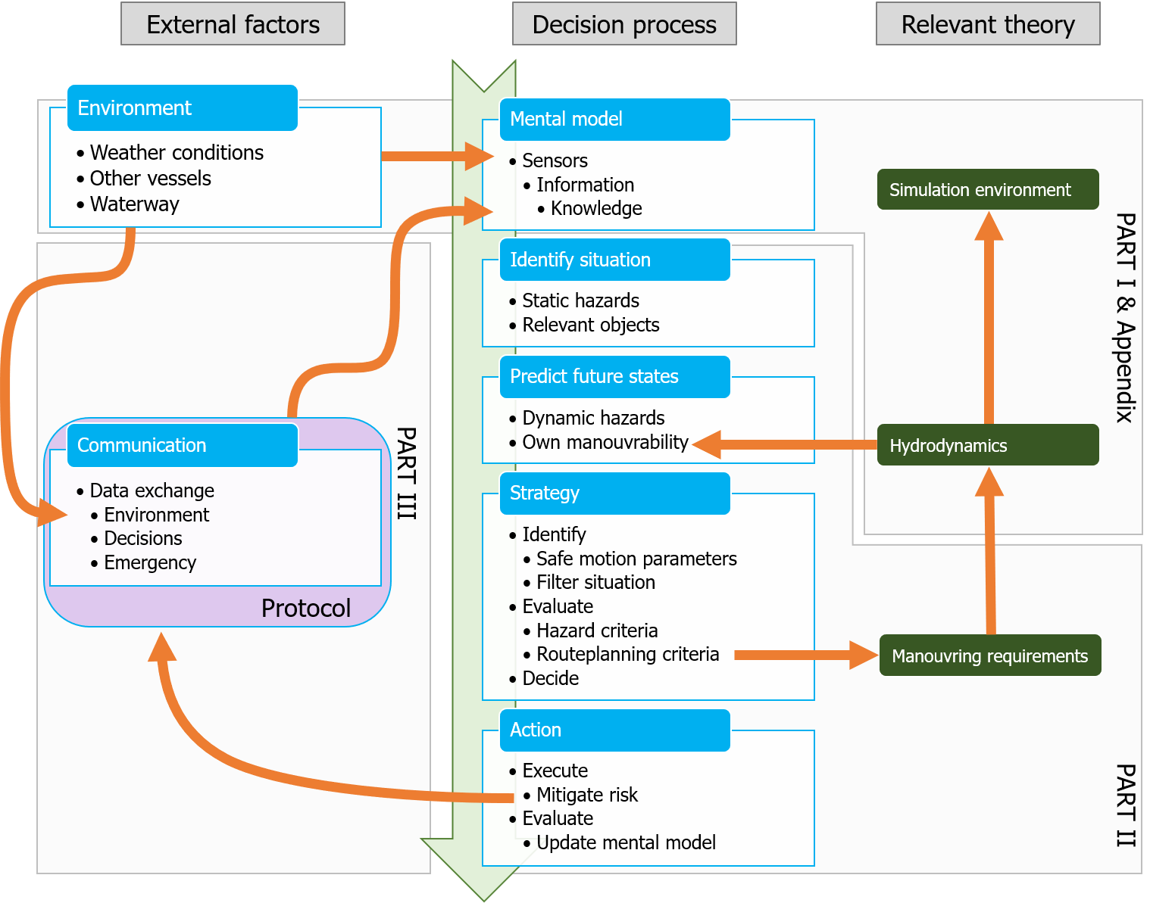

Figure 2.1: Decision model

* 1. *DECISION PROCESS* 19

form a correct mental model. For this research, only the result of this step is relevant: Is the acquired knowledge sufficient to identify the situation correctly, or is more information needed? Future technologies and sensors are not within the scope of this research, nor how their outputs can be combined into useful information.

#### Identify situation

The step from information to knowledge is in the phase where the situation, scenario, and hazards are identified. How this would go in practice is discussed in chapter 4. This step is taken to identify critical situations which should be evaluated during the design phase of an autonomous ship. This research will define a method to evaluate these critical situations. The situation and scenario are defined by the layout of the waterway, other nearby vessels, relevant regulations, etc.

#### Predict future states and decide on strategy

Based on the situation different strategies might be possible. These strategies have to be evaluated. This is done by predicting how the different strategies will influence the path of the different vessels. A trade-off must be made between exact calculations and computation time. For example is the closest point of approach (CPA) currently determined using linearized algorithms in common ARPA systems. Using non-linearized methods with for example a B´ezier curve will result in smaller errors. Simulations would improve this even more, however does a simulation with correct hydrodynamic models cost much more computational time. In chapter 5, the linearized and non-linearized methods are described. The simulation is done with the tool as described in appendix B, but this tool is not optimized for such calculations. Therefore will it not be able to do these calculations in real-time. The hydrodynamic model used in the simulation also described in appendix B.2.3. After this phase different manoeuvers are evaluated which corresponds to the different strategies. How this will be done for common critical strategies is discussed in chapter 6, this will result in manoeuvring requirements, these requirements can be used by ship designers, to ensure that the ship can operate safely with minimal need for communication. After the evaluation of these criteria is known which strategy will result in safe operation of the vessel.

## External factors

How easy it is to go through the decision process and end up at the right strategy depends on the situation. The situation is mostly influenced by environmental factors. In some cases are the static sensors not sufficient to analyze the environment properly, resulting in an incomplete mental model. This section will describe in more detail how the environment influences the forming of the mental model and how safe operation within this environment would benefit from communication.

### Environment

As discussed before, is the mental model mostly a representation of the environment in which the vessel acts. The sensors will measure this environment. Many critical situations occurred due to weather conditions. The reason is that the sight is limited during heavy rain or snow. Also might the wind and waves limit the manoeuvring capabilities of a vessel. This is also the reason some vessels are not allowed to enter a port when winds are too high. This is mostly due to the layout of the waterway. Due to currents, operations (e.g. maintenance and fishery) or limited depth, might some area’s be restricted. This information is often acquired via communication channels, but communication channels which only allow receiving and not sending, such as Navigational text Messages (Navtex).

The same goes for basic information on other ships. They might send their location and speed via AIS, but still key is the ARPA. Due to weather conditions, these systems could have worse performance, as heavy rain creates noise at the radar. In the situations where sensors do not function as expected. Communication is needed, even if the whole decision process itself is optimized to avoid communication. The same goes for communication with shore-based stations such as traffic controllers or in the future remote pilots. These often have information which could not be retrieved via sensors or current systems. Such as a place and time to berth or pick-up a pilot.

Both shore-based stations and ships can only share intentions and their planned path via the radio. Future unmanned will most likely be able to negotiate using other systems. But in case with manned-manned or manned-unmanned interaction is this only possible via VHF radio for now.

* 1. *EXTERNAL FACTORS* 21

### Communication

As described are there still cases in which communication is necessary. In part III the case where communication between manned and unmanned vessel is needed is discussed. Using the situated Cognitive Engineering (sCE) method a protocol is defined, based on existing systems and protocols. Thus using AIS to send written messages, or VHF and Standard Maritime Communication Phrases (SMCP) for verbal messages. Other cases such as communication with traffic controllers and pilots could use the same protocol. Although they might need to share more information with unmanned vessels, which could be done with a new system such as VHF Data Exchange System (VDES). This will however not be part of this research.

**Part II**

**Effect of manoeuvrability on decision making**

*We rarely recognize how wonderful it is that a person can traverse an entire lifetime without making a single really serious mistake. Like putting a fork in one’s eye or using a window instead of a door.*

– Marvin Minsky [Minsky et al. (1991)]

23

25

The previous part describes the context of this research and showed steps towards autonomous shipping, which are relevant to this research. This part will focus on the effect of manoeuvrability on the decision-making process. The steps taken to get to the right decision are similar to steps shown in the model of chapter 2. The insights acquired from the effect of the manoeuvrability on the decision process can be used to determine manoeuvrability requirements and answer the following question:

*How do ship manoeuvrability characteristics influence the domain for decision making, to ensure that the chosen strategy will result in a passing distance which does not require communication?*

The first phase of the decision process is the observation phase. This starts by updating the mental model and is followed by a phase where different chunks of information are connected. This means that situations and scenarios can be identified. This is the start of the decision making process in which different trees are used to identify potential hazards and problems which will result in strategies. These strategies are finally narrowed down to the actions. The different nodes and trees are discussed in chapter 3.

More detailed descriptions of the different phases within the decision-making process are discussed in the next chapters. First the identification of the situation and scenario is discussed in chapter 4. Which branch to take in the decision trees, is determined by evaluating criteria. These criteria determine if there are hazards and which manoeuvers are feasible. This works in two ways: While sailing these criteria can be used to determine the right strategy. While a ship designer can use these criteria to ensure a ship can sail safely in specific situations. The criteria to evaluate what kind of problem there is, are described in chapter 5. The criteria used to evaluate if strategies are feasible for critical situations are described in chapter 6. In chapter 6 is also described how designers can use these manoeuvers to determine the manoeuvring requirements for safe operation. To evaluate if these criteria are useful, manoeuvers are simulated with the tool as described in appendix B. These are also used to test several scenarios and see how these criteria affect the decision-making process.

The result of this part is a design matrix which can be used by designers to determine the effect of manoeuvring capabilities on the moment decisions have to be made. This is done for some specific manoeuvers, showing the minimal time and distance needed to make decisions in order to have a safe distance between vessels. This matrix depends on the manoeuvring characteristics, speed and type of manoeuvrer.

26

# *|* Decision making process

A rule-based time-domain decision model is used, to acquire more insight into the decision- making process. Using this can be answered what the situation is, and what problems might occur. This is done in a structured way by using a decision tree. Where the nodes are described with tags. This generalized model can be optimized in later stages to create a fully functional decision algorithm for autonomous and unmanned ships. Using advanced modeling techniques and machine learning algorithms. First the decision phases are described, followed by lists of nodes used to identify scenarios and situations. Combining this with the COLREGs will result in a functional decision model. Also the criteria necessary to go through the steps are discussed. The aim of this decision model is to gain insight into the decision process. To show which situations are critical when the goal is to avoid communication.

## Decision phases

The decision making process has different phases. As shown in chapter 2. A simplified version of the decision model is shown in figure 3.1. These different phases are described in table 3.1.

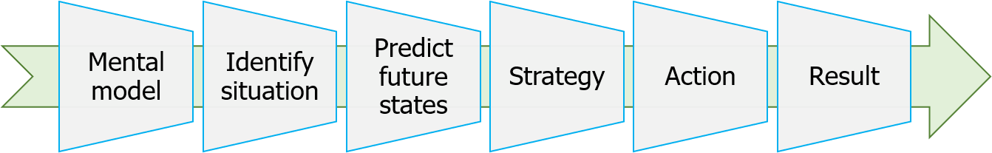

Figure 3.1: Decision process

Class

Mental model Situation identification

Predict future states Strategy

Action Result

Description

Acquire knowledge about the situation, not within the scope of this research

Identify the encountered situation, to determine which criteria are relevant, based on waterway lay-out and other ships.

Predict if a problem will occur, as there is only a change in strategy needed when this is the case.

If there is a problem, a new strategy should be chosen, this is based on the evaluation of criteria.

From this strategy, different actions will follow.

Finally the result is evaluated, using the same criteria to determine a problem in future states.

Table 3.1: Description of phases in decision process 27

## Nodes in decision making tree

To describe the nodes within the decision trees, short keywords are used. These describe in short what kind of situation, problem, strategy, action or result there is. By using the same terms, confusion is avoided. Definitions for those terms are given in this section.

#### Encountered situations

This is the first step to limit the number of strategies which are relevant to evaluate. The nodes within the identification process are described in table 3.2, more details on how this is determined are described in section 4.1.

Tag

Passing

Crossing Over-taking Merge

Description

The paths of both ships are in opposite direction, and do not cross.

The final direction of both ships differ, but they do cross. The paths of both ships are the same but at different speeds. The starting direction of both ships differ, but the final direction is the same.

Table 3.2: Tags for different situations

#### Predict future states

To identify if a problem will occur, different criteria are being evaluated. These criteria are described in chapter 5. In table 3.3 the nodes within the decision tree are discussed to evaluate if there is a problem, and which evaluations are possible for these criteria.

Tag

Closest point of approach Crossing point

Crossing distance Passing position Relative speed

Evaluation

Good; Too close In front; Behind Good; Too close

Port side; Starboard side Faster; Same speed; slower

Table 3.3: Criteria and result of evaluation to identify a problem

#### Possible strategies

Using the identification of the situation and prediction of future states. A limited number of strategies might be possible. The strategies will result in actions, but can be categorized

* 1. *NODES IN DECISION MAKING TREE* 29

in the groups as described in table 3.4. The possible actions per strategy are shown. To determine if an action is necessary and possible, the distance and time which is left to avoid a problem are evaluated. These criteria are described in table 3.5.

Tag Actions

Follow planned path Continue without change

Increase CPA by yourself Evasive manoeuvrer; Adjust speed Increase crossing distance by yourself Evasive manoeuvrer; Adjust speed

Work together with others Communicate; Evasive manoeuvrer; Adjust speed Emergency Emergency stop; Communicate

Table 3.4: Tags for different strategies

Tag

Time till problem Distance till problem

Evaluation

... seconds

... meter

Table 3.5: Criteria to determine if action is possible

#### Possible actions

From the chosen strategy, actions will follow. These action are a combination of an action type, and a moment to execute action. In table 3.6 and 3.7 these are described. These actions consist of different smaller sub-actions such as: ”rudder 35 degrees to port-side”.

Tag

Continue without change Evasive manoeuvrer Adjust speed

Emergency stop Communicate

Description

Do not change speed or rudder

Steer to starboard or port side first and end at same course Reduce speed or speed-up

Turn ship side-ways and set propulsion in reverse Discuss required actions with other vessel(s)

Table 3.6: Types of actions

Tag

Now

In ... minutes/seconds After action ...

Description

When action can be undertaken as soon as possible Wait to ensure action is necessary

Wait with action till you or other has done another action

Table 3.7: Time-domain for action

#### Result

Using the criteria from the action phase, can the chosen action be evaluated. Herein is the human factor on board of other vessels taken into account, in the form of perceived risk. This perceived risk is linked to the safety domains [Szlapczynski and Szlapczynska (2017b)]. The safety domain as described by Coldwell is used [Coldwell (1983)]. This domain is based on an ellipse, which is not centered at the location of the vessel, as shown in figure 3.2. This takes into account that ships rather pass on port-side and behind. In this model the safety domain only depends on the length of the ship.

Evaluations and criteria are shown in table 3.8. The evaluation of these criteria, determines if problems can be avoided.

Tag

CPA

Perceived risk Safe situation

Evaluation

Good; Too close

Safe; Uncomfortable; Close encounter; Too close Yes; Uncomfortable; No

Table 3.8: Tags for safe situation criteria

## Critical paths in decision trees

When combing the nodes as described in the previous section, very large decision trees are obtained. The decision tree for specific situations and scenarios is much smaller, than a tree covering all possibilities. Although a generalized model of the tree can be drawn, based on the previously described nodes. This model is shown in figure 3.3. Where the orange blocks show evaluation criteria and the white blocks are choices. Thereby should be considered that the actions are evaluated in a similar manner compared to predicting future states.

*In the next chapters* will the decision tree be used to identify critical paths. These paths will be evaluated for critical situations. When all possible paths are considered, this will result in a very big decision tree and many critical situations. Which does not result in more insight in a solution to avoid communication. Using identification and evaluation criteria several common critical paths can be identified which are used to define manoeuvrability criteria.

* 1. *CRITICAL PATHS IN DECISION TREES* 31

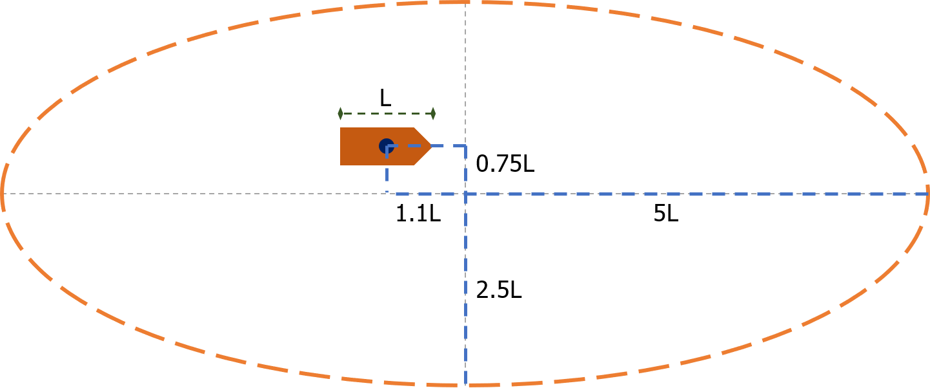

Figure 3.2: Model for safety domain by Coldwell

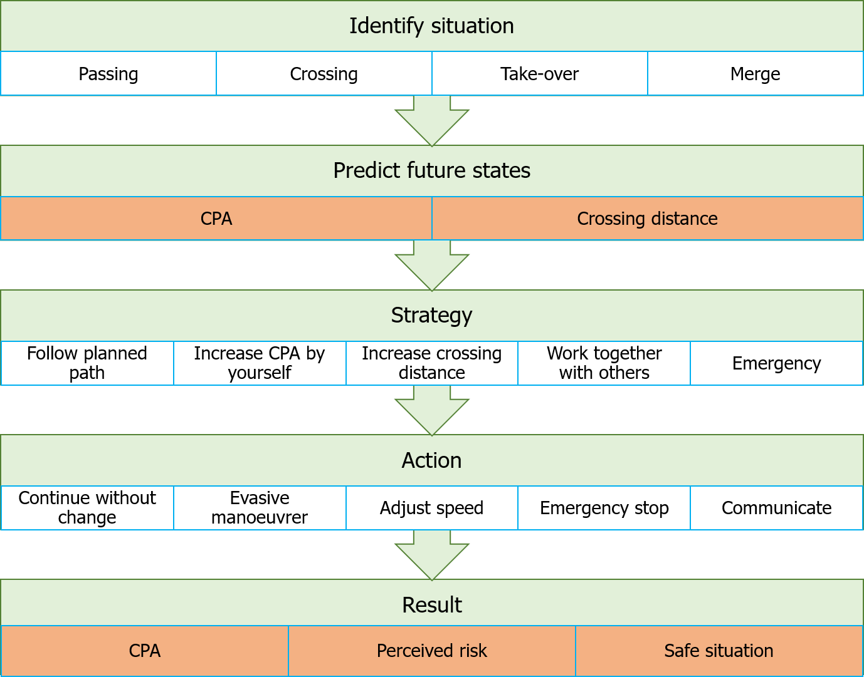

Figure 3.3: Generalized model for decision tree

# *|* Identification of situation and scenarios

After forming a mental model of the situation, starts the decision process with the identification of the situation and scenario. Where the decision tree from chapter 3, will help to identify common critical situations. The identification of these situations, aims to narrow down possible strategies in the next phases of the decision making process. This chapter discusses the first steps of classifying the situation. Followed by the steps taken in the orientation phase to narrow down the possible strategies. Which will help to determine which paths are common and critical, thus are good to be used while evaluating manoeuvring criteria.

## Situation identification

Situations can be classified into four types. These are also discussed in chapter 3, as these are the same nodes as in the decision tree. Table 4.1 shows these situations:

Situations Description

Passing The paths of both ships are in opposite direction, and do not cross. Crossing The final direction of both ships differ, but they do cross.

Over-taking The paths of both ships are the same but at different speeds.

Merge The starting direction of both ships differ, but the final direction is the same.

Table 4.1: Tags for different situations

It depends on the waterway lay-out which situation is likely. This can be influenced by traffic separation schemes, forbidden zones or land masses. To determine the situation, a classification of paths is used. To do this systematically, paths will be based on figure 4.1 and can be written as: [current position, direction].

To classify a situation where two vessels encounter each other, the paths are considered. Key is to determine the angle between those paths. This way it is possible to classify them using table 4.2 and figure 4.1.

The boundaries to determine if the other ship comes from direction A, B, C or D are based on COLREGs [IMO (1972)]. Direction A is between 112.5 and 247.5 degrees, as shown with the dotted line in figure 4.1. While sailing this angle can be observed using the mast-head lights. Which are seen as red when the vessel comes from B, green when from D and green and red from C. While from direction A the color of the light will be white. When in doubt if it is a head-on situation or a crossing situation. Always assume a head-on situation, as this stated in rule 14 [IMO (1972)].

33

|  |  |  |
| --- | --- | --- |
| Own ship | Other ships | Situation |
| [A,D] | [D,C] [D,B] [D,A] [C,B] [C,A] [B,A] [B,C] | Passing |
| [A,C] | [C,A] [C,B] [B,A] | Passing |
| [A,B] | [D,C] [C,D] [B,A] | Passing |
| [A,C] | [D,B] [D,A] [C,D] [B,D] | Crossing |
| [A,B] | [D,A] [C,A] [B,D] [B,D] | Crossing |
| [A,D] | [C,D] [B,D] | Merge |
| [A,C] | [D,C] [B,C] | Merge |
| [A,B] | [D,B] [C,B] | Merge |
| [A,D] | [A,D] | Over-taking |
| [A,C] | [A,C] | Over-taking |
| [A,B] | [A,B] | Over-taking |

Table 4.2: Path definitions for different situations

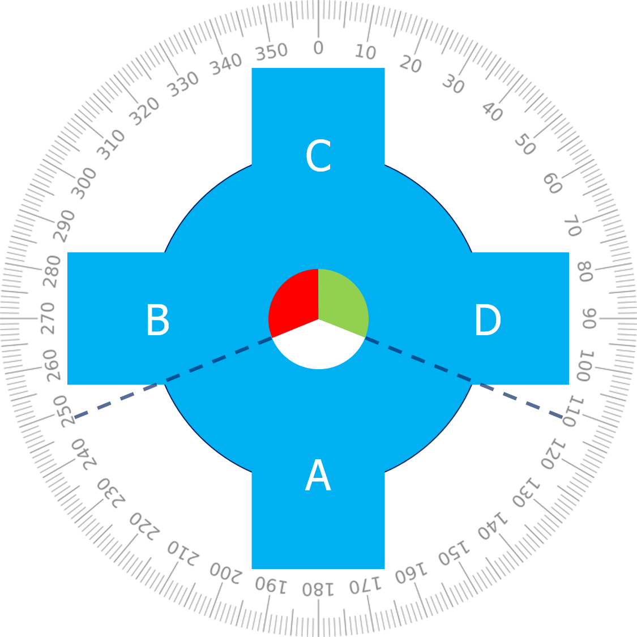

Figure 4.1: Path description for situation identification

*4.2. SITUATIONS WHICH LIMIT POSSIBLE STRATEGIES* 35

## Situations which limit possible strategies

Beside this first identification of the situation. More details must be taken into account to eventually form the right strategies, as these details might limit the possible strategies. Below the effect of the waterway and actors are discussed on possible strategies.

### Waterway properties

To limit the strategies which have to be evaluated, are strategies filtered based on the physical properties of the waterway. As this might restrict the area where can be sailed, or does behavior differ. For example is it common to over-take ships in open-water on starboard side. While on restricted waterways ships will sail as far as possible to starboard already. Which means that the ship which is over-taking will have to pass on the port side of the other vessel, at the center of the waterway.

In the next step other static hazards are considered to check if the chosen strategy does not lead to a collision. Or if there are specific regulation frameworks for this waterway. These are however not part of the first iteration of the decision model, as this will introduce much more complexity, without improving the result in most cases. Examples of static hazards which could be evaluated in future iterations are buoys, forbidden zones, bridges, quays, port mouths or shallow waters. As possibilities for over-taking or evasive manoeuvers are limited in those cases for example. This means the strategies are limited.

Another limiting factor related to waterways are the difference in regulations between waterways. Most obvious are traffic separation schemes, or other road marks such as signs which forbid to over-take or meet. But others are for example to not create wash or no turning, thus limiting the options to manoeuvrer. Or more directive signs on obligated directions or speed limits. This is most relevant for coastal and inland waterways.

### Dynamic objects

The second major step is the identification of dynamic objects. Those are all relevant moving objects. Most obvious are other ships, which come close. But in future developments of the decision model, objects which are not under any control of a human should also be considered, such as floating containers, this is however not within the scope of this research. The major difference between static hazards are of course that the ’forbidden zone’ around these objects change over time. This means more complex evaluation methods are needed to determine if there is no perceived risk, and thus a safe situation.

These complex evaluation methods will have to predict the path. To do this, first the general information about the object should be acquired. Such as manoeuvrability, speed, course, type of object, under control, etc. Thereby might it be possible in future developments to take into account the human factor to improve the path prediction. This could be based on the experience of the crew, availability of a pilot or if the vessel is completely unmanned.

Examples of such dynamic objects which limit the possible strategies, are for example: Fishery vessels, as they might have long nets behind them during operation. Ferries in inland waters which have priority over other shipping traffic. Ships with limited manoeuvrability or forbidden zones around them.

## Scenarios

Using the information about the properties of the waterway and actors, the scenario can be identified. Where the situation is based on observations and describes the current state. Do the scenarios take into account the possible future strategies of those actors and thus describe what the future states could be. Based on the scenarios, can be determined which rules to apply and what their implications are on the possible strategies. The same goes for the estimated path of dynamic objects. This might also narrow down the possible strategies.

Using the above mentioned information in the decision model, the strategies can be narrowed down. This can be used to simplify the decision tree and select the right criteria to evaluate. Different scenarios for the same situation could be that the ship turns to port or starboard. For both does a probability exist. Using a probability index for the decision of other vessels will in this case improve the eventual decision making. This can be taken into account by for example the safe motion parameters and safety domains as described by Szlapczynski [Szlapczynski and Szlapczynska (2017a)][Szlapczynski and Szlapczynska (2017b)].

*In the next chapter* the criteria are defined to evaluate the situations and scenarios. This evaluation shows if a problem might occur. These criteria are eventually used to determine the most critical common situations.

# *|* Definition of criteria

In order to determine if a problem might occur in the situations and scenarios as identified in the previous chapter, are different criteria evaluated. Most of these criteria are already calculated by the current systems, such as ECDIS and ARPA. However, do they use linearized algorithms. These do not predict the CPA and crossing distance correctly while turning, often resulting in many dismissed alarms. The description of different criteria is given, followed by the calculation needed to evaluate them. This is done for both the linearized algorithms and proposed algorithms. Later in the process, these criteria can be used again. To ensure that the chosen strategies ensures safe operation with low perceived risk.

## Calculations based on current systems

Within ARPA and ECDIS, different calculations are made, which can be used to evaluate if there is a problem in the current scenario. These calculations often use linearized algorithms, which results are not correct when turning. The false alarms given due to these wrong results can be easily dismissed by humans, but computers do not always handle false positives well. The advantage however is that the calculations can be done very fast. Below these calculations are discussed for the closest point of approach (CPA) and crossing position.

### closest point of approach (CPA)

The CPA refers to the positions at which two dynamically moving objects reach their closest possible distance. This is an important calculation for collision avoidance. The linearized form uses two points moving at fixed speed and fixed direction. An example is shown in figure 5.1. Where P and Q are the moving points, with corresponding direction vectors u and v, which include the speed and direction.

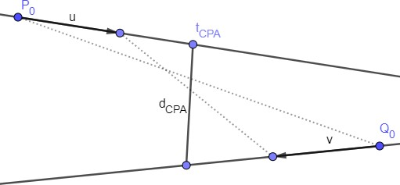

Figure 5.1: Example for closest point of approach (CPA) 37

A formula can be derived for the closest point of approach. With the motion equations for *P* and *Q*, the distance can be calculated. Where *P*0 and *Q*0 are the current positions, and *u* and *v* are the corresponding speed vectors:

*P* (*t*) = *P*0 + *t · u*; *Q*(*t*) = *Q*0 + *t · v* (5.1)

*d*(*t*) = *|P* (*t*) *− Q*(*t*)*|* = *|P*0 *− Q*0 + *t*(*u − v*)*|* (5.2)

Since d(t) is a minimum when *D*(*t*) = *d*(*t*)2 is a minimum, this is the case when the derivative is equal to 0:

*D*(*t*) = *d*(*t*)2 = (*u − v*) *•* (*u − v*)*t*2 + 2(*P*0 *− Q*0) *•* (*u − v*)*t* + (*P*0 *− Q*0) *•* (*P*0 *− Q*0) (5.3)

*dD*(*t*)

= 0 = 2*t*[(*u − v*) *•* (*u − v*)] + 2(*P*0 *− Q*0) *•* (*u − v*) (5.4)

*dt*

This can be solved for t to calculate the moment where CPA is the smallest:

*tCP A*

= *−*(*P*0 *− Q*0) *•* (*u − v*)

*|u − v|*2

(5.5)

*dCP A*

(*tCP A*

) = *|P*0

* *Q*0

+ *−*(*P*0 *− Q*0) *•* (*u − v*) (*u v*) (5.6)

*|u − v|*2

* *− |*

If *tCP A* is smaller than 0, the CPA is in the past. If *tCP A* is equal to 0, the CPA is right now, else it is in the future. If *u* and *v* are the same, the denominator of equation 5.5 is equal to

0. This means that the CPA is constant.

### Crossing distance

The crossing distance is the distance between two ships if they pass each others path. This can be both in front or behind a vessel. This distance is mostly relevant for how safe a crossing situation feels. The crew on manned ships do not want to have ships too close in front of them, as they can’t do an evasive manoeuvrer in those situations. The same motion equation as for CPA can be used (equation 5.1).

In figure 5.2 the distance is calculated between two points at a certain moment in time. The first step is to calculate the crossing point (cp) of the two lines:

*P* (*tcp,p*) = *Q*(*tcp,q*) *→ P*0 + *tcp,p · u* = *Q*0 + *tcp,q · v* (5.7)

*tcp,P*

= (*Q*0 *− P*0) *× v*

*u × v*

(5.8)

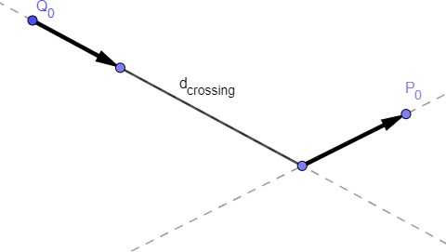

Figure 5.2: Example for crossing point and distance

*tcp,Q*

= (*P*0 *− Q*0) *× u*

*v × u*

l *·*

l *·*

(5.9)

*cp* = *P*0

+ (*Q*0 *− P*0) *× v u* = *Q*

*u × v*

0

+ (*P*0 *− Q*0) *× u v* (5.10)

*v × u*

The next step is to determine where each vessel is, when the other vessel is at the crossing point. To determine finally what the crossing distance is:

*P* (*t*

*cp,Q*

) = *P*0

+ (*Q*0 *− P*0) *× v u* (5.11)

*u × v*

l *·*

*Q*(*t*

*cp,P*

) = *Q*0

+ (*P*0 *− Q*0) *× u v* (5.12)

*v × u*

l *·*

*d*(*t*) = *|P* (*t*) *− Q*(*t*)*|* (5.13)

The crossing distance (cd) for when P crosses Q and vice versa, can be calculated using the following formulas:

*dcd,P Q*(*tcp,P* ) = *|P* (*tcp,P* ) *− Q*(*tcp,P* )*|* (5.14)

*dcd,QP* (*tcp,Q*) = *|P* (*tcp,Q*) *− Q*(*tcp,Q*)*|* (5.15)

## Proposed algorithm based on planned path

To improve the evaluation of criteria, better non-linearized methods are necessary for the calculation of the CPA and crossing point. By predicting the likely path of a vessel, better estimations can be made. Which first uses a first order change, based on rate of turn and course. This can be extended with a combination of expected location and the probability that another ship is choosing a specific strategy.

Although it will result in better evaluations, the disadvantage is that much heavier computations are needed, while also introducing uncertainty with the numerical solver. The first step will be

to make a combination of both the linearized and non-linearized methods. The calculations have to be done for every combination of ships.

The B´ezier curve is used to describe the paths in a non-linearized manner. The definition of a B´ezier curve is first given. Followed by the same criteria as in the previous section: closest point of approach (CPA) and crossing distance. This time describing the algorithm using to calculate it in a non-linearized manner.

### B´ezier curve

The first iteration of the algorithm is semi-linearized. Where the path of own ship is represented by a B´ezier curve, based on its waypoints and strategy. To describe the B´ezier curve, points have to be fitted along the planned path. This is similar to the method as described by Taams [Taams (2018)]. While the path prediction for the other ship is still linearized, as not enough information on the strategy and waypoints is known without introducing new systems and protocols.

For the calculation does the distance function not change. This is still *d*(*t*) = *|P* (*t*) *− Q*(*t*)*|*. However is P taken as own ship and gets a new formula using the B´ezier curve. This curve has a degree of *n*, which depends on the way-points and can be described using the following equations:

, *·*

*bi,n*

*n*

*P* (*t*) = *bi,n*(*t*) *Pi and* (5.16)

*i*=0

(*t*) = *n ti*(1 *t*)*n−i, i* = 0*, . . . , n* (5.17)

*−*

*i*

### closest point of approach (CPA)

The numerical algorithm used to calculate the CPA is shown below. Herein is the path of own vessel represented by a B´ezier curve. While other vessels are represented with the linearized function as described in section 5.1. This results in the following algorithm:

* + - 1. Check if situation (course, speed, other vessels) has changed since last calculation:
         1. No, break
         2. Yes, continue
      2. Use waypoints to determine expected path for own ship (B´ezier curve).
      3. Use path to determine location for each time-step.
      4. Use course and speed other ships to determine their location for each time-step
      5. Calculate distance between ships for each time-step:
         1. If smaller than stored CPA, update stored CPA with calculated CPA
         2. If larger than stored CPA, do not update
      6. Return CPA

### Crossing distance

The algorithm to calculate the crossing distance will require much less computational power, as not all time-steps have to be calculated. Just the ones where the path cross. The following algorithm can be used. It should be noted that some calculations from the CPA calculation can be reused.

* + - 1. Check if something has changed since last calculation:
         1. No, break
         2. Yes, continue
      2. Use waypoints to determine expected path for own ship (B´ezier curve).
      3. Determine crossing point(s) between linear path and B´ezier curve.
      4. Check if crossing points exist:
         1. No, break
         2. Yes, determine location for crossing point(s)
      5. Calculate time when ships are at crossing point(s).
      6. Calculate distance between ships at time of crossing.
      7. Return crossing distances.

*In the next chapter* criteria will be described which depend on the manoeuvrability characteristics of a ship. Using the CPA and crossing distance, it can be determined if the chosen strategy without communication will result in safe operation. Where the algorithms as discussed in this chapter, will give more exact results.

# *|* Manoeuvers for tool validation and testing

The criteria as described in the chapter 5 are aimed to evaluate if there is a problem. In case there is a problem, different actions can be undertaken to mitigate the risk. To determine which manoeuvers are feasible, other criteria are used. As the simulation of all possible manoeuvers can’t be done in real-time, due to its complexity. Will a look-up table be used. This look-up table has data for different manoeuvers and ship types. Every matrix shows how much the CPA can be improved at different speeds and for different decision domains (both time and distance). To make these matrices, simulations are performed for different ships and scenarios. In this chapter is described which manoeuvrer is most critical and will be tested in the simulation environment. The information gathered about the manoeuvers is used to determine relations between different input values, this will show if an action is possible. Thus in this chapter is information gathered about the time and distance needed for a manoeuvrer. Followed by an evaluation of the impact that the manoeuvrer has on the CPA.

## Manoeuvrer descriptions

Strategies often result in actions which are categorized in different types of manoeuvers. Most common to avoid critical situations, are evasive manoeuvers. The time needed to do an evasive manoeuvers, depends on the way it is executed and the manoeuvring characteristics of the ship. To ensure that the results from simulations are correct. Are manoeuvers used which are also used in sea-trials. These manoeuvers are used to validate if the manoeuvrability of a vessel is similar to the real-life situation. Examples of these manoeuvers are the zig-zag test and turning circle test. In this section the manoeuvers from sea-trials and the evasive manoeuvrer are described.

### Sea-trial

Manoeuvring capabilities of a ship are determined during the sea-trials. Using the same manoeuvring tests and metrics as currently used by ship designers, will ensure that the results of other tests are reliable. Different tests are performed to ensure the vessel complies with regulations and its contract on manoeuvring capability. The manoeuvers used to determine this, are the turning circle and zig-zag test. In this section these will be described. The resulting metrics are discussed section 6.2. These metrics are used to validate how well the manoeuvring model works, compared to existing sea-trials with the same ship. Using for example the trial database of Damen Shipyards.

43

#### Turning circle manoeuvrer

The first test is to determine the turning circle of the vessel. The rudder is given a maximum angle of 35 degrees. The ship will start turning. After some time the ship will turn at a steady speed and course change. The results of this test are an advance distance, which is the distance from starting to give rudder, till the ship has turned 90 degrees. The tactical diameter, which is the distance between the starting point and maximum distance the ship traveled to the side. And finally the steady turning diameter, which is the diameter of the turning circle when speed and course change are constant. An example is shown in figure 6.1. Showing the changes in the rudder angle, and how this affects the speed, acceleration and drift angle (*β*) for a 140-meter cargo-ship.

#### Zig-zag test

The second test is the zig-zag test. Herein is the initial turning time, yaw checking time and overshoot tested. This is done by putting the rudder at an angle of 10 or 20 degrees to port side, till the course change is also 10 or 20 degrees, than the rudder is changed to starboard side. This is repeated several times to get a good measurement of the overshoot. The overshoot is determined by measuring the course changes. In figure 6.2 the zig-zag test is shown. In figure 6.2b the rudder, course and heading changes are shown during a zig-zag test. The measured overshoot is a key metric for the manoeuvrability of a vessel, as it shows how easy it is to rotate the vessel. The overshoot is the maximum course change minus the test angle on which the rudder is changed (20 degrees in figure 6.2b). The larger the overshoot, the better the yaw checking ability, but this will result in a lower path changing-ability.

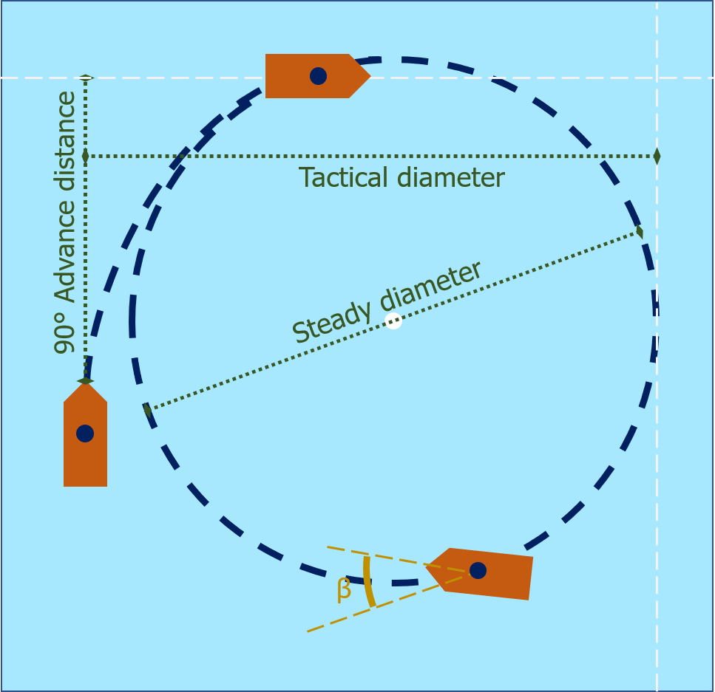 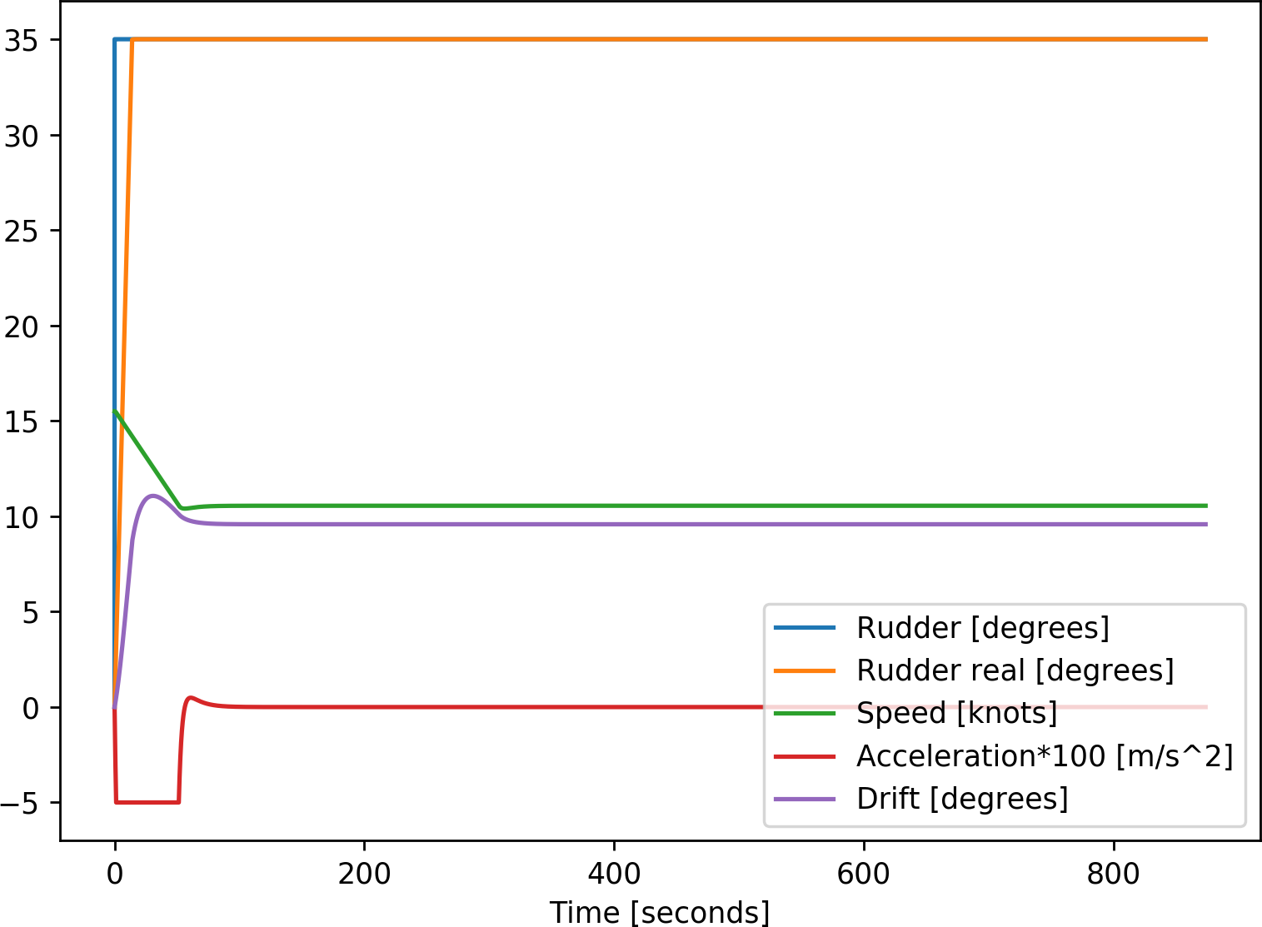

* + - 1. Illustrative path (b) 15kn with 140m cargoship

Figure 6.1: Turning circle test

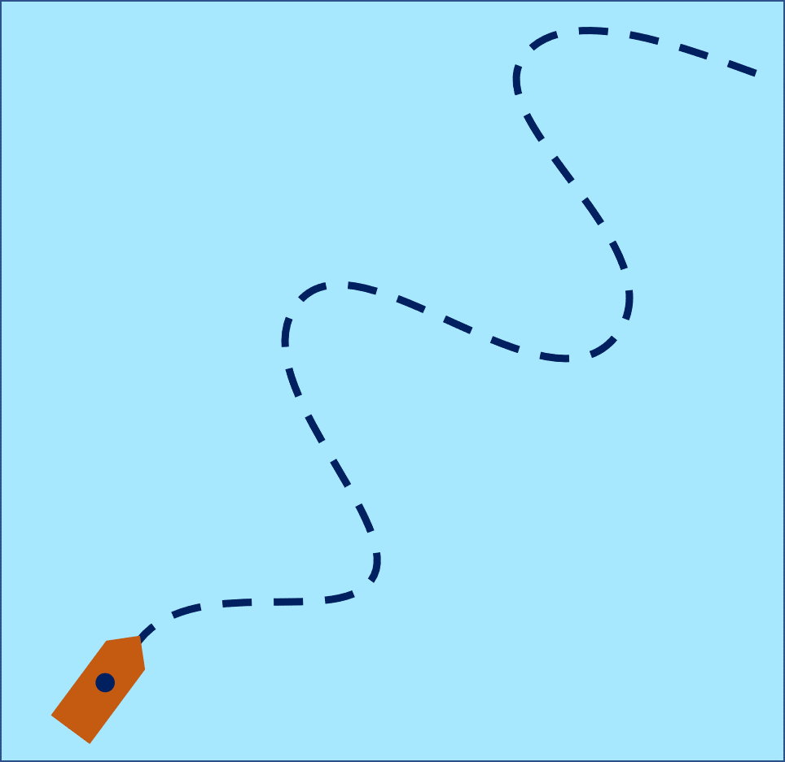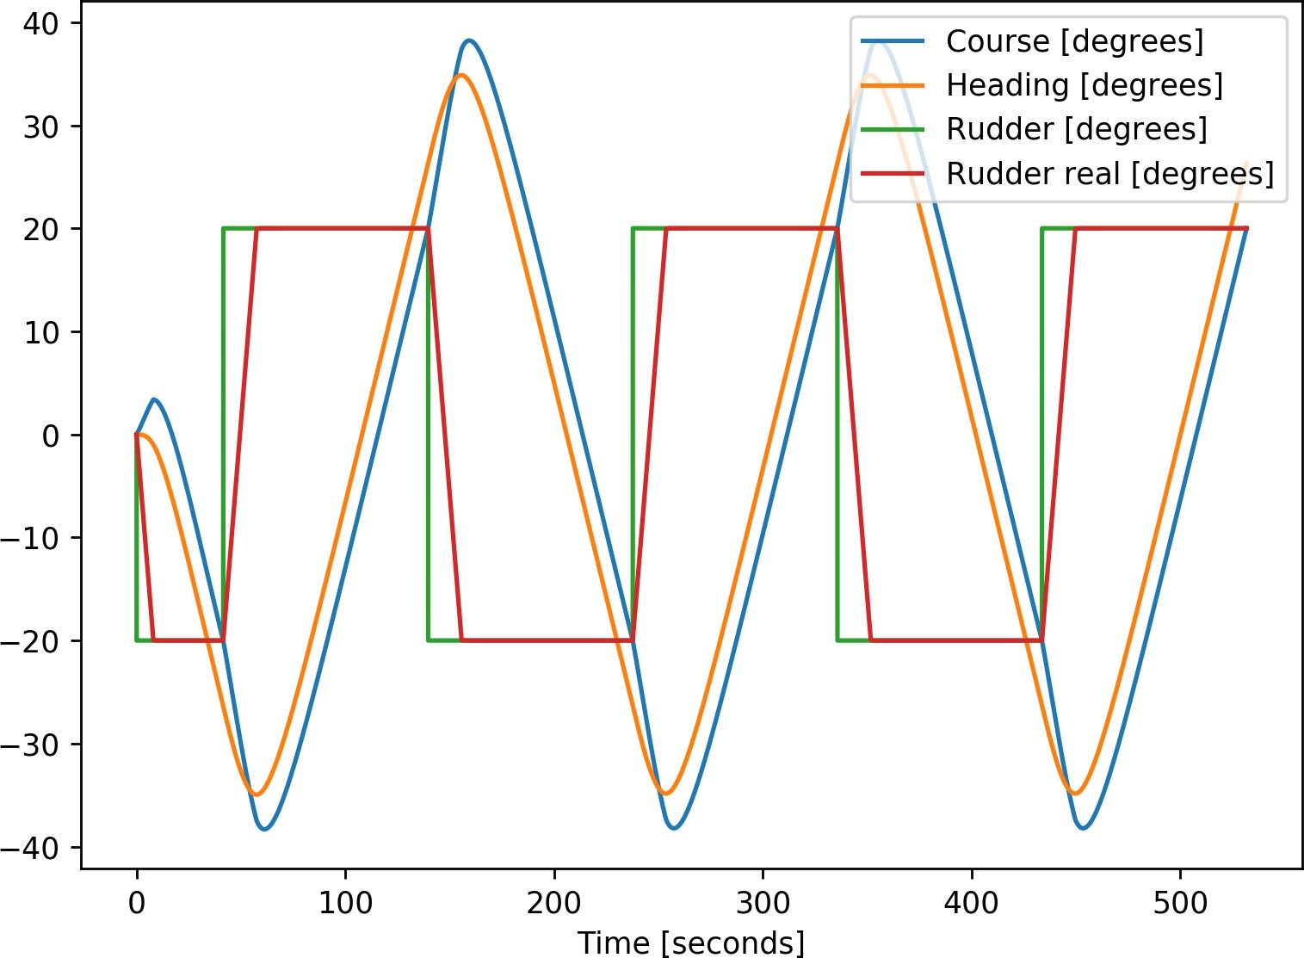

(a) Illustrative path (b) Zig-zag 20:20 test at 15kn with 140m cargoship

Figure 6.2: Zig-zag test

### Critical evasive manoeuvrer

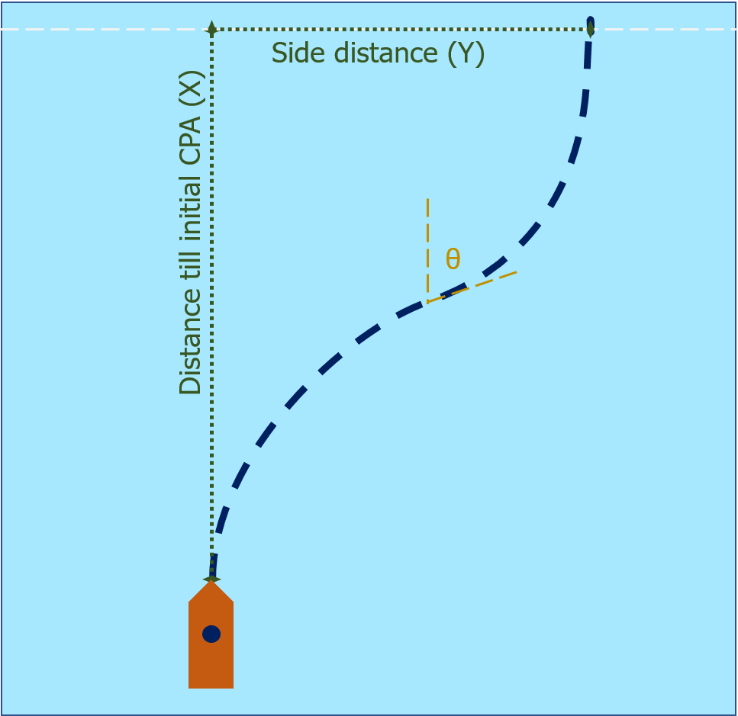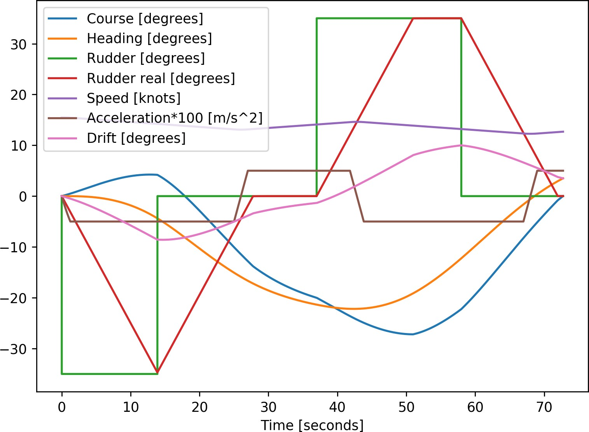The critical evasive manoeuvrer aims to increase the closest point of approach (CPA) as much as possible, and return to the original course. Using the least amount of time and advance distance. Based on COLREGs is there a stand-on and give-way vessel. The stand-on vessel is supposed to keep course and speed the same, while the give-way vessel is supposed to manoeuvrer. There are many ways for an evasive manoeuvrer to be done. However, the most critical situation is when maximum rudder is given to avoid another ship which has a perpendicular course. Thereby is te aim of the give-away vessel to end the manoeuvrer with the same course as it started with. In figure 6.3 an example of such manoeuvrer is shown for the give-way vessel. Figure 6.3b shows how the rudder is used during the evasive manoeuvrer. Also is seen that the speed reduces, mostly due to the drift angle. The manoeuvrer is simulated for different speeds and with different maximum course changes.

* + - 1. Illustrative path (b) 20 degrees at 15kn with 140m cargoship

Figure 6.3: Evasive manoeuvrer

## Tool validation

To validate if the results will be as expected, the same manoeuvers as in sea-trails are used. Thereby are different input settings tested to for the evasive manoeuvrer, to improve the final result. These manoeuvers are described in the previous section. This section will discuss the validation of the tool as discussed in appendix B. This is first done for the used hydrodynamic model. And than for the evasive manoeuvrer which will be used to determine the dependence of decision domain on manoeuvrability.

### Validation of hydrodynamic model

The hydrodynamic model which is used is described in section B.2.3 and the paper by Artyszuk [Artyszuk (2016)]. This linear dynamic higher-order model is based on the 2*nd* order Nomoto model [Nomoto and Taguchi (1957)]. Where different derivations are made to incorporate ship characteristics. The model is validated using the sea-trial database from

Damen Shipyards, criteria as described by IMO resolution A751(18) [Quadvlieg and van Coevorden (2003)], similar simulator comparisons [Tjøswold (2012)] and results presented at MARSIM ’96 [MARSIM (1996)]. Combining these sources will give ranges in which the metrics from the sea-trials are expected.

By using the same vessels and manoeuvers as are stored in the database, the quality of the hydrodynamic model is validated. This validation is done by comparing the resulting metrics from the simulation model to expected metrics, which are based on the database and regulations.

The overshoot measured during the zig-zag test has a larger spread compared to other metrics, as it depends much more on weather conditions and human factor. But the overshoot gives insight, if the input characteristics result in behavior which can be expected. For example should a tug have a larger overshoot, compared to a cargo vessel. As the course keeping characteristics are very different. The results for the turning circle test give more definitive answers on the quality of the model. The model is accepted when the results of these tests are close to the expected results. As not all input coefficients have been optimized for each ship to behave as realistic as possible. The optimization of these coefficients is not within the scope of this research. In table 6.1, the expected results are compared with the results from the manoeuvring model for different ship types and sizes. The overshoot is based on a 10 degrees zig-zag test, so change of course at 10 degrees and for 10 degrees of rudder. The turning circle test starts by giving the maximum amount of rudder. Both test start when sailing at design speed. For the small tug boat the results are not within the expected range. The overshoot and advance distance lare for the other vessels within the expected range.

The tactical diameter is however relatively too large. This larger difference between expected results and simulation results is seen more often [Tjøswold (2012)]. This has been identified as an error with non-linear damping. The critical evasive manoeuvrer is much more similar to the first part of the turning circle test in which the advance distance will be determined. Therefore the inputs for the manoeuvring model will not be changed to improve the tactical diameter. Thus when testing the critical evasive manoeuvrer, it should be considered that the model works better for larger cargo vessels and manoeuvers which do not go further than 90 degrees.

|  |  |  |  |  |
| --- | --- | --- | --- | --- |
| Ship type | Metric | Unit | Expected result | Model result |
| Tug | Overshoot | seconds | 8 - 45 | 29 |
| 28 meter | Advance | meter | 60 - 66 | 81 |
| 13 knots | Tactical diameter | meter | 35 - 41 | 68 |
|  | Final speed | knots | 6 - 7 | 4.4 |
| Cargo vessel | Overshoot | seconds | 4 - 10 | 8.6 |
| 115 meter | Advance | meter | 265 - 320 | 315 |
| 13 knots | Tactical diameter | meter | 280 - 365 | 362 |
|  | Final speed | knots | 7.9 - 10.5 | 8.7 |
| Cargo vessel | Overshoot | seconds | 4 - 10 | 8.4 |
| 145 meter | Advance | meter | 350 - 420 | 397 |
| 15 knots | Tactical diameter | meter | 340 - 450 | 475 |
|  | Final speed | knots | 5 - 11 | 9.6 |
| Tanker | Overshoot | seconds | 3 - 7 | 4.2 |
| 250 meter | Advance | meter | 600 - 650 | 609 |
| 10.5 knots | Tactical diameter | meter | 650 - 800 | 870 |
|  | Final speed | knots | 7 - 9 | 8.9 |

Table 6.1: Validation of manoeuvring model

### Input for critical evasive manoeuvrer

Section 6.1.2 describes the critical evasive manoeuvrer. During the manoeuvrer, there are several actions: give rudder, give rudder to opposite direction, steer straight. The timing of these steps determines the overshoot. Thereby should the maximum turning rate of rudder be taken into account. During the simulation different steps are taken:

* + - 1. Start of manoeuvrer. Rudder angle: 35 degrees to initial direction.
      2. Few seconds before reaching desired course change. Rudder angle: 0 degrees.
      3. At desired course change. Rudder angle: 35 degrees to opposite direction.
      4. Few seconds before reaching original course. Rudder angle: 0 degrees.

This will result in a manoeuvrer which has a bit of overshoot, but is comparable to the decision taken by an officer of watch (human or autonomous). 35 degrees is the maximum angle to which a rudder turns for most vessels. Everything is known except the ”few seconds”. This will be further referred to as ”change time”. Thereby does the initial direction depend on the location of the crossing vessel. How the initial rudder direction should be, depends on the location and direction of the other vessel. This is shown in figure 6.4. In order improve the CPA, you should steer away from the others path. This means that if the other ship is in the green area, you should steer to starboard. When the other ship is in a red area, your initial direction should be to port. Where the orange cross shows the initial collision location. The change time is determined using different tests, these are described in appendix B.2.4. Based on these tests is chosen to set the change-time to 18 seconds. The critical evasive manoeuvrer aims to increase the CPA as much as possible and return to the original course. The increase in CPA is determined by two factors. The first is the distance which the ship moves to the side. The second factor is the time it takes extra to reach the new CPA due to the longer path and slowing down due to steering. This extra time is multiplied with the speed of the other vessel. The increase in CPA is finally calculated by adding these factors to the original CPA.

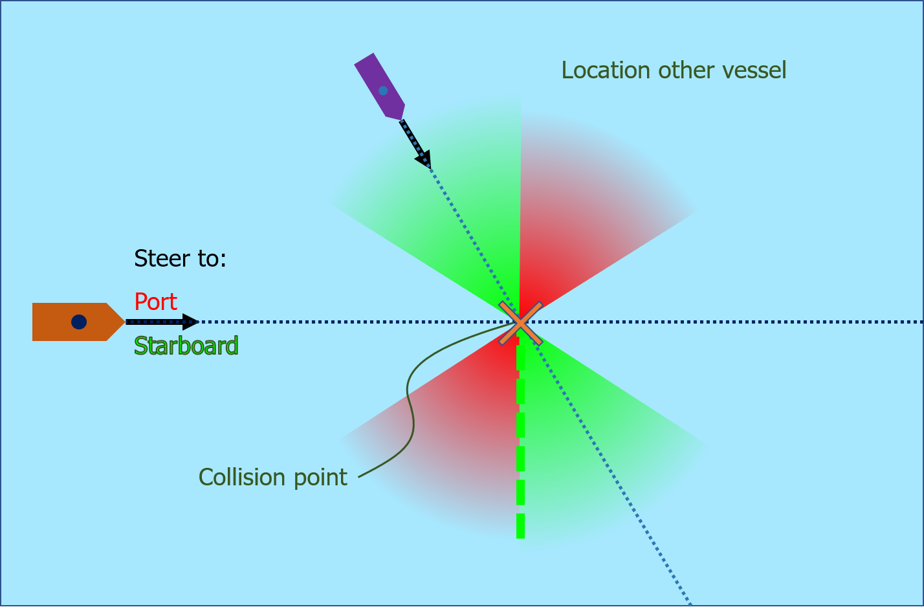

Figure 6.4: Direction for evasive manoeuvrer in crossing situation

## Trial results for critical evasive manoeuvrer

During the tests as described in section 6.1, different results are acquired. Using the simulation tool as described in appendix B different criteria are evaluated, such as CPA and crossing distance. The primary input for these results depend on the ship manoeuvrability and starting speed of the vessel. To eventually calculate the closest point of approach and passing distance, the speed of the other vessel and crossing angle should be taken into account. To evaluate the above mentioned criteria, are the metrics acquired as described in table 6.2 and shown in figure 6.3a.

Metric Description

Time needed for manoeuvrer Time from first rudder, till ship returned to original course Advance distance (X) Distance traveled forward in direction of original course Side distance (Y) Distance traveled perpendicular to original course

Extra time Time needed for manoeuvrer, minus the time it would have taken to travel the same distance forward

Extra passing distance Adding the distance to the side to the extra time times the

speed of the other vessel

Table 6.2: Metrics for evasive manoeuvrer

When two ships are parallel, the situation becomes a head-on or take-over situation. Which is less critical and more easy to solve than a crossing situation. To get into one of these situations from a crossing situation, the ship has alter its course. In the case of a crossing angle of 90 degrees, the ship has to turn the most. This is deducted from figure 6.4. Therefore is the used crossing angle during the tests for the critical evasive manoeuvrer: 90 degrees. As this is the most critical crossing angle.

Due to the perpendicular approach the passing distance is most relevant. This is used to calculate the increase in CPA, in the case where the CPA is not sufficient, but there is not risk for collision. This is calculated by adding the distance to the side, to the speed of the other vessel times the extra time needed for the manoeuvrer. For the speed of the other vessel is in this case 14 knots used. The effect of the speed of another vessel is relatively small, for the same passing distance will the distance till CPA vary with less than 50 meters. 14 knots is a common speed for large cargo vessels which can be encountered at open-sea. If the speed lowers, the possible passing distance decreases for the same distance till CPA.

Results of trials showing the relation between passing distance, distance till crossing point and starting speed are shown in figure 6.6. There exist a maximum at the distance for every ship and speed. This distance is equal to the distance needed to do an evasive manoeuvrer with a

maximum course change of 90 degrees. As in this case the ship becomes parallel to the course of the other vessel. Which means that its not a crossing situation anymore. For the critical evasive manoeuvrer is therefore only the minimal distance till a possible problem relevant.

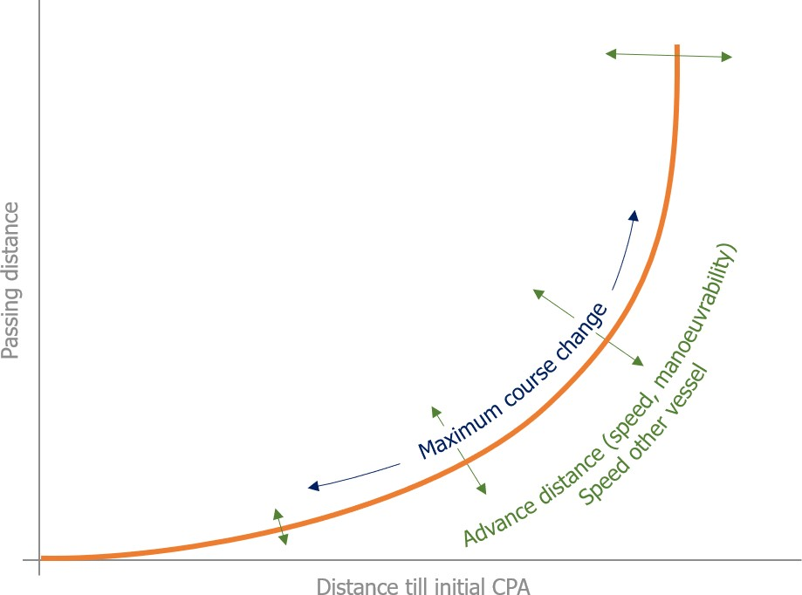

Figure 6.5: General curve for relation between distance till CPA and passing distance

The wedges as shown in figure 6.6 should be read as follows: If I’m operating the Gulf Valour at 13 knots, and I’m currently on a collision course with another vessel sailing 14 knots. It means that I have to start acting at least 860 meter before the collision point to end-up with a CPA of 500 meter. For the Emma Maersk at a similar speed of 13 knots and also a desired passing distance of 500 meter, do they have to act 1150 meter before the expected collision. The curves within these plots are generalized in figure 6.5, thus the location of the curve depends on the advance distance and speed of other ship.

## Relation between advance distance and passing distance

The key manoeuvrability characteristic relevant for the critical evasive manoeuvrer from sea- trials, is the advance distance measured during the turning circle test. To show the relation between the advance distance, distance till CPA and passing distance, is a comparison be made between the trial results as shown in figure 6.6. Many more ships are however needed to get a continuous graph which can be used for general purposes. These ships are mocked by varying not only the start speed and course change, but also the input for the manoeuvring model. This is done by varying the empirical amplification factor of the rudder force, this means that the rudder is more effective, in reality this can be acquired by changing the size of the rudder or adding an extra rudder. Due to non-linearities can’t be said that a doubling of this factor is the same as adding an extra rudder, it will however give a requirement for

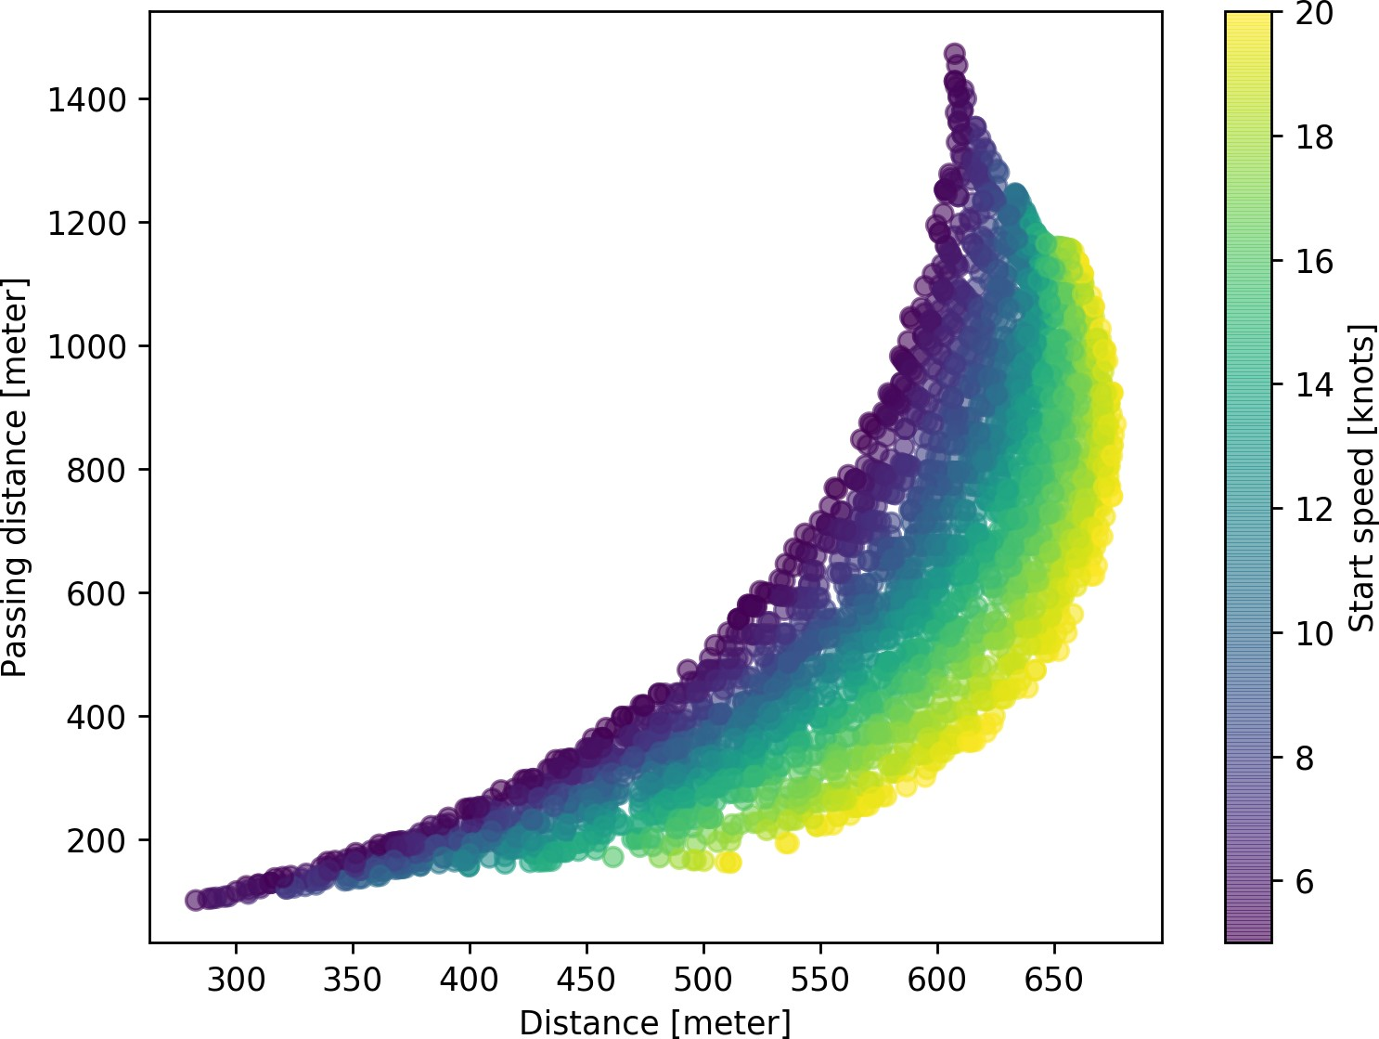

1. Astrorunner (140m cargo ship)

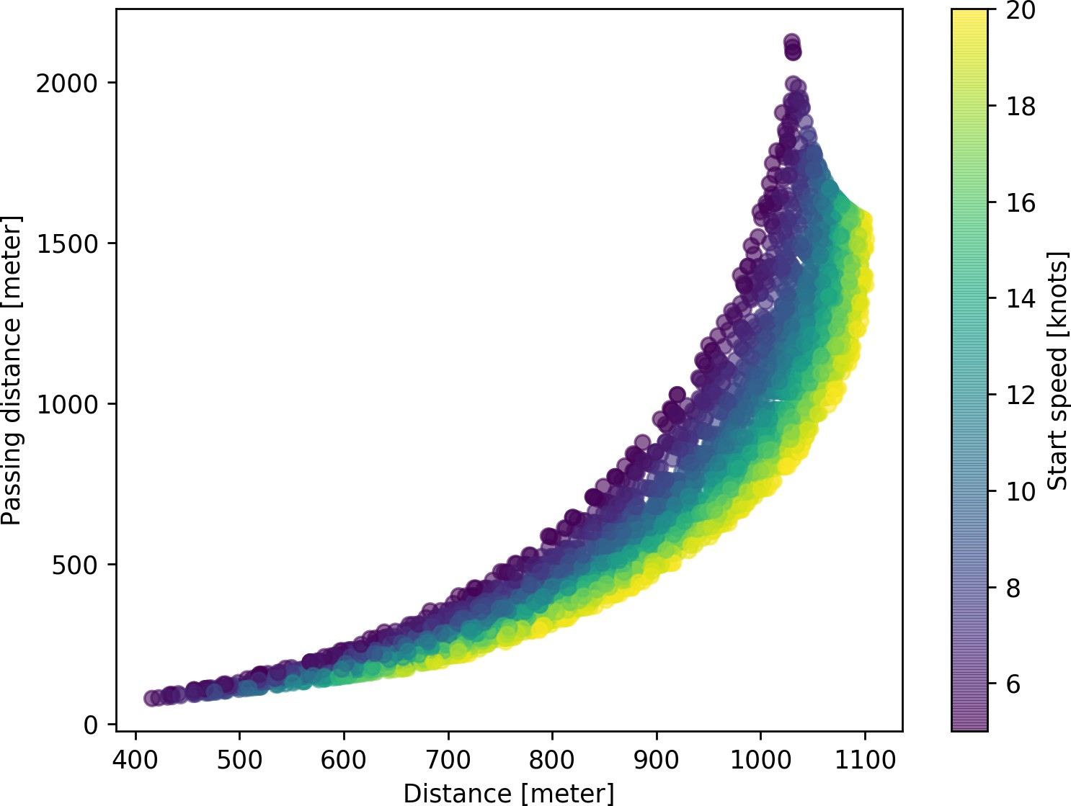

1. Gulf Valour (250m tanker)

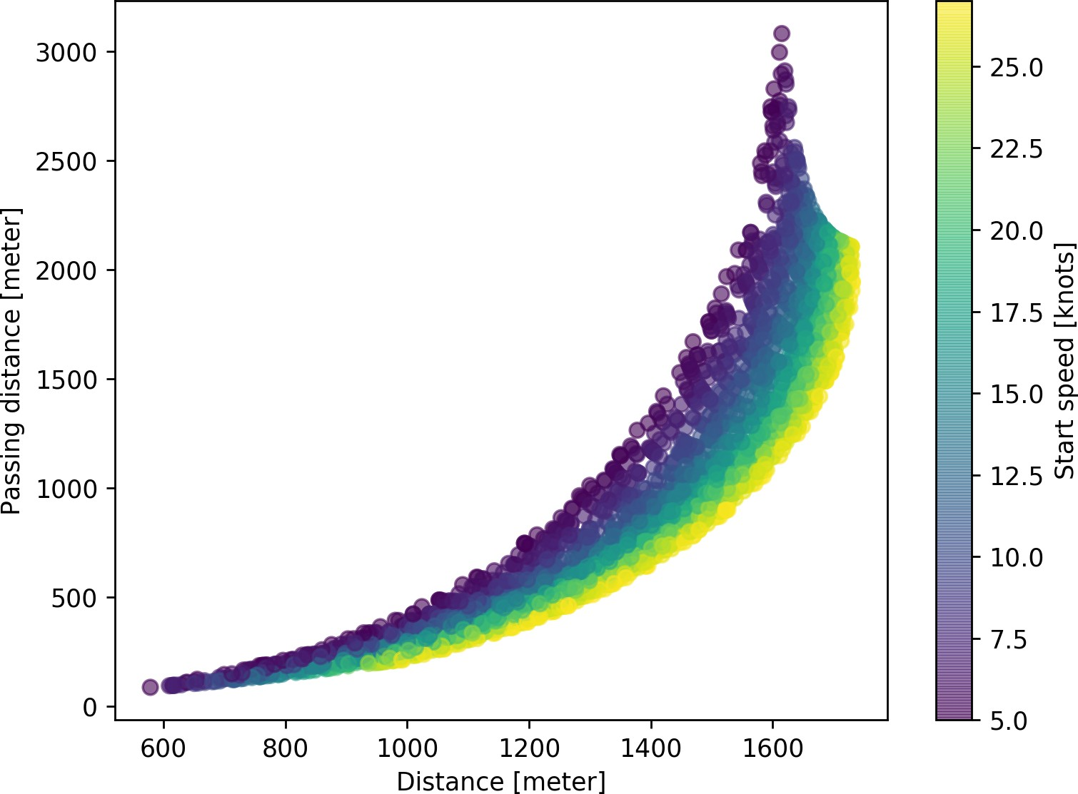

1. Emma Maersk (400m container ship)

Figure 6.6: Relation between passing distance, distance till CPA and start speed

the advance distance when a maximum CPA is required. Examples of the resulting relation between passing distance, distance till CPA and start speed are shown in figure 6.7. Due to the mocking are there no clear curves visible for the start speed, as is the case in figure 6.6, because the mocking influences the advance distance, and this does form the clear curves.

In figure 6.7d is shown how the relation between distance till CPA and the final passing distance depends on the advance distance. Where the advance distance depends on the ship (140m cargo ship, 250m tanker or 400m container ship), the start-speed and the empirical rudder amplification factor. This has created a continuous graph, which can be used during the design process or while operating a vessel to determine the required advance distance for a specific situation. This can be used on its turn to define vessel dependent speed limits or manoeuvrability requirements for specific area’s.

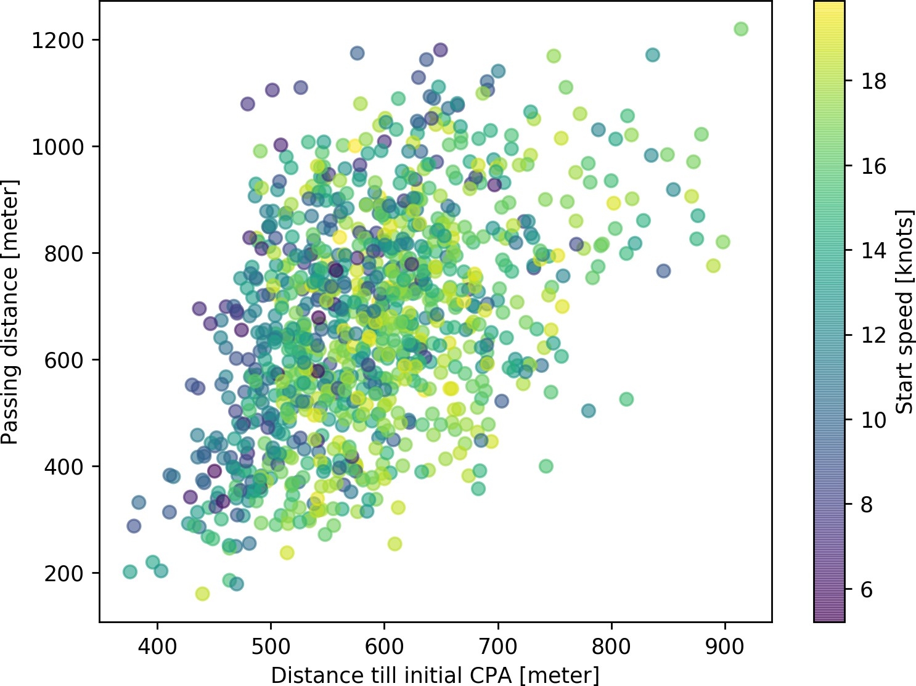 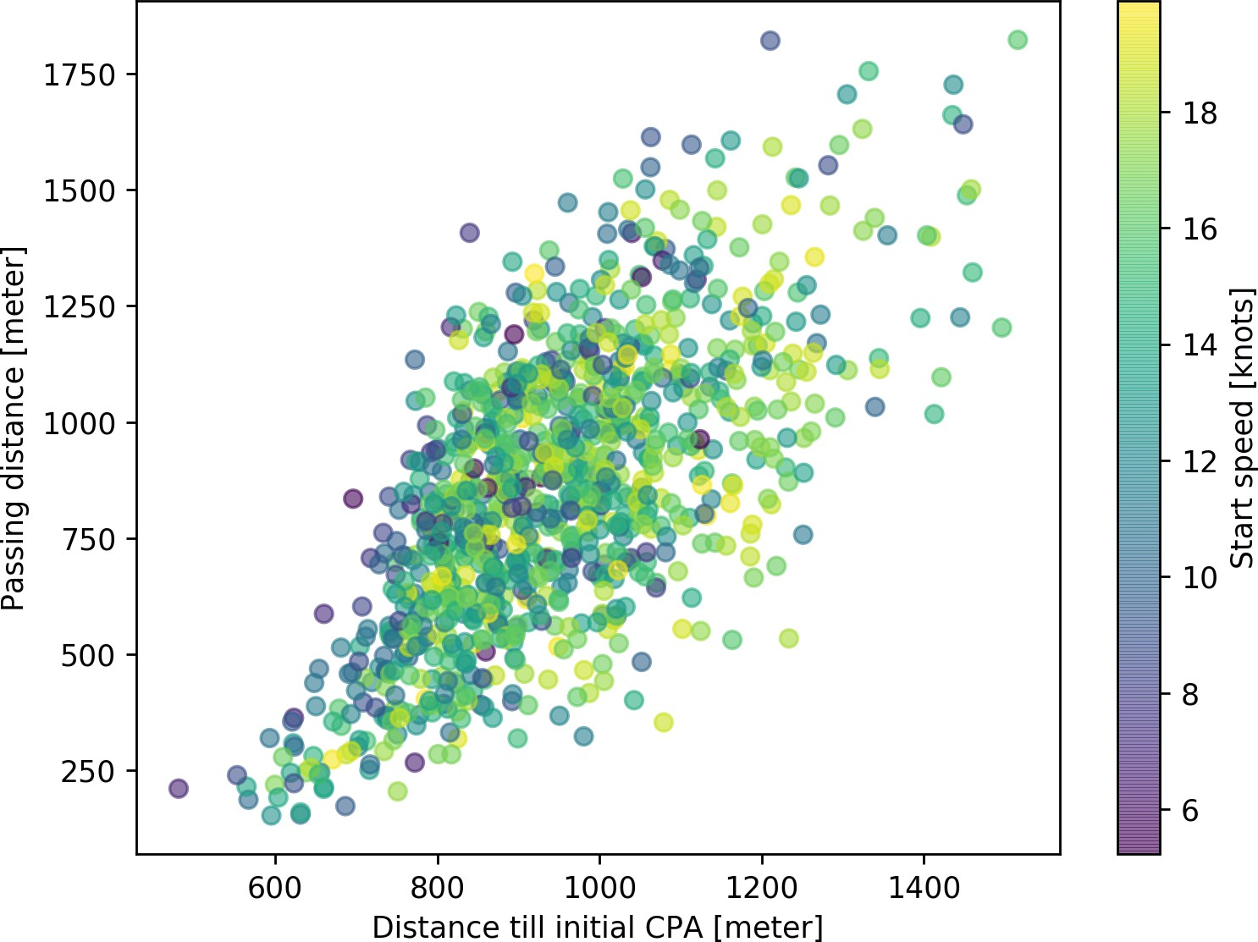 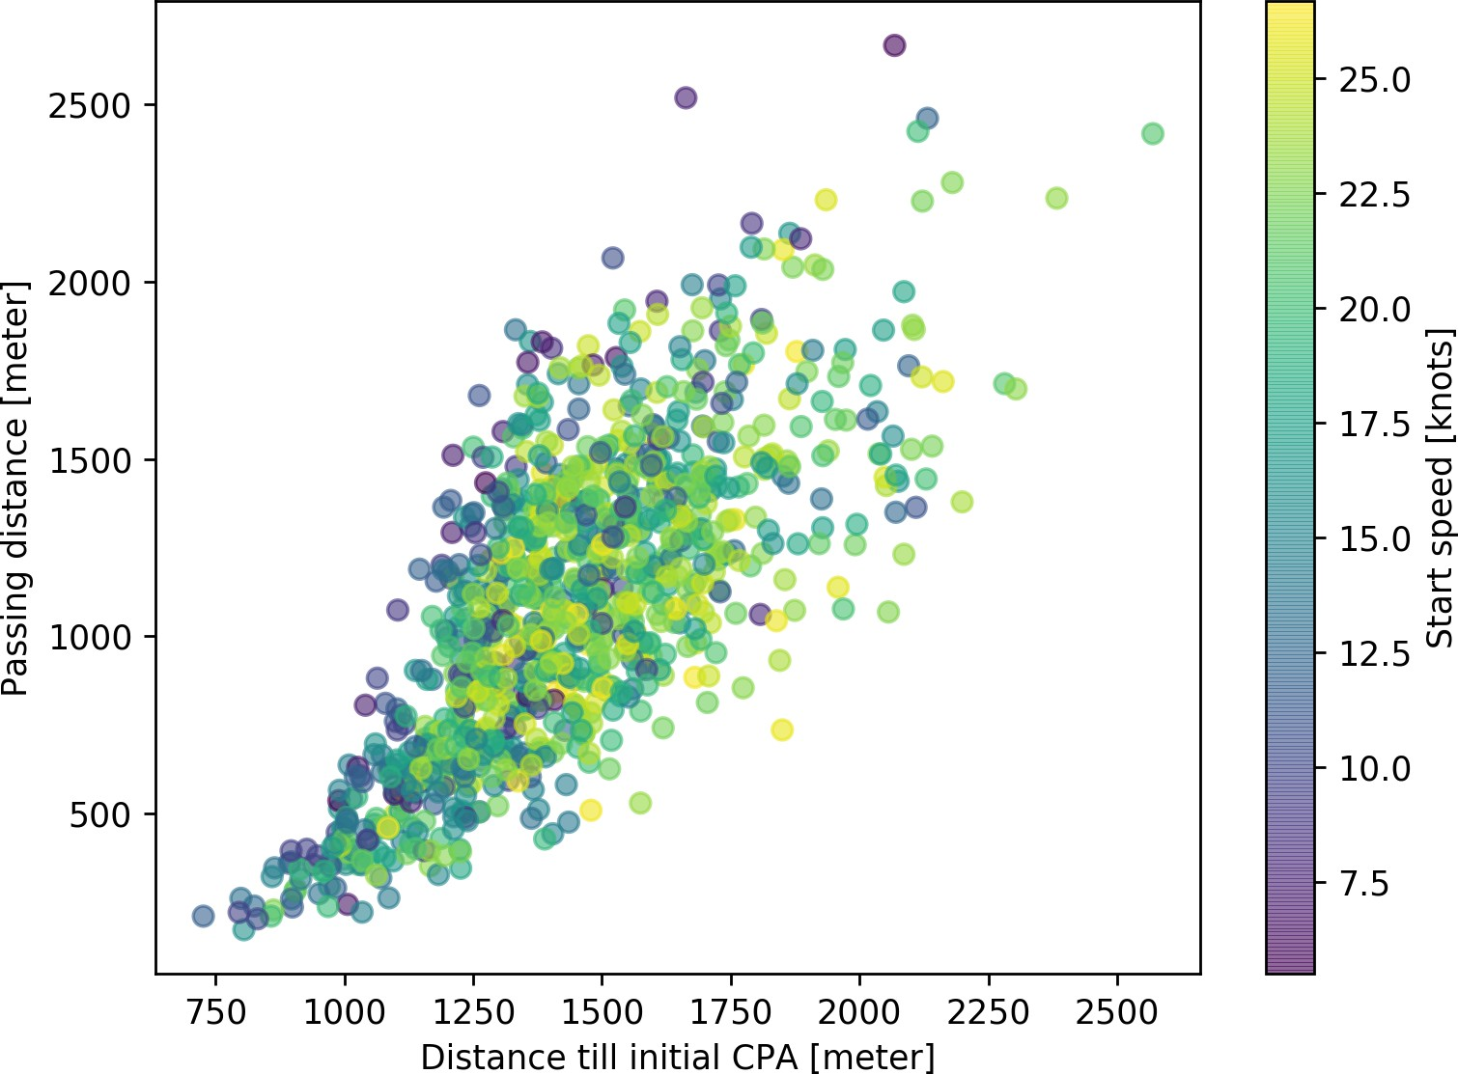

(a) 140m cargo ship (b) 250m tanker (c) 400m container ship

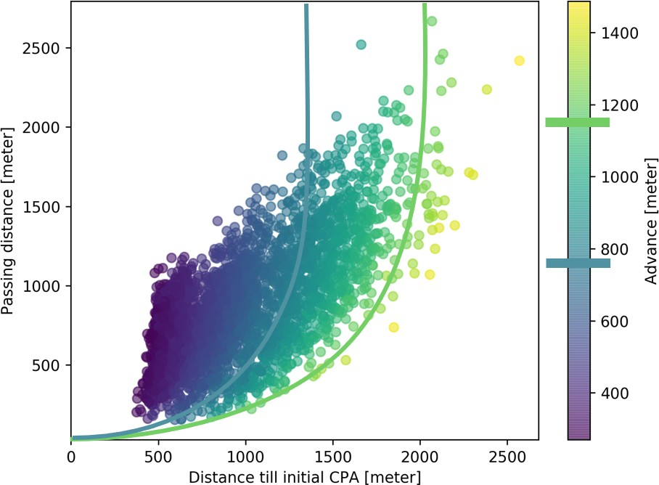

(d) Combined plots with advance distance

Figure 6.7: Relation between distance till CPA, passing distance and advance distance by varying start speed and rudder amplification factor

# *|* Evaluation

In the previous chapters are steps taken to identify common critical situations, and show how ships with different manoeuvring characteristics act in those situations. To avoid communication is it key to have enough clearance, this can be acquired by making the right action well in advance. In critical situation this is however not always possible. When a situation becomes critical, depends on the manoeuvrability of the vessel. In section 6.4 is shown what the relation is between the possible passing distance and distance before initial CPA for different advance distances. By increasing the manoeuvrability of an unmanned vessel is it possible to reduce the number of critical situation and therewith the amount of communication, as a safe passing distance is still acquired. In order to achieve this, does this chapter show how the passing distance can be improved in general by changing manoeuvrability characteristics, and how this should be taken into account in the design or decision process of unmanned ships.

## General relation for critical evasive manoeuvrer

In chapter 6 are results shown for the relation between passing distance and distance till CPA for different start speeds and vessels. There is a direct relation between start speed and the advance distance. The manoeuvring characteristics of a vessel are a second input for the advance distance. By both varying the start speed and manoeuvring characteristics, is a general image acquired which shows the relation between passing distance and distance till CPA for different for different advance distances.The general curve for this is shown in figure 6.5 and can be extracted from the plot as shown in figure 6.7d.

Going left or right on the curve relates to the maximum course change. The position of the curve depends on two factors, the advance distance and speed of another vessel. Where the speed of another vessel has a relatively small impact, as the bandwith of these curves is small. By comparing different curves, is seen that an increase of 1 knot, will result in a maximum change of 1 percent of the distance till CPA, when the passing distance is kept constant. This means for a 400 meter container ship, that for a passing distance of 1000 meter, the distance till initial CPA varies between 960 and 1070, when the speed of the other vessel is between 0 and 18 knots.

The advance distance is however much more relevant for increasing the ability of unmanned vessels to ensure safe operation in critical situations. In case of an evasive manoeuvrer does a reduction of 1 percent of the advance distance, already result in a 1 percent reduction of the distance till initial CPA. A reduction of 10 percent in advance distance can already

57

58 *CHAPTER 7. EVALUATION*

be acquired by using different rudder profiles than commonly used profiles, as shown by Liu [Liu et al. (2015)]. Similar results are acquired by using a high-lift rudder [Zaky et al. (2018)]. For a 250 meter tanker at 12 knots, with a desired passing distance of 1000 meter, does this mean a reduction of 100 meters on the distance till initial CPA was reached.

## Use case

Wanneer is resultaat toepasbaar, gebruik case uit CS deel

# *|* Conclusion

The model developed in this part will start with a sensory information on a situation, it will classify this situation and make a decision based on the evaluation of criteria. The result is an advise to execute a specific strategy, or if the model can’t evaluate criteria sufficiently a subset of possible strategies and the remark it needs more information to narrow it down further.

*How do ship manoeuvrability characteristics influence the domain for decision making, to ensure that the chosen strategy will result in a passing distance which* *does not require communication?*

Answer research question

59

60 *CHAPTER 8. CONCLUSION*

**Part III**

**Necessity of a protocol to enable teamwork between manned and unmanned ships**

*Meant is not said, said is not heard, heard is not understood, understood is not done.*

– Marcus Rall [Rall and Dieckman (2005)]

61

63

It is not always possible to operate without communication, as is tried to accomplish in part II. This is often the case due to missing information, or a lack of understanding about the intentions of other vessels. With manned ships, verbal communication via VHF radio is used to acquire the missing information or discuss strategies with other ships. This is likely also necessary when unmanned vessel operate between manned vessel. In this part, the development process of such a protocol is discussed and the relevance is proved using an experiment, answering the following question:

*Will a protocol based on existing maritime systems and communication protocols be sufficient to ensure safe navigation, while manned and unmanned vessels encounter each other?*

A protocol defines the format and the order of messages exchanged between two or more communicating entities, as well as the actions taken on the transmission and/or receipt of a message. Where it is most straight forward to use verbal communication, will it not be limited to this. As it might result in better situational awareness for both the manned and unmanned to use other means, such as visible signals or text messaging.

The communication which currently happens between vessels is most common when COLREGs do not result in clear strategies, or when intentions are not clear. Other communication which will not be within the scope of this research, are the communication with traffic controllers and how conversations are interpreted by other vessels. Thus this research is a starting point to develop a full protocol needed for the acceptance of unmanned vessels.

Using the situated Cognitive Engineering (sCE) method, this protocol can be developed using an iterative process, where a requirement baseline is continuously refined by reviews and prototype evaluations. How to apply sCE is described by Neerincx and Linderberg [Neerincx and Linderberg (2012)].

The first step is to create a foundation. The current situation of the problem is discussed, which have to be solved. Thereby considering existing knowledge which might be relevant to solve the problem and finally in short the envisioned technology. The next step is to define the system design specification. In which scenarios are described which show how the problem is solved. From this can be extracted what should be designed and why this is done. Using this a design is made which is being evaluated to make improvements in next iterative steps.

64

# *|* Foundation

The foundation segment in the situated Cognitive Engineering (sCE) methodology, describes the design rationale in terms of operational demands, relevant human factors knowledge, and envisioned technologies. Together, these three constituents describe the problem to be solved, the existing knowledge on ways to solve the problem, and the technology needed to implement that solution.

## Operational demands

The operational demands describe the current practice as it is, i.e. without the envisioned technology. For the operational demands, the sCE method prescribes as main components the stakeholders and their characteristics, and the problem description and analysis thereof.

### Problem scenario

Convention on the International Regulations for Preventing Collisions at Sea (COLREGs) have been developed long before bridge-to-bridge voice communications became available. They are supposed to be unambigious. It is the responsibility of all bridge watch keepers to know how to apply them instinctively, on the basis of observation by sight and radar. They work effectively when ships in an interaction obey them; they also specifically address circumstances where one ship does not.

However, as shown in the previous parts, are COLREGs not always sufficient to decide on the right strategy. For example due to missing information. This happens already more often due to larger ship, more complex manoeuvers and more traffic. In those cases the VHF radio can be used for verbal bridge-to-bridge communication. Leading here are the Standard Maritime Communication Phrases (SMCP). The primary task of these phrases and surrounding protocol is to diminish misunderstanding in safety related verbal communications. Beside this verbal communication, non-verbal communication might be used, such as light signals, sound signals and text messaging.

Reasons for safety related verbal communication are: You will deviate from the rules, deviant behavior is registered, or more information is needed to decide on the right strategy. This is often necessary due to lack of visual information. For example due to bad weather, obstacles like bridges and terminals, or the information received via AIS is not reliable. This does not only impact the information you get by looking out of the window, but also the quality

65

of the Electronic Chart Display Information System (ECDIS) and Automatic Radar Plotting Aid (ARPA) is worse.

The different ways for communication are not developed to be used by unmanned vessels. On the other hand, it is not feasible to require all manned vessel to install new systems for communication, before introducing unmanned vessels. As this will require many more new regulations, development time and time to train seafarers.

When using the current systems in a way they are not designed for. This might result in misunderstanding and problems with communication. Due to for example information overload of the crew and communication channels. This can be caused by the way the VHF is designed. As it is a receiver or a transmitter, but can’t be both at the same time, which means that in case two messages are send at the same time, both senders will not receive the others message.

### Problem analysis

To avoid misunderstanding which could result in hazardous situations. It is important that manned and unmanned vessels are able to communicate. To solve this problem, a more extensive analysis is made. Describing the values of the different actors and discussing their related problems.

#### Primary actors

The focus of this research will be on bridge-to-bridge communication. This means the most important actors for unmanned and manned vessel are:

* + - * Manned vessel

**–** *Officer of watch*. He is the responsible person. He might work together with a helmsman and a lookout. He has to ensure a proper functioning of all available systems. Thereby does he discuss with other crew members if there are any unusual activities. He is responsible to follow a proper navigation plan, while having his own safe passage plan, to avoid collisions. He will use sight, Automatic Radar Plotting Aid (ARPA) and Electronic Chart Display Information System (ECDIS). Thereby is he aware of the ship’s speed, turning circle and other handling characteristics to decide on the right strategy. He will monitor the VHF radio all the time while underway, to assist in emergencies if necessary, to hear Coast Guard alerts for

* 1. *OPERATIONAL DEMANDS* 67

weather and hazards or restrictions to navigation, and to hear another vessel hailing you.

He wants to avoid information overload, while being aware of the situation. This is only possible when he stays concentrated, to acquire this, the tasks must be challenging and he needs to have a form of autonomy [Porathe et al. (2014)].

**–** *Helmsman and lookout*. Both monitor the situation and execute commands from

the officer of watch. A risk for them is information overload or underload [Neerincx (2008)].

* + - Unmanned vessel
      * *Controller agent*. This agent is responsible for situational awareness. Thus getting safely from A to B. It will decide on the navigational strategy, it will do this based on the information acquired via all different means. Including newly developed communication protocols, computer vision and algorithms to transform sensory data to useful information. His duties are similar to the duties of the officer of watch as described for the manned vessel.
    - Other vessels
      * *Crew and pilots on nearby vessels*. They might want to know the intentions of other vessels to base their strategy on. However do not want to receive all discussions. As this will result in an information overload.

#### Secondary actors

Beside the first group of actors, others could also be influenced by the new protocol. Although they are not within the scope of this first design cycle, they should be considered to avoid problems such as information overload on current communication channels or confusion.

* + - Only recipients
      * Crew on vessels which are not traveling.
      * Shipowners of unmanned vessels, monitoring vessel from remote location.
    - Not within scope of the research
      * Vessel traffic controllers
      * Crew which are in distress and require assistance

#### Goals

The main goal is to ensure reliable sharing of information, without the risk for information overload or misunderstanding. Such that manned ships will trust unmanned ships to choose the right strategy. As manned ships can be informed, using natural language describing the reasoning of unmanned vessels.

This means that manned vessels should be updated only when requested or in case of an unusual activity which could affect their strategy. And manned vessel should be aware when unmanned vessels desire more information to decide on the right strategy.

Using the same philosophy, it might be possible to develop a protocol for communication with traffic controllers in later iterations. This becomes more important when the time needed to develop a new systems for traffic controllers also takes too much time to develop and/or implement.

#### Infeasible solutions

The easiest solution for unmanned ships would be to just install a new system. This is however not feasible as mentioned before. To implement this, it would mean that all ships which could encounter an unmanned ship will have to install this too. It might be possible to make it obligatory via regulations, this will however cost a lot of time and money. Making the introduction of unmanned ships less likely. This is also the reason to use a Non-visual User Interface (no-UI), as a GUI will require new screens or changes to the ECDIS which are only possible when regulations are changed.

## Human factors

When designing technology, there are two driving questions that need to be well-thought out:

(1) What tasks and/or values is the user trying to accomplish and how can the technology support the user in doing so?, and (2) How can the technology be designed such that the user is able to work with the technology?

The Human Factors segment of the sCE method describes the available relevant knowledge about, for instance, human cognition, performance, task support, learning, human-machine interaction, ergonomics, etc. Note that we emphasize that this knowledge should be relevant for the problem and its design solution: the knowledge described here should lead to a better

* 1. *HUMAN FACTORS* 69

understanding of either (1) or (2). The three elements important to the human factors analysis are: The human factors knowledge, measures, and interaction design patterns.

#### Human factor knowledge

Human factors knowledge describes available knowledge coming from previous research about how to solve the problems that have been identified in the problem analysis. The key problems relevant for human factors are the information overload, situational awareness, autonomy, and learning a new protocol. Thus the following questions should be answered:

* + - When does information overload occur?
      * In case of divided attention there is a high risk for information overload and distraction by low priority messages. Therefor the developed system should be context aware so it can limit this risk by adapting the message to the situation [Arimura et al. (2001)].
      * Overload might appear due to a competition for the operator’s attention that is going on between different information items. If many tasks are handled by automated systems, the operator can deal with high workload circumstances, but will suffer from severe underload during quiet periods, probably losing his or her situational awareness [Neerincx (2008)].
      * The information acquired at one particular moment does not necessarily serve for high-level situation awareness, for the user needs to recall the previous related information to understand the situation thoroughly. But constantly providing information might not be the solution because there will be a huge risk of information overloading. Admittedly it is plausible to deliver needed information for the coming task by task detection, the user might still fail to keep pace to the rapid changing system and fulfill multi-threaded tasks[Porathe et al. (2014)].
    - Which information is needed for situational awareness?
      * Understanding the current picture is not enough for full situational awareness. Expert decision makers must be able to project their understanding into the future. This enables them to make the decision they must take now to create the best options in the future. Projection requires to have good mental models of the dynamic relationships between the relevant parts of the environment over time. Expers focus a lot on creating their own futures via present decisions. In turn, these decisions are formed out of their comprehension of the likely interactions of all the

elements they deem both relevant and important [Gregory and Shanahan (2010)].

* + - * Situational awareness can be enhanced by feedback, perceived information from the

environment, information from other agents, as well as remote sensors. [Carver and Turoff (2007)]

* + - How is information perceived when acquiring it passively of actively?
      * Attention profoundly modulate the activity of sensory systems and this can take place at many levels of processing. Imaging studies, in particular, have revealed the greater activation of auditory areas and areas outside of sensory processing areas when attending to a stimulus [Palmer et al. (2007)].
      * Good teamwork involves anticipating the needs of teammates and that means pushing information before it is requested. Therefore, if things are going well, there should be little need for pulling information. In this study task, participants were instructed to push information to others, and over time master the specific timing of information sharing to the intended recipient. Findings indicate that pushing information was positively associated with team situation awareness and team performance, and human-autonomy teams had lower levels of both pushing and pulling information than all-human teams [Demir et al. (2017)].
    - What is needed for successful teamwork between human and a computer?
      * People need to understand what is happening and why when a teammate tends to respond in a certain way; they need to be able to control the actions of an agent even when it does not always wait for the human’s input before it makes a move; and they need to be able to reliably predict what will happen, even though the agent may alter its responses over time [Bradshaw et al. (2003)].
      * Effective team communication, a fundamental part of team coordination, is crucial

for both effective team situation awareness and team performance [Demir et al. (2017)].

* + - Do people trust automated systems?
      * When using automation, the role of the human changes from operator to supervisor. For effective operation, the human must appropriately calibrate trust in the automated system. Improper trust leads to misuse and disuse of the system. [Walliser (2011)].

#### Human factor measures

Measures describe how to operationalize the quality of the intended behavior or performance,

i.e. how well is a user working with the design able to reach his/her objectives and what is

* 1. *ENVISIONED TECHNOLOGY* 71

the quality of the collaboration between the human worker and the technology?

* + - Is the system used correctly?
    - Does the protocol act as expected?
    - Will it solve the problem of missing information?
    - What is the impact on attitude towards unmanned ships?

#### Interaction design patterns

Interaction Design Patterns (IDPs) focus on the Human-Computer Interaction (HCI), such as usable interface design and control options. IDPs offer generic solutions to recurring HCI design problems that have been proven to be effective. Relevant IDPs are given in table 9.1.

Radio communication Usage of message markers and conversational agent Visible signals Light signals, mast head signals and flags

Audible signals Horn and speakers Distress, urgency and safety signals Flares and smoke

Table 9.1: Interaction design patterns

## Envisioned technology

The envisioned technology describes the available options of using existing technology and/or the need to develop novel technology in order to come to a system solution. The sCE method asks designers to specify what devices (hardware) and software could be used in the system design. In addition, for each type of technology, an argument should be provided as to why this technology might be of use and what the possible downsides might be of that particular type of technology.

The envisioned technology will use only existing systems to develop a no-UI. Different systems which are currently used, are described in appendix A. Below different systems and protocols are mentioned which can be used in the new protocol. Using these already existing systems will shorten the development, learning and implementation time. The used systems, equipment and protocols are given in table 9.2.

Radio communication Conversational agent

Negotiating agent

Usage of message markers Availability on VHF

Natural language variations on SMCP NATO phonetic alphabet and numbing

Addressed AIS message to exchange information or interrogate

Visible signals Light signals Mast head signals Flags

Heading, position and movements

Audible signals Horn Speakers

Table 9.2: Envisioned technology

Using already existing protocols makes it more easy to learn, such as Standard Maritime Communication Phrases (SMCP) and COLREGs. This also makes it recognizable, which means that users will understand the benefits quicker. Show that it is easy to use and useful are key for the acceptance of technology [Davis (1989)].

The type and amount of information presented to users must be tailored to the unique situation in which the information is to be used. Prior research on trust in automation found that providing human operators with information related to the reliability of an automated tool promoted more optimal reliance strategies on the tool. Further, information related to the limitations of an automated tool aids in trust recovery following errors of the automation. This added information appears to be useful in deciphering the boundary conditions under which the tools are more or less capable. Thus, providing human operators with information related to the performance of an automated tool, appears to be beneficial [Lyons and Havig (2014)]. Therefor it is beneficial for the cooperation between manned and unmanned vessels to clearly show if it is an unmanned vessel. This will firstly be done using visible signals, and also at the start of radio communication. This also happens in industry projects such as Google Duplex [Nieva (2018)].

*In the next chapter* the system design specification will be given for the envisioned technology. Most important will be the definition of the usage of radio communication and how this should be supported with other forms of communication, such as visible and audible signals.

# *|* System design specification

The system design specification describes the solution to the problem in the form of a system design that makes use of the identified relevant human factors knowledge, and the envisioned technology. The system specification consists of design scenarios, use cases, requirements, claims, and ontology. This chapter will answer the question how a protocol should look like to ensure safe navigation, when manned and unmanned vessels meet.

## Design scenarios

The sCE method prescribes the specification of design scenarios. Design scenarios are short stories that provide a clear description of how the user will work with the technology thereby enjoying the solution offered to one of the problem scenarios. Together, the problem and design scenarios provide a contextualized view on:

* + 1. The problem the design aims to solve.
    2. The people that are currently affected by this problem.
    3. The way in which the current system design aims to solve this problem.
    4. How people will use the system.

Manned ships are able to understand intentions of unmanned ships, resulting in good situational awareness. In cases they desire more information, they are able to acquire this using current systems. Without the risk for an information overload. Thereby are the additions to existing protocols for those systems easy to understand, as they use the same philosophy as current protocols.

Trust in autonomous ships is formed, as the information is reliable, the interaction is similar to the interaction with other manned ships. This resulted in acceptance of unmanned ships on the general waterways. Where the risk for collisions and perceived risk reduces, or at least does not increase.

#### Information extraction from problem scenario

In the previous chapter the problem is described which has to be solved with the envisioned technology. To solve the problem, the following issues have to be tackled:

1. Different actors are afraid of information overload.
2. Officer of watch is afraid to lose situational awareness.

73

1. Officer of watch is afraid to lose autonomy.
2. Current systems are not designed to be used by unmanned vessels.
3. Manned ships want to ask for support or information.
4. Unmanned ships want to ask for support or information.

#### Envisioned effect of system implementation

How the above mentioned problems are tackled are shortly discussed below. This shows what the result is after implementing the envisioned technology:

1. The system will send only on demand or when it has tried any other solution. This will reduce the probability for information overload. As a threshold to check if the system is successful in solving the problem of information overload, the current amount of communication can be used.
2. The protocols which are currently used by the officer of watch are the same. The purpose is to make it more easy to get information. This means that the situational awareness will minimally be affected by the system on board of the manned vessel. Also here the current level of situational awareness can be used as a threshold.
3. By introducing an negotiating agent, decisions can be made in a similar manner to current ships. Using the decision tree it will have a favorite strategy, but it might be possible to use others if this is better for the encountered manned ship. This will ensure that the officer of watch at the manned ship, still has a feeling of autonomy, similar to that of the current situation.
4. Although the current systems are not designed to be used by unmanned vessels. Are there major developments on conversational agents in the last few years. This means that voice communication is starting to become more easy to develop. Certainly when considering that a lot of radio conversations are recorded. Thus it will be more easy to train the agent. Thereby must still be considered the importance of transparent communication. Thus also being open about being a robot.
5. Using addressed AIS messages and a conversational agent at unmanned vessels. Manned ships will be able to ask for support or information at all time. It is even likely they will receive the information faster compared to manned-manned ship communication.
6. The conversational agent is most relevant for unmanned ships when they want to ask for support or information. As addressed messages are not often used at the moment.
   1. *FUNCTIONAL REQUIREMENTS AND CLAIMS* 75

They will use the SMCP in a similar way to how it is currently used. So not much will change compared to the current situation for manned ships.

## Functional requirements and claims

The functional requirements and claims, describe specific functionalities the technology should provide to its users, this is followed by the system’s objectives, and the hypotheses to be tested during system evaluations. This is accomplished by annotating all functional requirements with their underlying objectives (called claims).

This explicit linking of requirements to claims enables designers to formulate hypotheses that need to be tested in system evaluations to justify the adoption of the functional requirement. If the claim cannot be proven to be valid through system evaluations, the designers need to refine their system design, for instance, by trying to improve the functionality, replacing the functionality with a different one, or dropping the functionality and the claim altogether (i.e. by deciding that the objective is not reachable at this point). Either way, there is no use of including a functionality that does not achieve its underlying claims. User stories are used to do this, these are usually in a from: ”As an *(actor)*, I want to *(what*?*)*, so that *(why*?*)*”. Followed by an acceptance criteria, to determine when this part is correctly implemented. The primary actors who will be taken into account in this first iteration are: Officer of Watch (OoW), unmanned vessels, and nearby vessels

#### User stories

* As an officer of watch, I want to know if there are unmanned ships in the area, so that I know if I have to adapt my way of communication. AIS shows if ship is manned, and what its status is.
* As an officer of watch, I want to validate if information received via AIS is correct, so that I can base my decision on correct information. When officer of watch asks unmanned ship via VHF, the answer should be reliable and based on current information.
* As an officer of watch, I want to make my intentions clear towards all other ships, so that they can anticipate to this. Shared intentions should be incorporated into the decision making process of unmanned ships.
* As an officer of watch, I want to be able to make small mistakes when following a protocol, so that I can still act fast when I do not know the exact SMCP sentence.

The unmanned vessel should understand the message, even if its not exactly the SMCP sentence.

* As an officer of watch, I want to use existing protocols, so that the extra effort to communicate with unmanned vessels will be kept to a minimum. Current seafarers should be able to understand what they should be doing without an explanation on the protocol.
* As an unmanned vessel, I want to initiate communication, so that I can exchange information or ask questions to another specific ship. The unmanned ship needs situational awareness based on a digital model of the reality to know which ship sails where and what the interactions could be in order to make the right decision.
* As an unmanned vessel, I want to validate if acquired information is correct, so that I can base my decision on correct information. Check via communication if digital model is correct.
* As an unmanned vessel, I want to be able to check if they understand my intentions when other ships do not act as expected, so that I know if I should change my strategy. The communication should be incorporated in the decision making process and unexpected actions by others ships should be registered.
* As a nearby vessel, I want to receive only information which is relevant to me, so that the risk for information overload is limited. By switching VHF channels for full conversations this is similar to the current way of working.

## Use case

Scenarios are used to create more specific descriptions of step-by-step interactions between the technology and its users (i.e. use cases). Use cases include actors, to specify which stakeholders/agents are interacting with each other in a given action sequence. Use cases make the design scenario more concrete by describing exactly how the technology makes sure that the problem is solved. Use cases are informed by human factors theories as described in the previous chapter.

The purpose of the use case, as described in this section are: To give insight in all interactions during a common critical situation at sea. Tags are used to relate them to the situations and scenarios as described in chapter 3. By making it very specific, better insight is acquired in factors which should be taken into account when defining functional requirements.

* 1. *USE CASE* 77

#### Autonomous fast crew supplier crossing shipping lane in front of cargo ship

*Tags: Crossing, Move away from other, Evasive manoeuvrer now, Crossing distance,* *CPA**, Intention, Messaging*

A 26 meter autonomous fast crew supplier (FCS2610) is heading towards a wind farm at the north sea with a speed of 22 knots. To get there, she has to cross a busy traffic lane. In which she will pass a 150 meter container ship (Reefer), sailing at 14 knots. The FCS2610 noticed the Reefer late and has to make an evasive manoeuvrer to pass in front of the Reefer with a distance of 900 meter or 0.5 Nautical mile. Which is just accepted according to the safety domains [Szlapczynski and Szlapczynska (2017b)], using criteria from chapter 5. To ensure the Reefer understands the intentions of the FCS2610, communication is necessary. This will take place in the following manner:

* The AIS, masthead and flags are showing the vessel is sailing autonomously. This means there is no crew, but the autonomous systems listens to the VHF.
* A conversation is started by the FCS2610, calling the station on board of the Reefer and updating status in AIS to communicate intention.

Reefer, C-6-Z-G-7

Reefer, C-6-Z-G-7

This is unmanned FCS2610, 2-F-F-P-4 Unmanned FCS2610, 2-F-F-P-4

Switch to VHF channel seven-two over.

* The FCS2610 waits for a response from

Unmanned FCS2610, 2-F-F-P-4

This is Reefer

Agree VHF channel seven-two over.

* At VHF channel 72, FCS2610 communicates her intentions.

Reefer, C-6-Z-G-7

This is unmanned FCS2610, 2-F-F-P-4

Intention. I intend to pass in front with a distance of 0.5 Nautical mile. over.

* At VHF channel 72, Reefer confirms intention.

Unmanned FCS2610, 2-F-F-P-4

This is Reefer, C-6-Z-G-7

Intention received. You intend to pass in front. Distance is 0.5 Nautical mile. over.

* Close communication and pass in front.

Reefer, C-6-Z-G-7

This is unmanned FCS2610, 2-F-F-P-4 Nothing more. Have a good watch.

Over.

Unmanned FCS2610 This is Reefer Thank you.

Over and out.

* Update AIS status of FCS2610 to show it has no questions, and is listening.

## Ontology

Lastly, the sCE method prescribes the construction of an ontology, i.e. a vocabulary describing a common language to be used throughout the system specification to avoid miscommunication, misunderstanding, and inconsistencies. Furthermore, the ontology can serve as the basis for the technology’s data structure. By specifying important concepts in the ontology and also choosing to use only one word instead of various ambiguous synonyms, communication becomes clearer and misunderstandings can be reduced to a minimum. The terms specified in the ontology are consistently used throughout the entire project. For this project they are categorized in status, messages and situations.

### Status

By defining different states for the system, does the system know which functions and protocols should be executed. The different states are described below:

**Listening** Listening to the radio without taking action.

**Waiting** Waiting for a response by other ship.

**Negotiating** Deciding on the right strategy by discussing this with other ship(s).

* 1. *ONTOLOGY* 79

**Messaging** Sending a message. While sending it is not possible to receive a message.

**Updating** Adjusting the information stored within the system, which will consecutively be send to others ships via AIS.

**Unavailable** There is a problem with the system, which makes it unable to communicate.

These states will also be communicated via AIS, to ensure transparency between different agents and avoid confusion.

### Types of messages

Both in the messaging and negotiation states, will there be messages send. These messages form the conversation. In the different phases of the conversation, different messages will be send. These are described below:

**Call** Start of conversation, in which a ship only requests contact with another ship.

**Acknowledge** Accept invitation for conversation.

**Message** Starts with ”marker word” to clarify communication purpose, followed by the actual message and ended by a request for confirmation. The SMCP use the following marker words: *advice, information, warning, intention, question, instruction* and *request*.

**Response** Response to the previous message in conversation.

**Close** End conversation with greeting.

The Standard Maritime Communication Phrases (SMCP) will be used, as this is a known protocol for seafarers. This protocol has its own ontology. This is described by IMO in the [regulations](https://puc.overheid.nl/doc/PUC_1418_14/1/#16830) [International Maritime Organization (2000)]. A short summary of the SMCP can be found in appendix A.1.4.

### Speech acts

As can be seen in the use case in section 10.3, does a conversation contain several steps, which relate to the different message types. Where every message within the conversation ends with *over*, and should be answered with a response from the other vessel.

Using the speech act theory of Austin [Austin (1975)], can be validated that each message and conversation are useful. As communication should be kept to a minimum. This means that every message send, should have an locutionary, illocutionary and perlocutionary speech act.

Where the locutionary part are just the sounds. The illocutionary part is the intrinsic message. And the perlocutionary speech act, aims to trigger an action. Thus in case of the locutionary act, *What are your intentions?*. Is the illocutionary message, *I want you to tell me that your intentions are*. While the perlocutionary aim is that the other vessel will tell what the intentions are. Below the different **perlocutionary**, illocutionary, and (locutionary) acts in a conversation are shown. Where should be considered that the MESSAGE itself also has these different acts.

**Other ship pays attention** I want other ship to listen to me.

(*< name* & *call sign other vessel >*, *< name* & *call sign other vessel >*. This is

*< name* & *call sign own vessel >*)

**Other ship switches to right VHF-channel** I want to communicate via specific VHF-channel. (Switch to VHF channel *< channel >*)

**Other ship takes action and/or shares information** I want other ship to understand message. (*< marker word >*, *MESSAGE* )

**Other ship closes message too** I want other ship to know, the conversation has ended. (over and out)

To make it more clear what the illocutionary act is, does the SMCP define seven marker words, these introduce the content and purpose of the communication. The marker word is placed in a message after calling the other vessel and introducing yourself, but before the real message. Examples for messages including the different marker words are given below:

* + - * *Advice*. Stand by on channel 6 - 8.
      * *Information*. The fairway entrance is: position: bearing 1-3-7 degrees true from North Point Lighthouse, distance: 2 decimal 3 miles.
      * *Warning*. Buoy number: one - five unlit.
      * *Intention*. I intend to reduce speed, new speed: eight knots.
      * *Question*. What are your intentions?
      * *Instruction*. You must alter course to starboard.
      * *Request*. Immediate tug assistance.

# *|* Design evaluation

The last part of the sCE method is the design evaluation. The design evaluation aims to test and validate the system’s design, or to discriminate between multiple design options, such that the current design can be improved upon in incremental development cycles.

The evaluation method will be an experiment within a simulation environment where participants have to decide on the actions, followed by a questionaire related to this experiment. The participants are experienced seafarers. The aim of the interviews is to answer the following question:

*Will the described protocol ensure safe navigation and more situational awareness, when manned and unmanned vessels encounter each other?*

Different measures are used for validation and verification. Key variables are: performance, trust, situation awareness and satisfaction. In this chapter, these will be described in more detail. The aim of this chapter is to test if the earlier described protocol, will indeed result in more situational awareness. This should on its turn result in safer navigation.

To get the right feedback, several situations will be simulated. These situations are based on the accident reports as described in appendix C, common situations around the port of Rotterdam and cases used in literature. The situations are simulated and visualized using the tool as described in appendix B. This will enable the experts to gain situational awareness and give useful feedback on the protocol. The protocol itself is mostly knowledge based and not automated during the evaluation. Thus the interviewer has to know the Standard Maritime Communication Phrases (SMCP) relevant to the experiment, and usage of systems like Automatic Identification System (AIS) and Automatic Radar Plotting Aid (ARPA).

## Evaluation method

The evaluation method is so-called Wizard of Oz evaluation. This technique enables unimplemented technology to be evaluated, by using a human to simulate the response of a system. As

the technology itself has not yet been implemented. The ”wizard” simulates the systems responses in real-time. Using seafarers and the Wizard of Oz method, an expert evaluation can be acquired on the proposed protocol without implementing it.

81

### Experiment set-up

To do the experiment, a participant is needed to have the role of Officer of Watch (OoW) and tools to execute. During the experiment, different variables will be tested. This is part of the experiment design and described in this section.

#### Experiment design

An interview with the participant will be done, during the interview the participant has to do two assignments. In only one of the two assignment is the participant allowed to use the protocol. This means that the experiment is a within-subject design. The most significant benefits of this type of experimental design is that it does not require a large pool of participants. A within-subject design can also help reduce errors associated with individual differences. A major drawback which should be taken into account during the experiment is that the result of the first assignment may influence the result of the second assignment. A problem known as a carryover effect. This is mitigated by counter-balancing the participants, thus some are allowed to communicate using the protocol during the first assignment, others the second.

Thereby are variables measured on different levels. This is done by using the same set of questions every time. within the questionnaire there are both questions using a linear scale and open questions. The linear scale questions are on a ordinal level, it is not possible to do calculations, but making an histogram of the results will show the tendency of the participants. The level of measurement of open question is on a nominal level. Where conclusions can be drawn by grouping answers on subject.

#### Participants

The 16 participants in this experiment are classified, based on their experience and expectations from autonomous shipping. All participants are Dutch, but their experience differs in certification, types of vessel they have operated, and their years of experience. Their experience is described by the certificates they have acquired, and their years of experience at the bridge.

**Officer in charge** This category has the lowest ranked officers at the bridge. In this case they were trained to be officers of watch, but only had limited sailing experience, therefore they are not yet allowed to be chief mate or master. They are currently studying at STC-Rotterdam. The advantage of this group is that they had tests on their knowledge of SMCP and COLREGs within the last year.

**Chief mate** The chief mate is head of the deck department of a merchant ship. This means he is responsible for the deck crew and cargo. He reports to the master or captain. The officer directs the helmsman to carry out course or speed changes.

**Master** He is the highest ranked officer, therefore he is ultimately responsible for the safety and security of the ship. The master ensures that the ship complies with company policies, local regulations and international laws. The captain is ultimately responsible for aspects of operation, including the safe navigation of the ship.

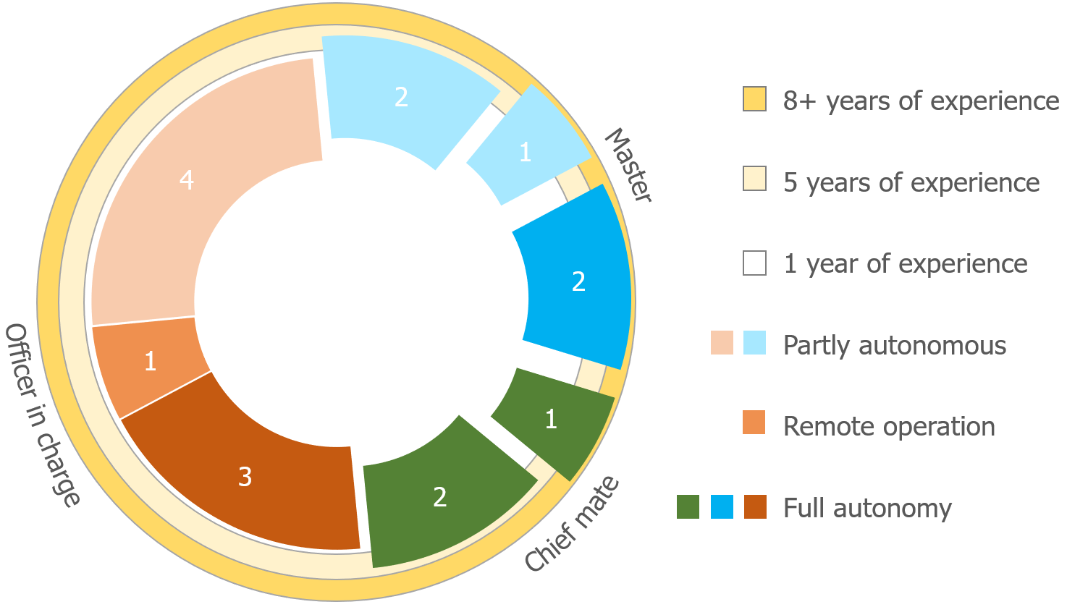

Figure 11.1: Classification of participants based on experience

The classification of participants is shown in figure 11.1. Where the different colors indicate the participants highest rank, according to their certification. The maximum radius corresponds to their years of experience, while the shading the autonomy participants think ships will eventually have. The lightest color is for participants who expect vessels to be partly autonomous. Which means that they expect there will always be crew on board. Remote operation means that they expect ships to sail without crew, but that every ship will be monitored 24/7 from a remote location, where the operator can intervene at any time. The darkest colors show the participants who think ships will eventually be able to operate fully autonomous, even in the busiest regions, such as the Dover and Malacca strait.

The number of operators and their role per ship-type is shown in figure 11.2, some participants sailed on different ship types. Where tugs and fast crew suppliers are under small vessel. Complex workboats are crane barges and dredgers. Coasters and general cargo vessels are most common. Ro-Ro and Ferries are more complex than the coasters and often also a bit longer. Cruise ships bring much more responsibility due to the number of passengers, resulting in larger safety domains. Tankers are the least maneuverable vessels operated by one of the participants.

#### Tools

Beside the participants, tools are needed to do the experiment. The tools needed are:

* + - * Screen to show simulation environment
      * Questionnaire to be used before, during and after the experiment
      * Room without distractions to do the experiment
      * Possibility to store and later process actions during the experiment

The simulation environment is discussed in more detail in appendix B. The simulation environment is shown in figure 11.3. Where the map is shown on the left, the side-bar can be used to control the selected vessel. In the status-bar at the bottom of the screen, information is given on possible actions, errors and status of simulation.

#### Dependent variables

During the experiment different variables will be evaluated. These are based on the human factor measures, as described in section 9.2. This will be a combination of both quantitative and qualitative measurements. Thus combining numerical values with non-numerical arguments. Using the variables can be concluded if the system acted as expected and will result in safe navigation when using existing protocols. The dependent variables within the experiment are:

**Performance** ”Yes” or ”No” evaluation if the participant operated safely. Thus did he safely navigate the vessel by making the right decisions. Which means that the participant followed the applicable COLREGs and showed good seamanship. The resulting closest point of approach (CPA) is a good measure for this. Also the reasoning and situation recognition which results in choosing the right strategy is a measure.

**Trust** The system acts not only out of self-interest, but in order to acquire a pareto-optimal solution. The participants must have a feeling of confidence that unmanned vessels act as they expect. Therefor they must be confident that the system works as it is supposed to do. In later stages this will also be supported by evaluations of well-known institutions. [Ozawa and Sripad (2013)]. For now the survey is leading here. Where questions will be asked on the participants trust in autonomous systems, their trust in SMCP and how they thought the communication went during the experiment.

**Situation awareness** The perception of environmental elements and events with respect to time or space, the comprehension of their meaning, and the projection of their status [Naderpour et al. (2016)]. This is measured using an observer rating system, showing

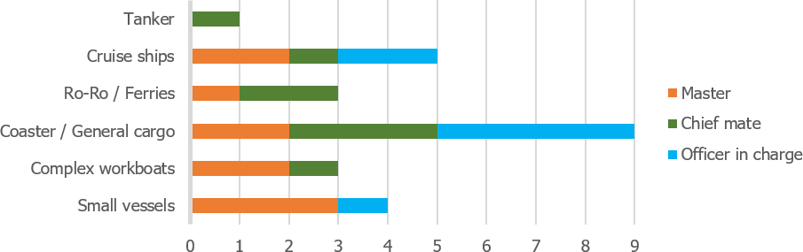

Figure 11.2: Ship-types operated by participants

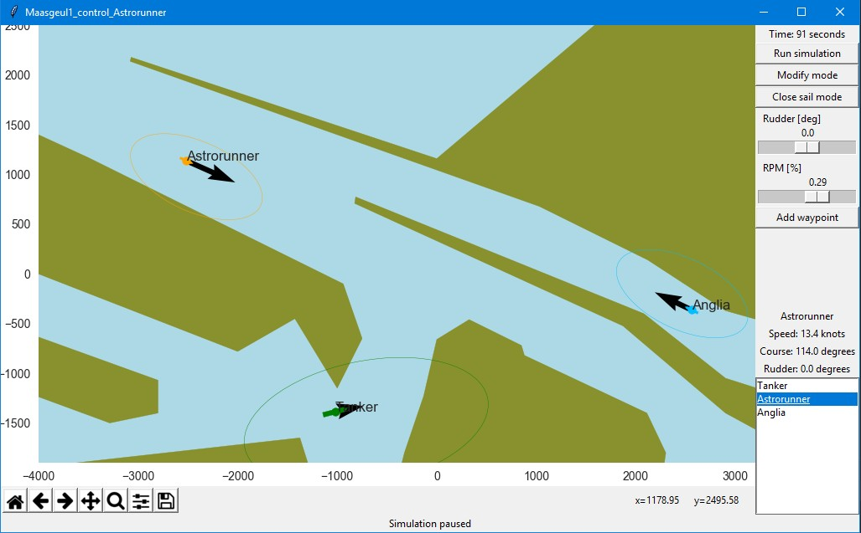

Figure 11.3: Simulation environment

if participants have noticed changes in course, the color of different vessels and relative speed.

**Satisfaction** The participant should like to use the protocol. This is measured by questioning them on the effectiveness of SMCP, observe their usage of the protocol during the experiment and their reaction to vessels using the protocol.

### Experiment task

The participant will act as an Officer of Watch (OoW) in different situations. The duties of the OoW are to keep watch and navigate the vessel. While keeping a watch on the bridge he is the representative of the ship’s master and has the total responsibility of safe and smooth navigation of the ship. This means he has to follow a proper navigation plan to avoid any kind of collision according to COLREGs. Thereby is he aware of ship’s speed, turning circles, and ship handling characteristics. He also communicates with other vessels when that is necessary.

More specific will he sail a vessel in different scenario’s. It depends on the scenario how and if the participant can communicate with other vessels. He will do this by directing a vessel on a 2D-map as shown in the simulation environment. He will have access to the same information as any other bridge, also presented in a similar way, except for the visual 3D-view. But this lack of information is compensated by more reliability for the ECDIS and Radar. Within the experiment, tests will be done for different situations and scenarios. The resulting strategies are listed below.

1. Crossing situation at North-Sea
   1. Follow COLREGs strictly
   2. Cross in front
   3. Cross at the back
2. Entering Maasgeul from Maasvlakte
   1. Cross in front
   2. Cross at the back
   3. Pass without crossing

#### Crossing situation at North-Sea

The first situation for the experiment is a crossing situation based on the accident between MV ARTADI and MV ST-GERMAIN (appendix C.2). Where both ships followed COLREGs, but due to a lack of communication and wrong presumptions on the intentions, did the accident occur.

The traffic in this simulation consists of three ships: a 250-meter tanker (GULF VALOUR), a 140-meter cargo vessel (ASTRORUNNER) and a 400-meter container vessel (EMMA MAERSK). This situation is shown in figure 11.4. The relevant information for these ships is given in table 11.1.

For the situation when operating the Astrorunner while crossing the Gulf Valour at the North- Sea, an example of the communication is given below:

* + - Call

Gulf valour, Gulf valour. This is Astrorunner. Over.

* + - Acknowledge

Astrorunner. This is Gulf Valour. Over.

* + - Message

Gulf Valour. This is Astrorunner.

Question. Is your intention to alter course to Starboard?. Over.

* + - Response

Astrorunner. This is Gulf Valour

Question received. We will alter course to give way and pass 1 nautical mile astern. Over.

* + - Close communication.

Gulf Valour. This is Astrorunner. Understood. Have a good watch. Over.

Astrorunner. This is Gulf Valour. Over and out.

|  |  |  |  |  |
| --- | --- | --- | --- | --- |
|  | GULF VALOUR | ASTRORUNNER | EMMA MAERSK |  |
| Length | 249.0 | 141.6 | 397.7 | m |
| Width | 48.0 | 20.6 | 56.4 | m |
| Draft | 13.2 | 6.5 | 12.6 | m |
| Deadweight | 114900 | 9543 | 156907 | m |
| Type | Oil tanker | General cargo vessel | Container vessel |  |
| Position | [-1400, -1400] | [3250, 0] | [400, 2400] | m |
| Speed | 16.0 | 15.2 | 12.0 | knots |
| Course | 45 | 278 | 225 | degrees |
| Previous port | Singapore | Zeebrugge | Rotterdam |  |
| Next port | Rotterdam | Dover | Hongkong |  |
| Direction | North-east | West | South-west |  |

Table 11.1: Relevant information crossing at North-Sea

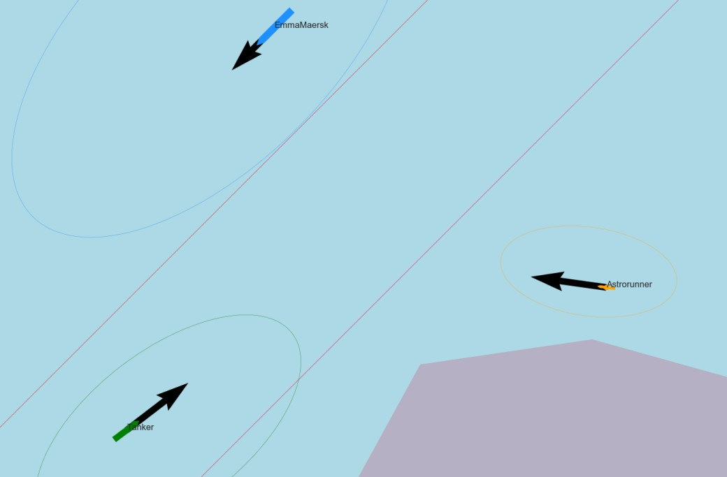

Figure 11.4: Situation sketch crossing situation North-Sea

#### Entering Maasgeul from Maasvlakte

The second situation is a common situation at the port of Rotterdam. The situation is based on the description by Pilots from ’Nederlands Loodswezen’. The big challenge here is that ships are accelerating and decelerating. Therefore do traffic controllers notify ships about others intentions. But in the case as presented does this not always happen, or too late.

The traffic in this simulation consists of three ships: a 250-meter tanker (GULF VALOUR), a 140-meter cargo vessel (ASTRORUNNER) and a 140-meter Ro-Ro vessel (ANGLIA SEAWAYS). This situation is shown in figure 11.5. The relevant information for these ships is given in table 11.2.

For the situation where the Gulf Valour is leaving the port of Rotterdam and has to cross or pass the Astrorunner the following conversation is likely:

* + - Call

Astrorunner, Astrorunner. This is Gulf Valour. Over.

* + - Acknowledge

Gulf Valour. This is Astrorunner. Over.

* + - Message

Astrorunner. This is Gulf Valour.

Question. What is your port of destination? Over.

* + - Response

Gulf Valour. This is Astrorunner.

Question received. My port of destination is the Vulcaanhaven. Over.

* + - Message

Astrorunner. This is Gulf Valour.

Instruction. You are stand-on vessel and should keep course and speed. Over.

* + - Response

Gulf Valour. This is Astrorunner.

Instruction received. We will stand on. Over.

* + - Close communication.

Astrorunner. This is Gulf Valour.

Nothing more. Have a good watch. Over.

Gulf Valour. This is Astrorunner. Over and out.

|  |  |  |  |  |
| --- | --- | --- | --- | --- |
|  | GULF VALOUR | ASTRORUNNER | ANGLIA SEAWAYS |  |
| Length | 249.0 | 141.6 | 142.4 | m |
| Width | 48.0 | 20.6 | 23.0 | m |
| Draft | 13.2 | 6.5 | 5.0 | m |
| Deadweight | 114900 | 9543 | 4650 | m |
| Type | Oil tanker | General cargo vessel | Container vessel |  |
| Position | [-1372, -1377] | [-3090, 1395] | [3000, -550] | m |
| Speed | 7.8 | 13.4 | 10.3 | knots |
| Course | 98 | 114 | 291 | degrees |
| Origin | Princess Arianehaven | North-Sea | Vulcaanhaven |  |
| Destination | North-Sea | Beneluxhaven | North-Sea |  |
| Direction | Leaving | Entering | Leaving |  |

Table 11.2: Relevant information entering Maasgeul

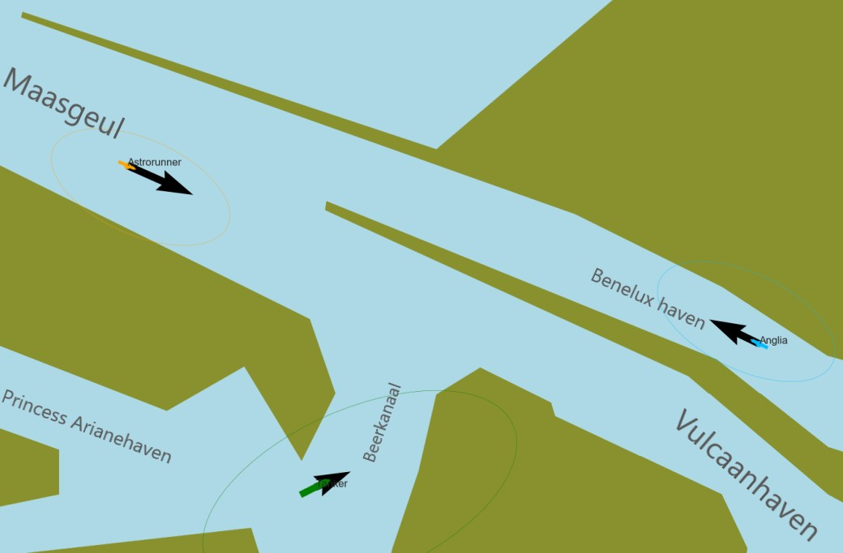

Figure 11.5: Situation sketch port of Rotterdam

### Experiment procedure

To execute the experiment. Several steps are taken together with the Officer of Watch (OoW):

1. Explain how the OoW can take actions, such as steering, change speed, set way-points or engage in communication.
2. Ask general questions on attitude and basic information.
3. Explain situation to OoW in a similar way, to a common watch hand-over. Only discussing relevant issues for navigational duties.
4. Start simulation.
5. Depending on the simulation, let autonomous ship take actions or wait for the OoW to engage in communication.
6. End simulation.
7. Question OoW why decisions were made.
8. Evaluate the simulation.
9. Repeat step 3-8 for more situations.
10. Question OoW about advantages and challenges of protocol.

The answers to the questions are collected using a Google form. This form includes the same questions as described below. These questions are yes/no, a yes to no scale of four steps or answers can be selected in a list. Often followed by an open question to explain the answers in more detail.

#### Explanation and basic information (1, 2)

The participant is not explicitly informed about the exact purpose of the research. The participant will however get a short introduction on how to use the simulation environment. This includes the commands it can give as an officer of watch. The environment is easy to use, as action are similar to the ones currently happening at the bridge. Thereby is some information about the participant acquired, followed by some general questions relevant to the protocol, such as there knowledge on Standard Maritime Communication Phrases (SMCP).

* + - * Which certificates do you have?
      * What is you experience as captain and mate?
      * Which type of vessels did you operate?
      * What do you expect from the developments towards autonomous shipping?
      * What do you see as the biggest challenge for introducing autonomous and unmanned vessels?
      * Do you expect to trust autonomous ships more?
      * Do you want to know if a ship is unmanned?
      * Are ship’s horns still used to communicate intended manoeuvers?
      * What are the most important forms of communication?
      * Do you still use SMCP consciously?
      * How does a standard conversation look like, according to the SMCP?
      * Is the protocol around SMCP easy to use?

#### Situations and scenarios (3, 4, 5, 6)

The next steps are repeated several times for the different situations. The communication in that situations should be about the intentions of the other vessel. When using the designed protocol, the conversation should be similar to the examples given in section 11.1.2. It depends on the experiment order, in which situation it is possible to communicate:

1. Crossing situation at North-Sea
2. Leaving port of Rotterdam via Maasgeul

#### Relevant questions for situation (7, 8, 9)

To gain insight into the quality of the experiment and effectiveness of the protocol, different questions will be asked. Thereby is a link made to the decision process as discussed in section 2:

* + - * What type of situation is this?
      * Which criteria are relevant?
      * Which strategy did you choose?
      * Which actions were taken?
      * What was the speed of different vessels?
      * How often did the ships change their course?
      * Which color did every ship have?
      * Did other ships behave as expected?
      * Were you in control over the situation?
      * Did you miss any information to come-up with the right strategy?
      * Was it necessary to communicate?
      * If there was communication, was this as you expected?
      * Would you have acted differently is you knew there was a human officer of watch?

#### General questions on protocol (10)

After running the different situations an interview is held. This part of the experiment is intended to answer the following questions from the participant perspective and explain the purpose of this research:

* + - * Is the protocol around SMCP easy to learn?
      * Is the protocol around SMCP a complete protocol?
      * Do you have any other commands on SMCP?

## Evaluation results

The evaluation results describe the outcomes of the test. Because of the iterative and rapid research cycles, the evaluation does not necessarily include all requirements/claims/use cases available in the system specification. Oftentimes the evaluation investigates a subset of the system specification. Therefore, it is often useful to also specify what claims were tested, with the use of what evaluation method, and what artefact was used during the evaluation (i.e. which requirements, technology, interaction design patterns were included in the artefact).

The results of the experiment are evaluated in a systematic way for the 16 responses. First, a summary is made of the reactions to the Google form. This is done using both a statistical analysis on the ordinal level, and classification of answers on the nominal level. Dependent variables discussed are discussed, using this summary.

### Observations during simulations

Situational awareness is tested by questioning participants about the relative start speed, color and course changes. The participants focused at possible future risks. Speed estimations did they often base on normal behavior for different ship types, instead of taking the speed vector into account.

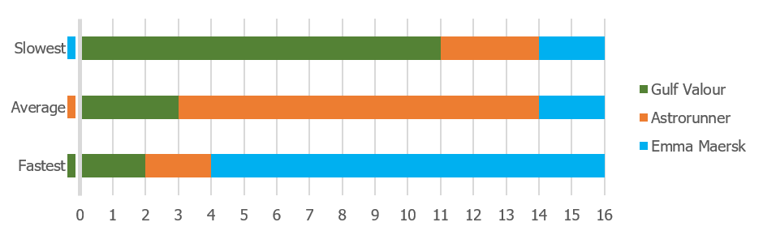The first case is the crossing situation at the North-Sea. The situation was implemented in such a way, that the container ship was the slowest, and tanker the fastest. As can be seen in figure 11.6 did the participants think the opposite. This can be explained that a large container ship (Emma Maersk) usually go the fastest, the smaller general cargo vessel already a bit slower (Astrorunner), and the tanker (Gulf Valour) the slowest. Thus opposite to how the scenario was set-up.

Figure 11.6: Estimation of relative start speed from memory for North Sea

Wrong estimations could also be the result of the simulation environment. But the estimates of the participants are opposite to the vertical-horizontal illusion when considering the speed vectors as measurement [Prinzmetal and Gettleman (1993)]. Thereby did participants estimate the speed correctly, when they were able to see the speed vectors and were questioned about the speed during the experiment, instead of making an estimation based on memory.

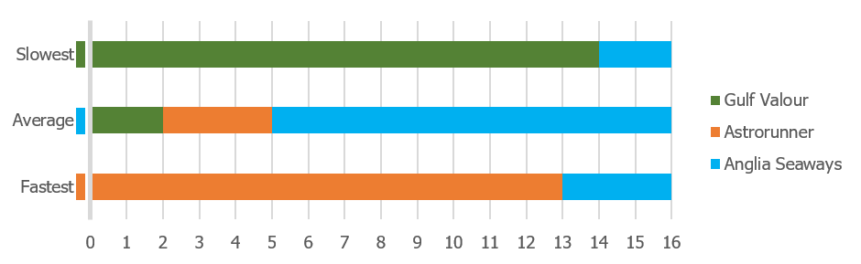The relative start speed in the second situation when leaving the port of Rotterdam via the Maasgeul, had results as could expected. This is shown in figure 11.7. Where most participant did estimate the relative speed correctly.

Figure 11.7: Estimation of relative start speed from memory for entering Maasgeul

The estimation for the number of course changes went a lot better for the first situation. The Emma Maersk did not alter course and this was correctly observed. Just as the single course change for the Astrorunner to ensure a perpendicular passing of the traffic separation scheme. The course changes of the Gulf Valour depended on the situation. If the participant controlled the Gulf Valour, they said that two course changes were made: Alter course to starboard and return to original course. While in the case where the participant operated

from the Astrorunner, was the last alternation not counted for. Thus did the participants count only one course change for the Gulf Valour. This can be explained by the attention of the participant. When the Gulf Valour alters course for the second time, is the Astrorunner close to the Emma Maersk, the participant pays therefor attention to the Emma Maersk and not the Gulf Valour.

In the second situation are the course changes much more clear, as two vessels go straight (Astrorunner and Anglia Seaways), while the Gulf Valour make one clear turn. It depends on the exact actions the participant took how many course changes were made. But there were no wrong answers given at this point. Being able to communicate, did affect the strategy and thereby actions, but not the ability to register the right amount of course changes.

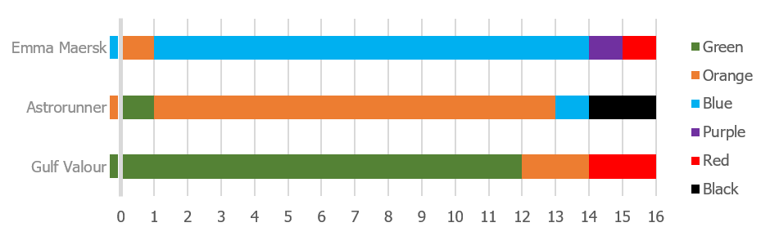The color is something which does not have any affect on the decision, it is however information which shows if they remembered irrelevant details about the simulation. This is a measure for the free cognitive capacity, as more irrelevant details are remembered when a situation is less complex, also known as inattentional blindness [Most et al. (2000)]. This difference can be seen between the situation when crossing the North Sea, and entering the Maasgeul. Figure 11.8 and figure 11.9 show that more participants have the color correct in the crossing situation at the North Sea, which is also the less complex situation when it comes to making the right decision.

Figure 11.8: Response to color of vessels in situation when crossing at the North Sea

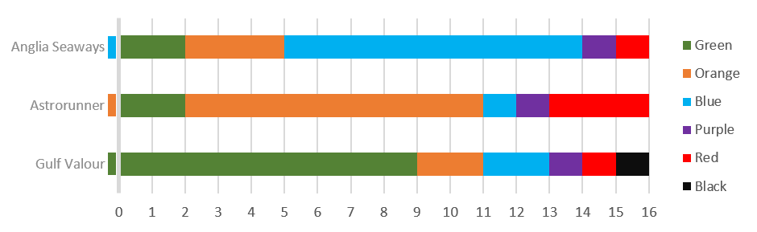

Figure 11.9: Response to color of vessels in situation when entering Maasgeul

After each simulation did the participants also answer questions on actions of other vessels, communication and missing information. The results of this are shown in figure 11.10 and

figure 11.11. It should be noted that the experiment was not fully counter-balanced, and due to the limited number of participants is there a high margin of error. Therefor are conclusions drawn only when there is a big difference between the results for protocol vs no-communication.

Interesting is that 40% of the participants would have acted differently when no communication was possible. Their explanation for this is that they could not anticipate to other vessels, thus slowed down, hoping that they could deduce from the actions of the other vessels what their plans were. If the protocol works well, this is not needed. The other participants said they followed the COLREGs, and expect unmanned vessels to do the same, thus would the participants act the same when the other vessel was manned.

A conclusion which was expected is that the participants would miss information when they were not able to communicate using the protocol. This is the case in the second situation when entering the Maasgeul. However did most participants indicate they were also missing information on the CPA. In the first situation at the North Sea did more than half of the participants think it was not necessary to communicate. Therefore did a similar amount of participants miss the same information in both cases (protocol vs no-communication).

Also did the type of ships participants have operated, influence their behavior. As operators who used to sail on small vessels did often take more risk and expected higher accelerations and manoeuvrability. While the operators who used to be operate large vessels, such as tankers and cruise ships, rather waited for other ships to act first. If they were missing information.

In case the participants used the protocol, the communication was in both situations as expected for most of them. This shows that the natural language variation on SMCP as proposed is the communication other seafarers will expect.

The participants are questioned about their trust in autonomous systems, in all cases they want to know if a ship is unmanned. So that they can anticipate to it. They gave as example that it is likely that an autonomous vessel will follow COLREGs more strict than ships operated by an Filipino crew. But in an emergency situation, such as failure in the engine room, do the participants trust autonomous ships less. Therefor there was not a definitive answer if autonomous vessels will be trusted more or less, compared to manned vessels.

### Evaluation of the protocol

The questionaire tries to validate design choices for the protocol. A design choice which is based on COLREGs, but unknown if it works in practice is the usage of the ship’s horn to communicate the intended manoeuvrer. All participants said that the ship’s horn is only used in two situation. When a ship wants to get attention from another ship, in case other means

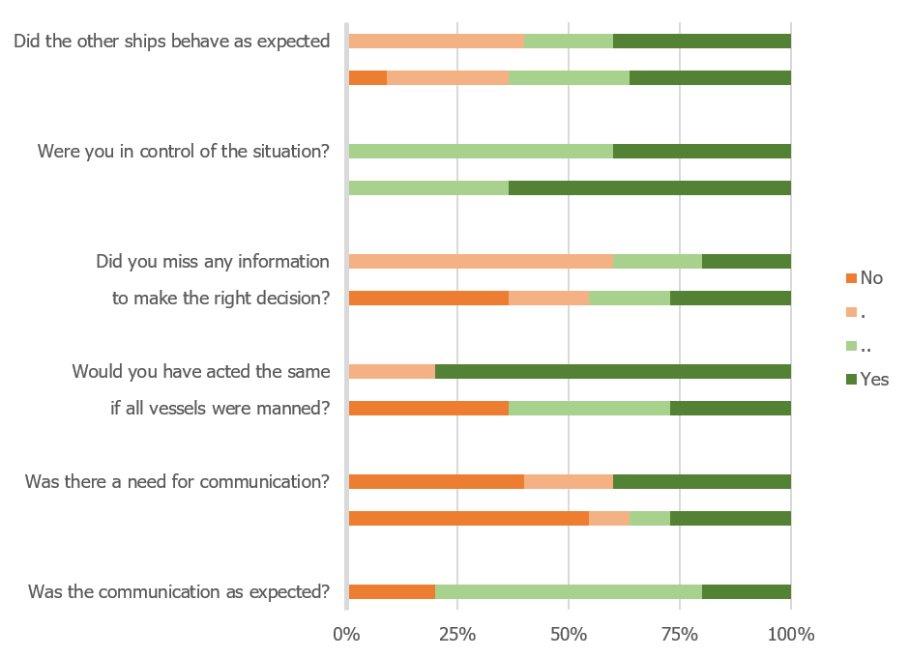

Figure 11.10: Protocol vs no-communication when crossing at the North Sea

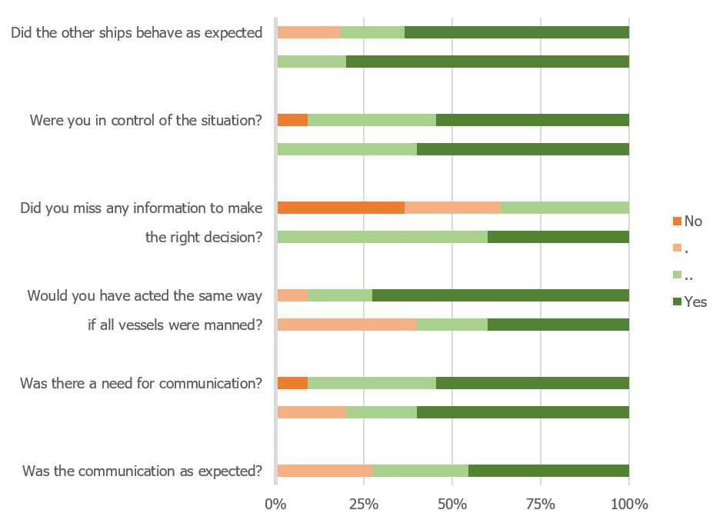

Figure 11.11: Protocol vs no-communication when entering Maasgeul

of communication do not work. Or in case of fog, is the fog horn sounded every few minutes to make other ships alert of presences [IMO (1972)].

The most important form of communication is the VHF radio. Although new systems are also used more often, such as AIS text messaging and INMARSAT-C. INMARSAT C provides two- way data and messaging communication services to and from virtually anywhere in the world. Which improves the ship-to-ship communication, the disadvantage is that surrounding vessels are not able to listen to the conversation, and thus will not receive the shared information.

According to the participants are conversations via VHF based on SMCP, but do not follow the protocol strictly. A few key characteristics are described by the participants:

* + - * Start of every message, has the purpose to get attention, by calling specific vessel: ”(*< name other vessel >*, *< name other vessel >*. This is *< name own vessel >*)”
      * Common practice is to use the words as defined by SMCP (alter course, instead of change course). The sentences are often not used as described by SMCP.
      * Marker words are not used.
      * When responding, the previous message is repeated.
      * Message is ended with over, conversation with over and out.

In general do they state that the protocol is easy to use, easy to learn and complete. This is also shown in figure 11.12. The drawback is that the protocol covers too much, therefor people can’t always remember how they should follow the protocol.

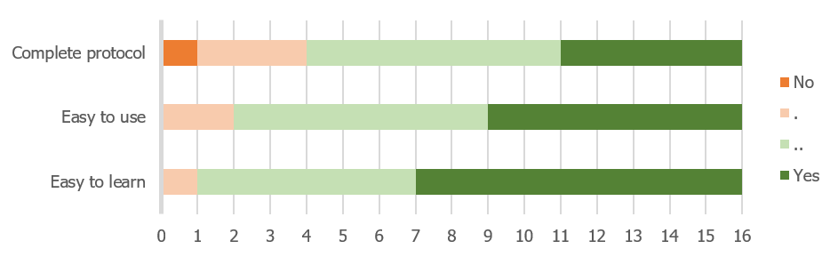

Figure 11.12: Opinion of participants on SMCP

Less relevant for SMCP, but more for the final design of the protocol is the knowledge of English. As the level of and pronunciation of English is not at the right level for all officers, certainly for example with Filipino, Indian or Pakistani crew. This means that the voice recognitzion should be tested for these accents. It is also important to know the names of different systems (e.g. LORAN, DSC, etc.) and places (e.g. camping, seal beach, etc.), which vary per ship and area and can not always be found on maps.

*11.3. LESSONS LEARNED* 99

Thereby was the identification of vessels hard before the introduction of AIS. This should be considered during the development of such a protocol. As it should also be possible to identify ships when the AIS fails, this means it should be possible to identify ships without knowing the call-signs and name via AIS.

Due to the speed and starting point of the simulation, did the operators have to decide quickly if they wanted to communicate. Therefor was commented by some of them, that they would have liked to communicate earlier, than the moment the simulation started. So they would have had enough time in case the other vessel did not respond immediately. Although the designed protocol and the current usage of VHF differ in the way how strict SMCP is used. Does it take the same amount of steps, and a similar amount of words. Therefor it is not expected that the conversations will take longer, if the voice recognition works correctly.

## Lessons learned

The aim of the experiment is to determine if the designed protocol will ensure safe navigation and more situational awareness, when manned and unmanned vessels encounter each other. This is can be answered by looking into different measures on how the participants and protocol performed during the experiment. This shows what should be taken into account in the next iterative steps in developing the protocol.

The *performance* is a simple evaluation if the participant followed regulations such as COLREGs. Thus did he safely navigate the vessel by making the right decisions. None of the cases did result in an accident, there were however some close encounters. There was no clear correlation between the ability to communicate and the closest point of approach (CPA). As some participants took more risk, when the intention of another vessel was known. The protocol did however help to acquire the right information to chose a strategy earlier in the process. This gave them more control over the situation, and ensured them that the other vessels will also follow COLREGs. Thereby was the communication as expected when using the protocol, after reminding participants how the communication should be according to SMCP. This corresponds with the opinion of participants, that it is a complete protocol, which is easy to use and learn.

*Trust* is the second measure which is evaluated. This means that the participants are confident that the system works as expected. The participants were most worried about the voice recognition, certainly for Filipino, Indian or Pakistani crew. As these have a clear accent. The protocol itself shouldn’t be the problem, as it is optimized to be well understandable via radio. The recognition of speech acts could be difficult, but it has the advantage that clear keywords

are used. Thereby is every response started with a confirmation of the previous message, which helps to increase trust in the protocol and unmanned vessels in general.

The third measure is *situation awareness*. This is measured by checking if the participants were aware of relevant and irrelevant details such as estimating relative speed, number of course changes and the color of a vessel. The relevant details went better in the complex situation which demanded high attention. Irrelevant details such as course changes of vessels which already passed, or the color of a vessel were remembered less in these situations. This was however not influenced by the protocol, which means that the protocol has a small effect on the free cognitive capacity.

The last measure is *satisfaction*. Thus, do the participants like to use the protocol. Here is the voice recognition most important, if this will understand natural language variations to SMCP, are most participants very positive. As SMCP itself is and ’idiot proof’ system. If it is possible to communicate this way with vessels, will strategies not differ from interactions with manned vessels.

# *|* Conclusion

This part has shown that it is possible to solve the challenge of communication by enabling unmanned vessel to communicate with manned vessels, to ensure safety. This is done by designing a protocol for communication, based on existing maritime systems and protocols, by using the situated Cognitive Engineering (sCE) method. Where the first phase includes a description of operational demands, relevant human factors and envisioned technologies. The second phase are design scenarios and use cases, which result in a list of requirements. Which are used to define an ontology for the system and a description of what the system is capable of. With experts is evaluated if this is indeed enough to ensure that unmanned vessels can operate safely between manned vessel. All this combined will answer the question:

*Will a protocol based on existing maritime systems and communication protocols be sufficient to ensure safe navigation, while manned and unmanned vessels encounter each other?*

Using Standard Maritime Communication Phrases (SMCP) as the core for a new protocol, will ensure safe navigation. As the advantage of SMCP is that it is already optimized for radio communication. The clear speech acts will make it more easy to automate the communication. Which means than unmanned vessels are able to use the same protocol as is currently used by manned vessels. Thereby did experts confirm that it is an idiot proof system, which is easy to use and learn, certainly when the speech recognition tool will be able to handle natural language variations on SMCP. This will be more easy when officers use the protocol as it is designed. After recent accidents between manned vessels was already decided that pilots and masters should use English speech and SMCP in all cases, to avoid misunderstanding. Avoiding misunderstanding will result in better situational awareness, which results in safer navigation. Thus it is possible to use existing maritime systems and communication protocols, to ensure safe navigation when manned and unmanned vessels meet.

The next step is to map different speech acts, to specific situations. This is only possible when situations can be identified by unmanned vessels in a systematic way. Which means that the recognition of situations is one of the key challenges to enable unmanned vessels.

101

102 *CHAPTER 12. CONCLUSION*

**Part IV**

**Wrap-up**

*All truths are easy to understand once they are discovered. The point is to discover them.*

– Galileo [Galilei (1632)]

103

# 13 *|* Final conclusion

Describe results when both researches are combined. Do they support each other. Relate this to the model

Is the acquired knowledge sufficient to identify the situation correctly, or is more information desired via communication? from chapter 2

Write final conclusion of report

105

106 *CHAPTER 13. FINAL CONCLUSION*

# 14 *|* Recommendations for future research

what was not within the scope what are the next steps

Recommendations for future research

107

108 *CHAPTER 14. RECOMMENDATIONS FOR FUTURE RESEARCH*

**Part V**

**Appendices**

*Studying history will not tell us what to choose, but at least gives us more options to choose from.*

– Yuval Noah Harari [Harari (2016)]

109

# *|* Current systems for safe navigation

Before developing new systems and procedures to improve safety, the first step is to know what is currently available. Thereby should be considered how different types of information can be supplied. Nowadays decisions on navigation are taken from the bridge. Thus all information must be available there. In this chapter these elements will first be discussed, how they are in theory. This is followed by a discussion on the differences between this theory and practice. Which results in a conclusion on relevant systems for the communication between manned and unmanned ships.

## Bridge system elements

To gain insight in a structured way, the bridge is split into four elements as described by DNV-GL. The human operator, procedures, technical system and the human-machine interface [DNV GL (2011)], as shown in figure A.1. This section describes every element in more detail.

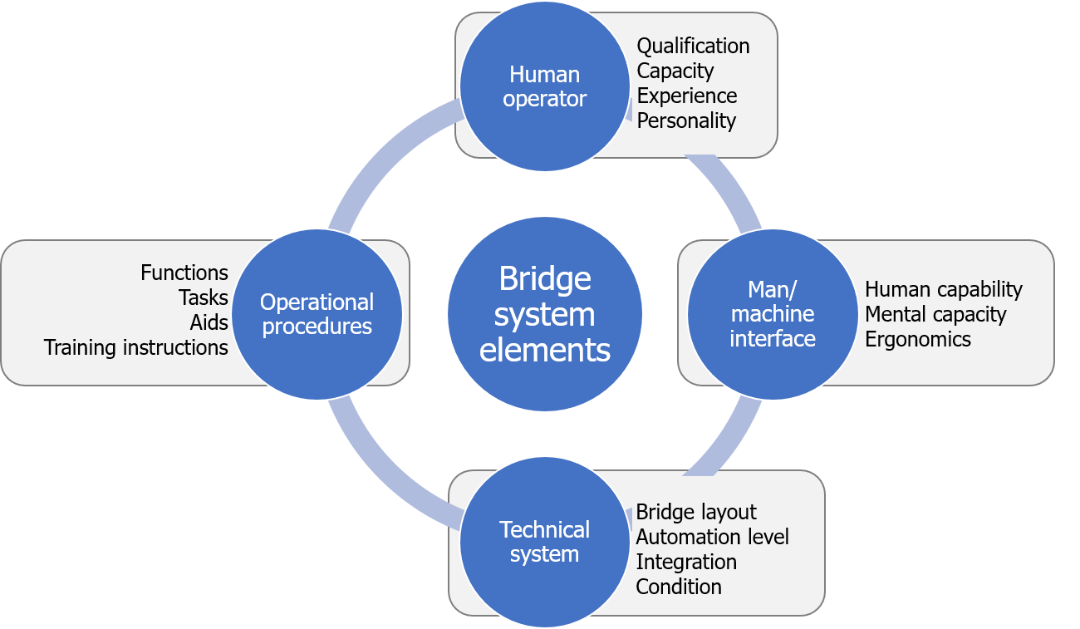

Figure A.1: Bridge system elements

### A.1.1 Technical system

The first element which will be discussed are the instruments and equipment at the bridge, the technical system. The different classification societies prescribe the equipment which is obligated to have at the bridge. These are based on the regulations for navigational equipment on board of ships from the International Convention for the Safety of Life at Sea (SOLAS), a modern ship should at least have:

111

* + - Magnetic compass
    - Gyro compass
    - ECDIS
    - Transmitting heading device
    - Automatic Identification System (AIS)
    - Receiver for Global Navigation Satellite System (GNSS)
    - Internal communication system
    - Bridge Navigational Watch Alarm System (BNWAS)
  + Telephone for external communication
  + Radar
  + Radar beacon
  + Daylight signaling lamp
  + Speed and distance measuring device
  + Echo sounding device
  + Rudder, propeller, thrust, pitch and operational mode indicators
  + Rate of turn indicator

Based on this list, DNV-GL demands at least the following equipment shall be installed at the bridge [DNV GL (2011)]. The equipment may have different roles. To control the ship, to present information, or to communicate:

* + - Propulsion control
    - Emergency stop machinery
    - Manual steering device
    - Steering mode selector switch
    - Heading control
    - Window wiper and wash controls
    - Control of dimmers for indicators and displays
    - Steering gear pumps
    - Gyrocompass selector switch
    - Navtex receiver
  + Automatic Radar Plotting Aid (ARPA)
  + Electronic Chart Display Information System (ECDIS)
  + Automatic Identification System (AIS) transceiver
  + General alarm control
  + Very High Frequency radio (VHF) unit
  + Whistle and manoeuvring light push buttons
  + Internal communication equipment
  + Central alert management system

Some of these systems will be highlighted to show the relevance for the development of unmanned vessels, as these systems are currently the most important systems while navigating. Thereby should be considered that more details on underlying procedures are given later in this chapter.

#### Navigational text Messages (Navtex)

Navtex (Navigational Telex) is an international automated medium frequency direct-printing service for delivery of navigational and meteorological warnings and forecasts, as well as urgent maritime safety information to ships. Navtex was developed to provide a low-cost, simple, and automated means of receiving this information aboard ships at sea within approximately 370 km (200 nautical miles) off shore. Transmissions are typically transmitted from the National Weather Authority, Coast Guard or other navigational authority. The system is an important element in the Global Maritime Distress Safety System (GMDSS). Therefore does SOLAS mandate certain classes of vessels must carry Navtex. Examples of messages which can be received are:

* + - Navigational warnings
    - Meteorological warnings
    - Meteorological forecasts
* Search & rescue information
* Piracy information
* AIS messages

The receiver automatically prints the messages. The officer of watch keeps track of the received messages, and anticipates on them when necessary.

#### Very High Frequency radio (VHF)

Marine VHF radio refers to the radio frequency range between 156 and 174 MHz. In the official language of the International Telecommunication Union the band is called the VHF maritime mobile band. A marine VHF set is a combined transmitter and receiver and only operates on standard, international frequencies known as channels. For example is channel 16 (156.8 MHz) the international calling and distress channel. Transmission power ranges between 1 and 25 watts, giving a maximum range of up to about 60 nautical miles (111 km) between aerials mounted on tall ships and hills, and 5 nautical miles (9 km) between aerials mounted on small boats at sea level (figure A.2). Frequency modulation (FM) is used, with vertical polarization, meaning that antennas have to be vertical in order to have good reception.

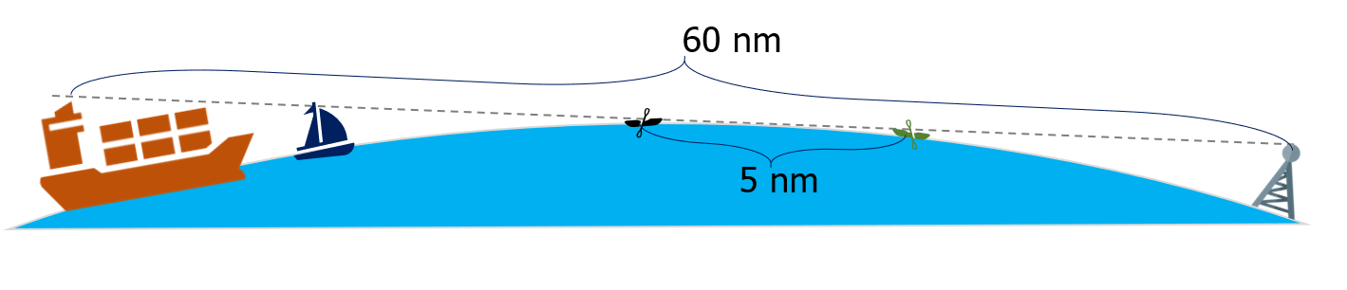

Figure A.2: Very High Frequency radio (VHF)

Modern-day marine VHF radios offer not only basic transmit and receive capabilities. Permanently mounted marine VHF radios on seagoing vessels are required to have certification of some level of ”Digital Selective Calling” (DSC) capability, to allow a distress signal to be sent with

a single button press.

Marine VHF mostly uses ”simplex” transmission, where communication can only take place in one direction at a time. A transmit button on the set or microphone determines whether it is operating as a transmitter or a receiver. Some channels, however, are ”duplex” transmission channels where communication can take place in both directions simultaneously when the equipment on both ends allow it (full duplex), otherwise ”semi-duplex” is used. Each duplex channel has two frequency assignments. Duplex channels can be used to place calls on the public telephone system for a fee via a marine operator. When full duplex is used, the call is similar to one using a mobile phone or landlines. When semi-duplex is used, voice is only carried one way at a time and the party on the boat must press the transmit button only when speaking. This facility is still available in some areas, though its use has largely died out with the advent of mobile and satellite phones. Marine VHF radios can also receive weather radio broadcasts, where they are available.

#### Automatic Radar Plotting Aid (ARPA)

Radars have been playing a vital role in ship navigation for several decades now, assisting in collision avoidance and early detection of obstacles.The history of marine radars goes a long way back to the time of World War II, when radars were introduced and effectively used by war ships for tracking and detection. Radar technology has improved immensely from post-WWII period to the present and the application of computer technology to commercial marine radar sets resulted in the introduction of Automatic Radar Plotting Aids (ARPA). A print-screen of an ARPA systems can be seen in figure A.3.

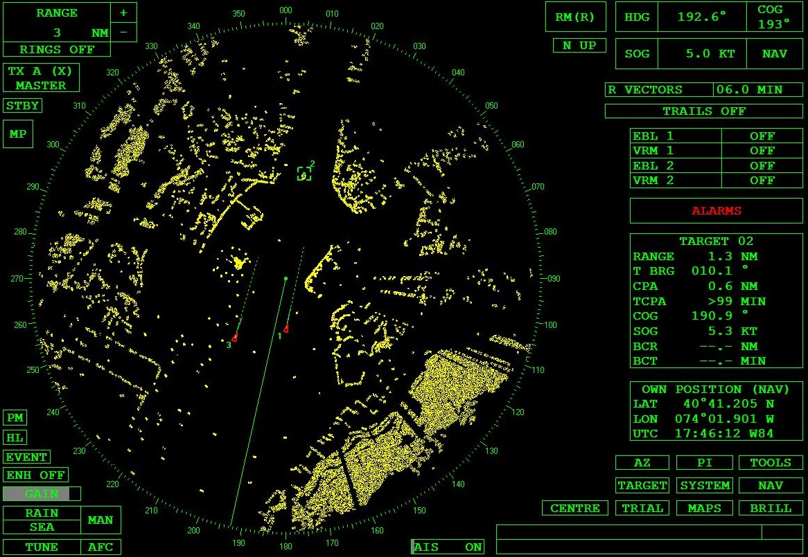

Figure A.3: Automatic Radar Plotting Aid (ARPA)

Automatic radar plotting aids are essentially utilized to improve the standard of collision avoidance at sea. Primarily designed as anti-collision radar, the ARPA technology removed the chore of plotting targets manually on a reflection plotter or separate plotting aid. The system is able to acquire automatically and constantly monitor number of targets, plot their speeds and courses, present these as vectors on the display screen, updated with each sweep of the antenna, and calculate their closest points of approach to own ship and the time before that will occur.

#### Electronic Chart Display Information System (ECDIS)

The Electronic Chart Display Information System (ECDIS) is a development in the navigational chart system used in naval vessels and ships. With the use of the Electronic Navigational Chart (ENC) system, it has become easier for a ship’s navigating crew to pinpoint locations and attain directions. ECDIS equipment complying with SOLAS requirements can be used as an alternative to paper charts. Besides enhancing navigational safety, ECDIS greatly eases the navigator’s workload with its automatic capabilities such as route planning, route monitoring, automatic ETA computation and ENC updating. In addition, ECDIS provides many other sophisticated navigation and safety features, including continuous data recording for later analysis. How the ECDIS is integrated in the bridge can be seen in figure A.4.

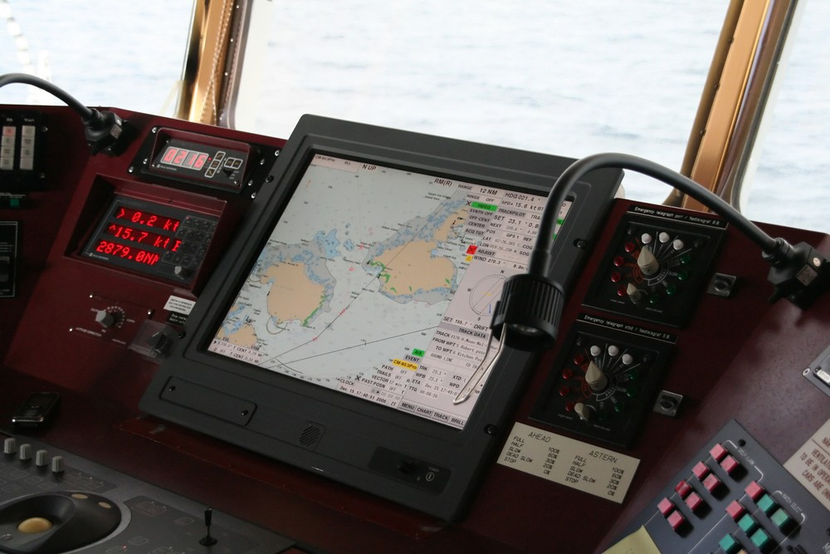

Figure A.4: Electronic Chart Display Information System (ECDIS)

The ECDIS utilises the feature of the Global Positioning System (GPS) to successfully pinpoint the navigational points. It also has to be noted that the ECDIS adheres to the stipulations set by the International Maritime Organisation, and thus it adds to the trustworthiness of the electronic chart system. ECDIS is basically a navigational information system, interfaced with other navigational equipments such as the GPS, Gyro, RADAR, ARPA, Echo Sounder etc.

#### Automatic Identification System (AIS)

AIS is designed to be capable of providing information about the ship to other ships and to coastal authorities automatically. The SOLAS regulations require AIS to be fitted aboard all ships of 300 gross tonnage and upwards engaged on international voyages, cargo ships of 500 gross tonnage and upwards not engaged on international voyages and all passenger ships irrespective of size. The requirement became effective for all ships by 31 December 2004, this means there are still ships which do not have AIS. Ships fitted with AIS shall maintain AIS in operation at all times except where international agreements, rules or standards provide for the protection of navigational information.

The regulations require the AIS to provide information on ship’s identity, type, position, course, speed, navigational status and other safety-related information. Which will be automatically send to appropriately equipped shore stations, others ships and aircrafts. While also being able to receive such information automatically from similarly fitted ships, to monitor and track them. Lastly they should be able to exchange data with shore-based facilities.

Originally the messages were send regularly via a VHF transmitter. The information originates

partly from ship’s navigational sensors. Other information, such as the vessel name and VHF call sign, is programmed when installing the equipment. Some information must be filled in by hand, such as the status or destination, which is often forgotten. The received information can be displayed on a screen or chart plotter, showing the other vessels’ positions in much the same manner as a radar display. Data is transmitted via a tracking system which makes use of a Self-Organized Time Division Multiple Access (SOTDMA).

There are different types of transmitters. Depending on the object it is installed on. This determines what kind of messages can be send and which protocol is used to access AIS slots. Below relevant types are described:

* + Class A, the most common type of AIS transceiver for large merchant vessels.
  + Class B, AIS for smaller vessels.
  + Base station, shored-based AIS transceiver, able to maanage AIS slots.
  + Aids to navigation, shore- or buoy based transceiver operating in fixed time-slots. Designed to collect and transmit data related to sea and weather conditions, or forward AIS messages to extend reach.
  + Search and rescue transceiver, designed to function as an emergency distress beacon, with high probability of success for transmission.

As mentioned before, there are different types of AIS messages, identification numbers are used to identify the type of message within the NMEA string. The following types of messages are relevant for this research and the development of unmanned ships [US Coast Guard (2018)]:

* + Position report, reports navigational information.
  + Standard class B equipment position report, less detailed report for vessels using class B transmitters.
  + Base station report, used by base stations to indicate presence.
  + Static and voyage related data, gives information on a ship and its trip
  + Binary addressed message and acknowledgment, an addressed point-to-point message with unspecified binary payload.
  + Binary broadcast message, broadcast message with unspecified binary payload.
  + Standard Search and Rescue Aircraft Position Report, used by an aircraft (helicopter or airplane) which is involved with search and rescue operation on the sea (i.e. search for and recovery of survivors of an accident at sea).
  + Addressed Safety-Related message and response, used to send text messages to a specified vessel.
  + Interrogation, used by a base station to get the status of up to 2 other AIS devices.
  + Aids-to-navigation report, used by an (AtN) aid to navigation device (buoys, lighthouse, etc.).
  + Multiple slot binary message with communications state, used to transmit binary data from one device to another.

### Man/machine interface

Previously all information was plotted by hand on navigational charts. With the developments of integrated bridge systems and for example the ECDIS, this is not necessary. This also means that a digital representation of the environment is already being made. Including calculations, relevant for navigational safety. These also give warnings to avoid collisions or represent information received via VHF. This is done in a way which is more easy to interpret by the officer of watch, as for example AIS, ENC and the radar are combined. Examples of the different systems can be found in figure A.5.

These screens are all integrated in some way into the bridge console. Depending on the size of the vessel, the lay-out may differ. Although, there are also regulations for the placement of systems in SOLAS. Examples of these bridge layouts can be found in figure A.1.

These lay-outs also show that bridges are operated in different ways. Where the officer of watch walks around on bigger ships, which also enables the crew to look together and discuss further actions. While on smaller ships the operator can see every screen from its seat. Certainly in those cases is it important to have the right balance between supplying the operator with enough information to decide on the right strategy. But avoid an information overload.

### Human operator

The human operator has two sides, to formal straight forward role as an operator. Which can be described with a list of tasks depending on their function. And the more difficult and unpredictable side of being a human. Which relates to the situational awareness and decision making ability.

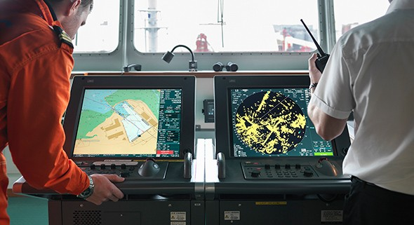 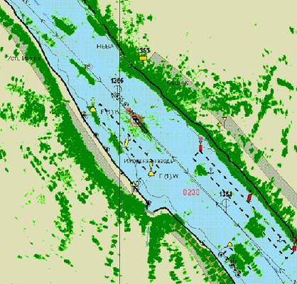

* + - 1. Separate screens for ECDIS and Radar (b) Radar overlay on ECDIS

Figure A.5: Radar and ECDIS

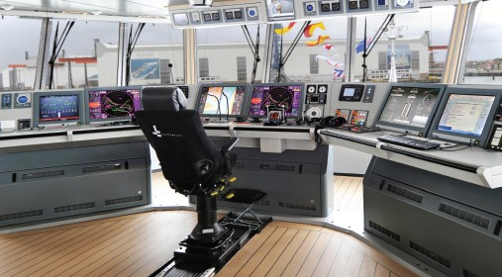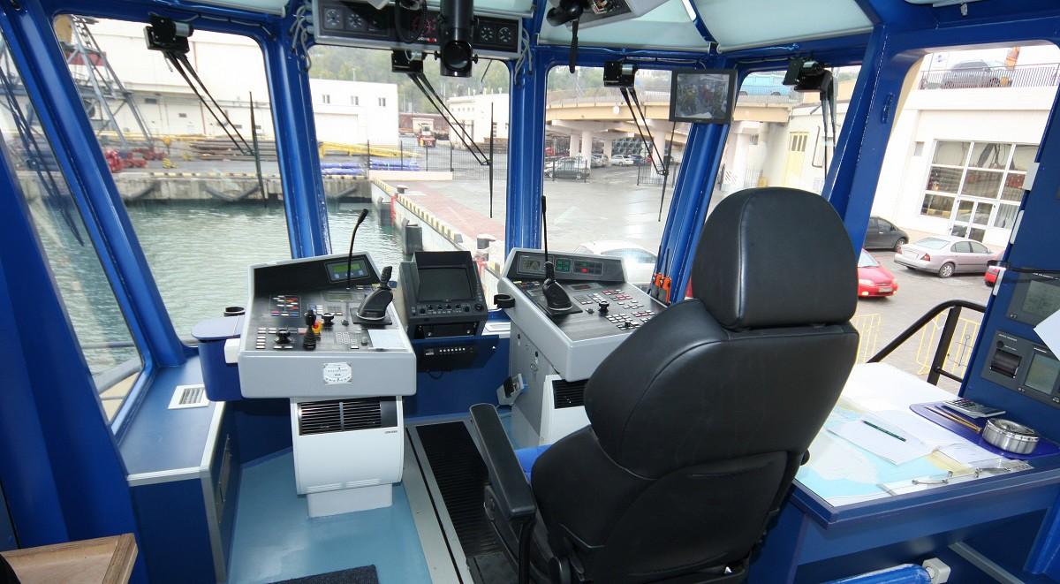

(a) Alphatron AlphaBridge (b) DAMEN ASD Tug 2310 (Patriot)

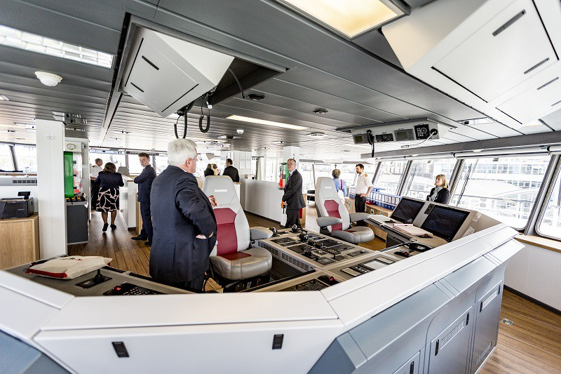 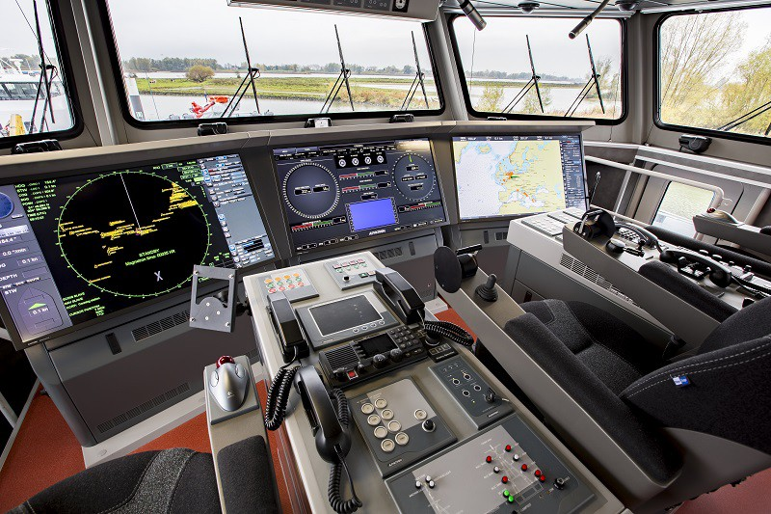

(c) BIBBY WAVEMASTER 1 (d) DAMEN Stan Patrol 5009

Figure A.6: Various examples of bridge designs

#### Role as operator

To give more insight into the different roles on board of a merchant’s vessel, is the structure shown for officers in figure A.7. At smaller vessels, roles are combined where possible. The Navy has in some cases even more operational crew members. Apart from the licensed officers who manage the vessel, does the crew also consist of ratings who have hands-on skills within their own domain. [Nedcon (2013)]

For this research the Deck crew is most relevant, as they are in charge of the vessel navigation, watch keeping, maintaining the ship’s hull, cargo, gear and accommodation, taking care of the ship’s lifesaving and firefighting appliances. The deck department is also the one in charge of receiving, discharging and caring for cargo. According to the vessel’s hierarchy, the deck officers are as follows: Master, Chief Officer, Second Officer, Third Officer and Deck Cadet (deck officer to be).

The supreme authority on board a merchant’s vessel is the Master or Captain. The entire crew is under his command. He is responsible for the safety, use and maintenance of the vessel and makes sure that every crew member carries out his work accordingly. He is also in charge of the following: payroll, ship’s accounting, inventories, custom and immigration regulations, and the ship’s documentation. In order to become Master, a seafarer must first have several years of experience as a deck officer and as Chief Officer. According to the vessel’s hierarchy, the first deck officer and the head of the deck department after the Master is the Chief Officer. He is in charge of the vessel navigation, watch duties, charging and discharging operations. The Chief Officer also directs all the other officers on deck, creates and posts watch assignments and implements the Master’s orders in order to maintain safe operations and maintenance of the vessel. Second Officer or Second Mate is the next in rank after the Chief Mate and is the ship’s navigator, focusing on creating the ship’s passage plans and keeping charts and publications up to date. Apart from watchkeeping, the Second Officer may also be designated to train the cadets on board or to fulfill the rank of security, safety, environmental or medical officer. The Third Officer or Third Mate is the fourth deck officer in command and is usually the Ship’s Safety Officer, responsible for ensuring the good functioning of the fire-fighting equipment and lifesaving appliances. He undertakes bridge watches and learns how to become a Second Officer. A Cadet on board a merchant’s vessel receives structured training and experience on board and learns how to become a deck officer.

Apart from the officers, the deck department crew also consists of ratings, such as AB (Able Body Seaman), OS (Ordinary Seaman) and Boatswain. The AB is part of the deck crew and has duties such as: taking watches, steering the vessel, assisting the Officer on watch, mooring and un-mooring the vessel, deck maintenance and cleaning. The AB also secures

and un-secures the cargo and carries our deck and accommodation patrols. OS is the crew member whose main duty is to maintain the cleanliness of the whole ship and serves as an assistant for the AB. Being an OS is considered to be an apprenticeship, a period called “sea time” in order to be allowed to take courses and training for AB. Both AB and OS are usually supervised by a Boatswain, who is also a rating, in charge of examining the cargo-handling gear and lifesaving equipment as well. The Boatswain usually holds an AB certificate as well. The structure for the deck department on board merchant vessels is mainly the same on all vessel types. [Nedcon (2013)]

#### Human factor

At unmanned autonomous vessels the human operator will be replaced by a computer. This means that the duties as described above will be executed by a computer. This automation step has unknown consequences for the ability to observe and decision making. While it has clear advantages when it comes to memory and reduced concentration due to fatigue.

Situational awareness is a model to determine the ability to observe and make decisions. How well humans perform is determined by their (learning) experience [Underwood et al. (2013)]. Hereby is important to notice that situational awareness is not limited to perceiving, but has multiple levels. This is described using the Endsley model (figure A.8). The first step is to acquire situational awareness. This is based on three different levels of information processing [Kalloniatis et al. (2017)]:

**Perception** Data is merely perceived.

**Comprehension** Interpretation of data, enabling understanding of relevance in relation to tasks performed and goals to be attained. Forming a holistic picture of the operational environment. Identifying the significance of objects and events in that environment.

**Projection** Making a forecast for likely future states of the situation. This is based on the interpreted data, experience and knowledge.

Based on the situational awareness, an decision is being made which results in an action. Changing the system and repeating the whole process. However there are factors which influence the effectiveness of this process. These can be internally or from the environment. Where automation is less prone to environmental factors, will it have a disadvantage when it comes to setting goals, preconceptions, acquiring knowledge or learning from experience. As many of the machine learning techniques are too much of a black box approach, or are not yet effective for the assignments where ships have to navigate for example. There’s also that indefinable matter of common sense that humans have but robots lack. Hundreds of

Master

Chief officer

Second officer

Third officer

Deck cadet

Figure A.7: Basic crew structure organogram



Deck crew

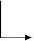

Engine crew

Third engineer

Second engineer

First engineer

Chief engineer

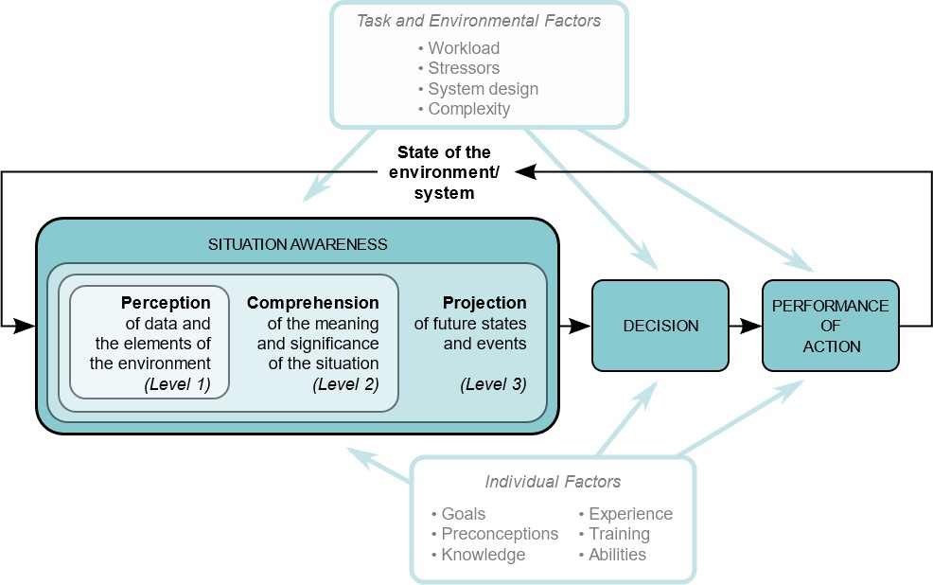

Figure A.8: Endsley model for situational awareness

thousands of years of evolution have provided us with a pretty good ability to recognize and make sense of things.

Whereas the human operator is more prone to environmental factors. Where workload is a big factor in the ability to concentrate and thus the ability to forecast future states and thus make the right decisions. The workload might be too high due to an overload of information [Speier et al. (1999)], when tasks are too easy [Washburn and Putney (2001)], or when limited attention is desired for a long time, and something unexpected happens [McMorris et al. (2018)].

These factors do only consider the single individual within the human operator team. But with larger ships there are multiple persons at the bridge, all with their own responsibilities. Research has shown that many of these crews have multiple cultures and nationalities work next to each other. Which often have a agreed working language which is not their first. This leads

not only to minor irritations. But in some cases to hazardous situations [Hetherington et al. (2006)]. Certainly when conversations happen via a radio with some noise.

### Procedures

To become a certified seafarer, different skills and knowledge must be acquired. The IMO has developed several conventions to standardize this knowledge globally, the International Convention on Standards of Training, Certification and Watchkeeping for Seafarers (STCW) is leading here. This ensures that ships sailing in international waters have skilled crew which know what they can expect from other vessels. This also means they have navigational abilities such as plotting on a radar. But they also have knowledge of the conventions and systems used for safe navigation. Below some of these are explained in more detail. Followed by a description of known flaws of these systems and differences when compared to procedures used in practice.

#### Convention on the International Regulations for Preventing Collisions at Sea (COLREGs)

The COLREGs set out the navigational to be followed by ships and other vessels at sea, to prevent collisions between two or more vessels. Although rules for navigating vessels inland may differ, the international rules specify that they should be as closely in line with the international rules as possible. In most of continental Europe, the Code Europ´een des Voies de la Navigation Int´erieure (CEVNI, or the European Code for Navigation on Inland Waters) apply. In the United States, the rules for vessels navigating inland are published alongside the international rules.

Prior to the development of a single set of international rules and practices, there existed separate practices and various conventions and informal procedures in different parts of the world, as advanced by various maritime nations. As a result, there were inconsistencies and even contradictions that gave rise to unintended collisions. Vessel navigation lights for operating in darkness as well as navigation marks also were not standardised, giving rise to dangerous confusion and ambiguity between vessels at risk of colliding. Different nations already came up with their own set of rules. But the first version was amended together with SOLAS in 1960. Additions were made including traffic separation schemes in 1972.

The COLREGs includes 41 rules divided into six sections: Part A - General; Part B - Steering and Sailing; Part C - Lights and Shapes; Part D - Sound and Light signals; Part E - Exemptions; and Part F - Verification of compliance with the provisions of the Convention. There are also four Annexes containing technical requirements concerning lights and shapes and their positioning; sound signalling appliances; additional signals for fishing vessels when operating in close proximity, and international distress signals.

Where part B is most relevant for this research, with subject like safe speed, obligation to determine risk of collision and take action with all means available, how to act in different situations with other ships, or in restricted waterways.

#### Standard Maritime Communication Phrases (SMCP)

As navigational and safety communications from ship to shore and vice versa, ship to ship , and on board ships must be precise, simple and unambiguous, so as to avoid confusion and error, there is a need to standardize the language used. This is of particular importance in the light of the increasing number of internationally trading vessels with crews speaking many different languages since problems of communication may cause misunderstandings leading to dangers to the vessel, the people on board and the environment.

In 1973 IMO started to develop the Standard Marine Navigational Vocabulary (SMNV), which was replaced by the SMCP in 2001. The ability to understand and use the SMCP is required for the certification of officers in charge of a navigational watch on ships of 500 gross tonnage or more. To assist in greater safety of navigation and of the conduct of the ship. To standardize the language used in communication for navigation at sea, in port-apporaches, in waterways, harbours and on board vessels with multilingual crews. Which is all instructed at maritime training institutions. These are not intended to supplant or contradict COLREGs or special local rules or recommendations made by IMO concerning ship routeing. Just as radiotelephone procedures should be followed strictly as set out in the ITU Radio Regulations.

* 1. *DIFFERENCE BETWEEN THEORY AND PRACTICE* 125

It is a collection of phrases used to standardize and simplify the communication, where synonyms and contracted forms are avoided. Some [examples of the usage of](http://www.segeln.co.at/media/pdf/smcp.pdf) SMCP are shown below, including message markers to indicate the type of message:

**Advice** Stand by on channel 6 - 8.

**Information** The fairway entrance is: position: bearing 1-3-7 degrees true from North Point Lighthouse, distance: 2 decimal 3 miles.

**Warning** Buoy number: one - five unlit.

**Intention** I intend to reduce speed, new speed: eight knots.

**Question** What are your intentions? **Instruction** You must alter course to starboard. **Request** Immediate tug assistance.

## Difference between theory and practice

In the previous section is described how different systems and components should function to form the bridge system. However this is not always the case. These exceptions should be taken into account when developing an unmanned vessel. It is not within the scope of this research to find all exceptions. But based on conversations with seafarers can some already be identified which are relevant for solving the problem with communication.

#### Natural language

The first challenge is the usage of a protocol. Every seafarer learns today the Standard Maritime Communication Phrases (SMCP). But during operation many natural language influences are used. This does include talking in the local language, for example Dutch in front of the ports in the North sea. This was one of the main issues during the collision between AL ORAIQ and FLINTERSTAR, as described in appendix C.1. Another example which occured when I sailed at inland waters was the usage of location descriptions. It is very common to tell at which point a decision is taken. Many of these locations exist on maps, but in some cases it also happens that area’s get names which are not written down on maps. For example was there a camping between Rotterdam and Dordrecht, which does not exist anymore. However the operators still refer to this bend as the camping. Autonomous systems

should be able to interpret natural language and recognize when manned vessel make natural language variations to known protocols. Or using completely different ontologies.

#### Incorrect AIS information

Another important issue is the usage of AIS, as mentioned on the VHF Data Exchange System (VDES) conference is AIS victim of its own success. Due to the popularity, more and more information is send over these radio frequencies. Limiting the number of AIS transmissions per ship per minute. Which automatically reduces the accuracy and relevance, as information is older. This make it harder to predict paths on the AIS information, therefor it is obligated to use Automatic Radar Plotting Aid (ARPA). This is however harder to interpret. Combining these would give very good information which can be used by the autonomous system. There is however another problem in this case. As shown by Loodswezen do some ships tweak the AIS information, in order to ensure that the officer of watch uses its ARPA. This can be seen in figure A.9. Here the vessel have an error of 150-200 meter compared to the ARPA. How to cope with this is not within the scope of this research, but is something which should be discussed within organizations, such as International Maritime Organization (IMO). As it will determine which solutions are possible.

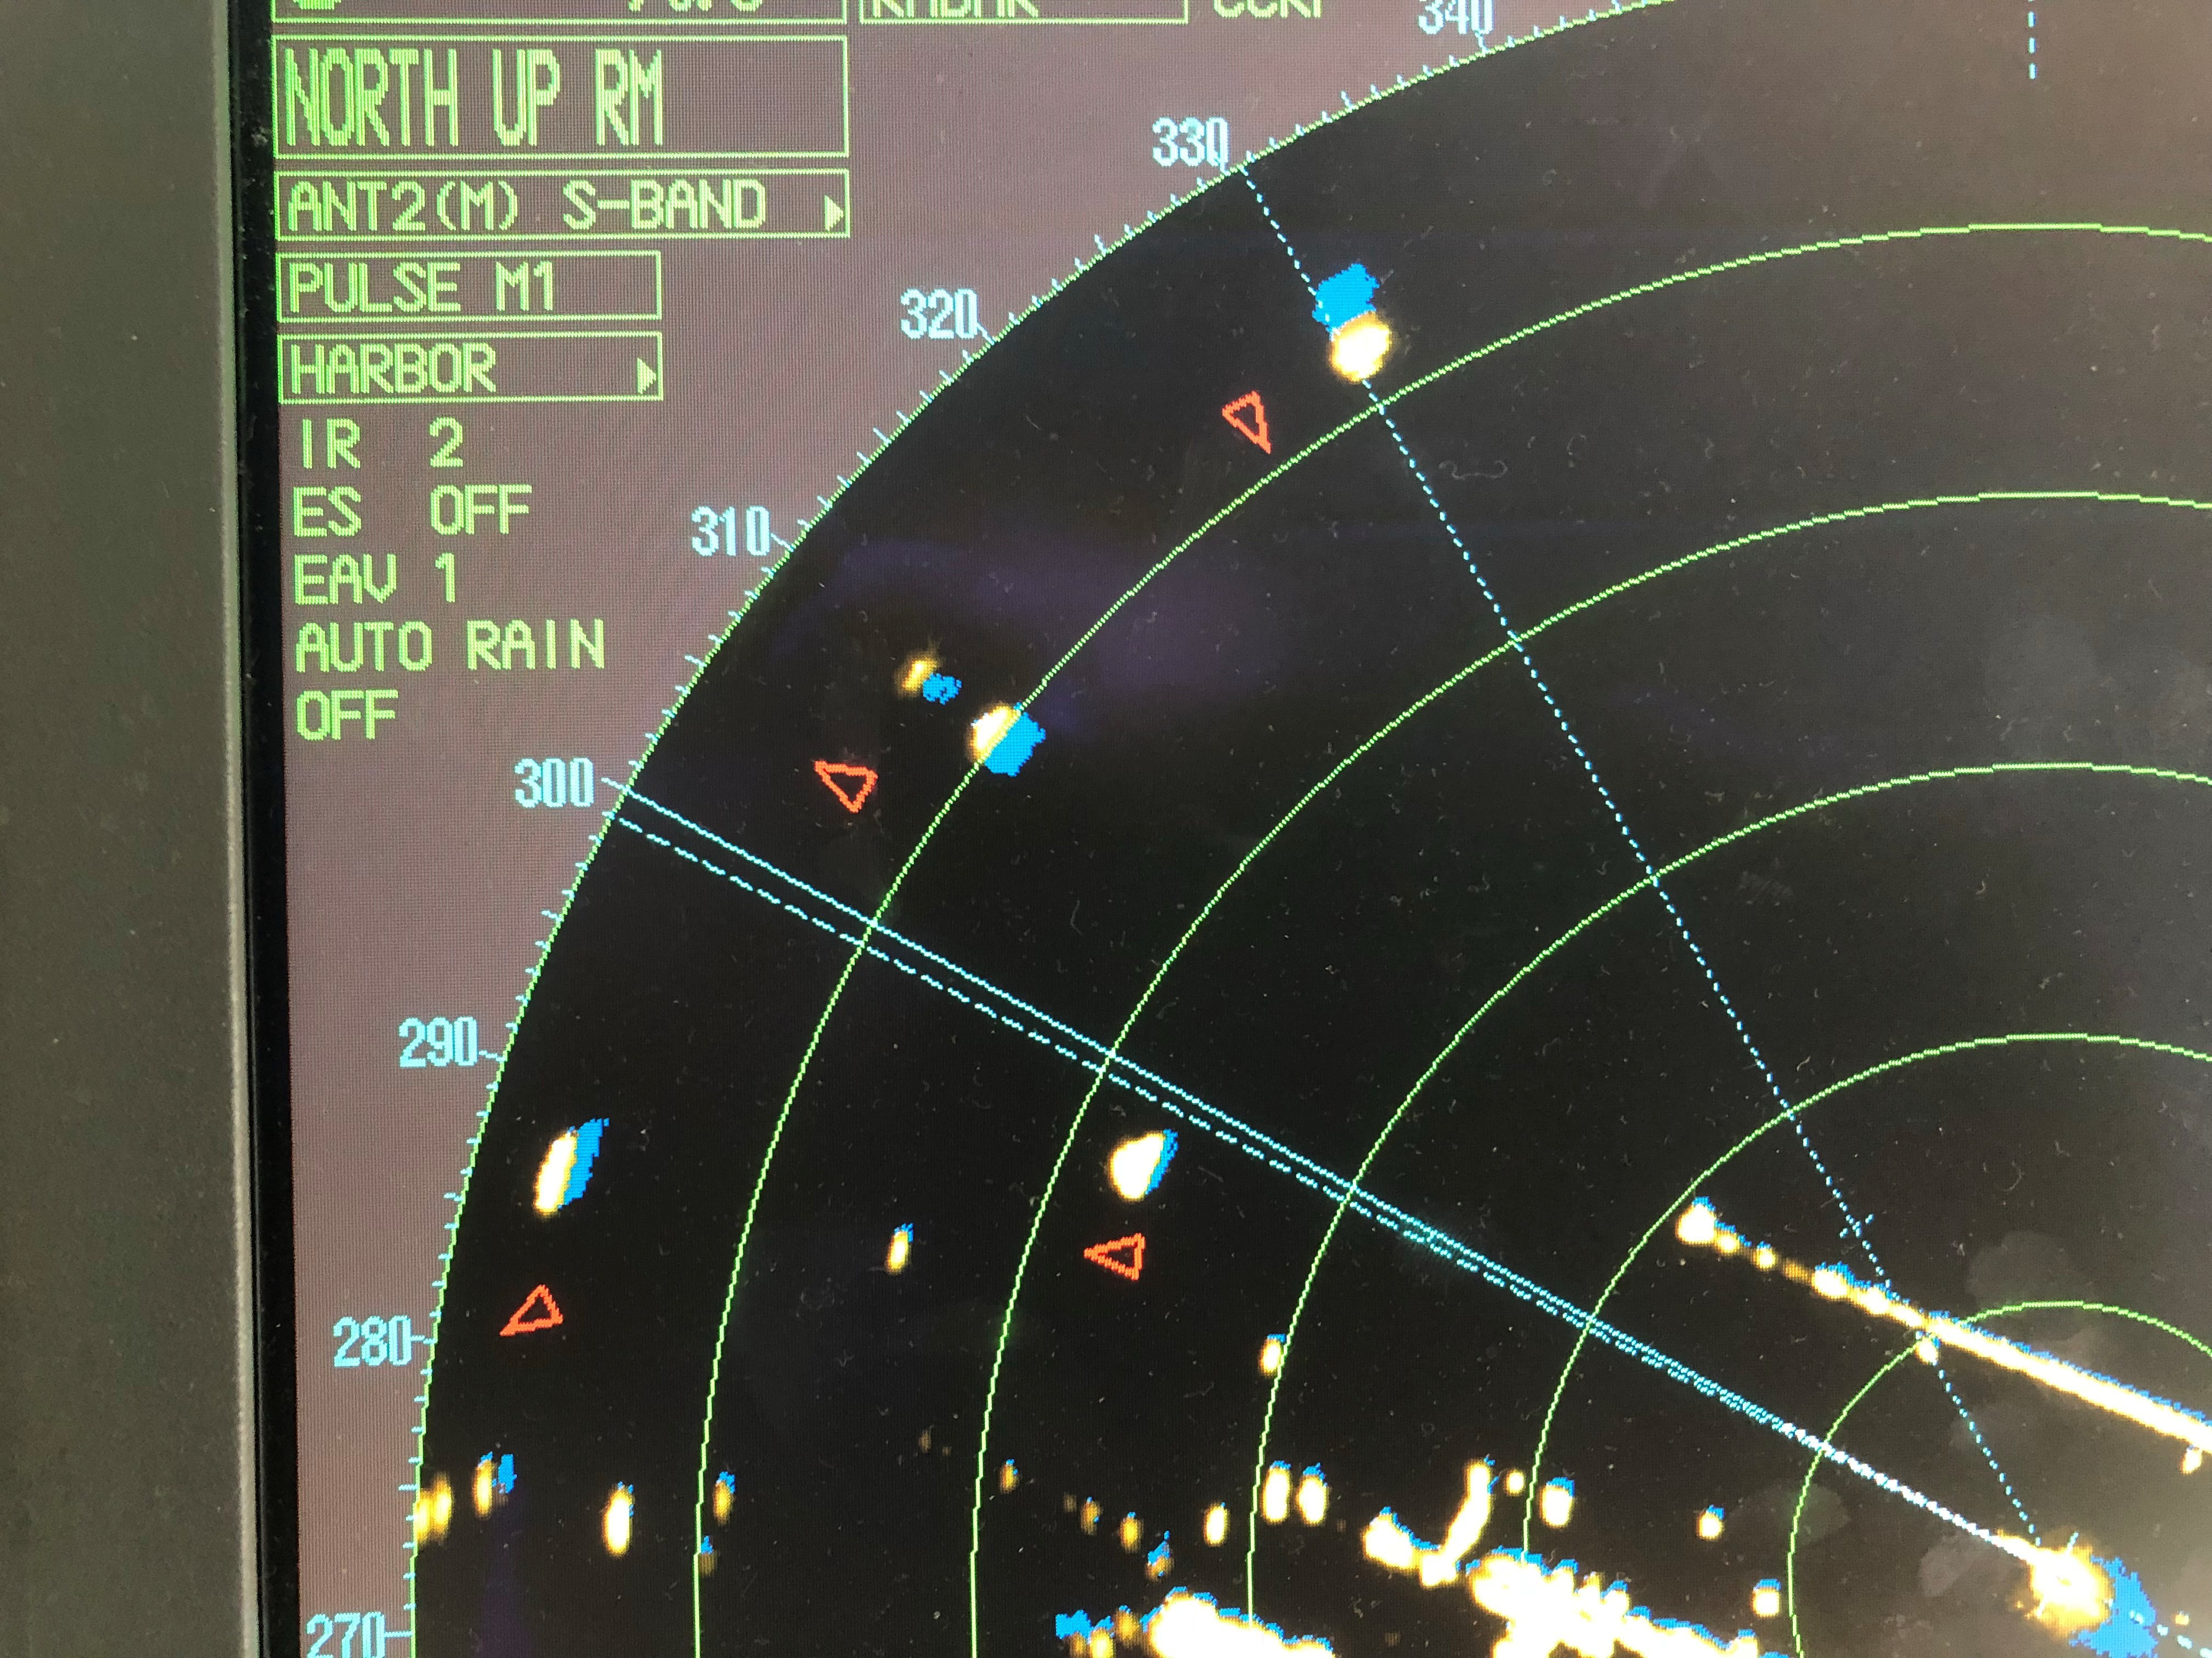

Figure A.9: Wrong AIS input when plotted on ARPA

* 1. *SUMMARY OF RELEVANT COMMUNICATION SYSTEMS* 127

## Summary of relevant communication systems

In the previous sections a lot of different systems are discussed. But not all these systems are relevant for the development of communication between manned and unmanned ships. In table A.1 the most relevant systems and technologies are discussed, this will be the basis for the envisioned technology. This only includes systems for the communication. Not the systems to make decisions and create situational awareness, such as the ECDIS and ARPA.

Radio communication Usage of message markers

Availability on VHF

Natural language variations on SMCP NATO phonetic alphabet and numbing AIS messages

Visible signals Light signals Mast head signals Flags

Heading, position and movements

Audible signals Horn Speakers

Table A.1: Current relevant systems and technologies

# *|* Simulation environment

This appendix will describe the development process of the simulation tool. This tool will be used to simulate situations and manoeuvers. For part II this is done to evaluate criteria for the decision model and problem identification. While part III aims to get expert feedback on the protocol.

The reason to use such a tool, is that full scale testing will cost much more money, time and effort, while it is harder to control. Only using algebraic solutions will give less insight, while introducing much more complexity. Therefore is chosen to build an application in which models can be simulated and tested numerically. A start is made with a basic tool, which will continuously be improved. Changes in requirements have appeared during the whole research. The code is written in such a way that it is easy to maintain and can be improved by using different modules.

## Foundation

The first step is to set the goals or requirements for the tool. This doesn’t mean it is a full description of the tool, but features it should at least have to be able to support the research. The most important requirement is that ships within the simulation behave similarly to ships in reality. Even when not all hydromechanics characteristics are known. But ships should have similar behaviors when turning or changing speed. This can be based on sea- trials and done using a mapping from current speed, current rotation, rudder angle and throttle to future speed and turning speed. This is combined with a model for hydrodynamic calculations by Artyszuk [Artyszuk (2016)], which is based on the often used 2*nd* order Nomoto model [Nomoto and Taguchi (1957)]. The second requirement should be that it is flexible. This means different scenarios can be added, tested and visualized easily. Thereby changing ship characteristics, shared information and other inputs. The third requirement is that it should be possible to predetermine run the simulation with pre-determined actions, paths and manoeuvers.

The next step is to define users stories from the requirements. User stories are in a form: *”As a [user] I want [action] so that [result]”*. Extending them with an acceptance criteria this will result in the features which should be implemented.

Within the tool there will be different roles. For which these user stories can be used. These can be split between users and objects. Below these are described:

129

* *Operator*. The person who set-up the simulation and fills in the different properties for the ships and specific scenario.
* *Viewer*. Someone who uses the application to view a specific scenario. Thereby trying to answer the research questions.
* *Ship*. Object in the map which is used by the simulation. But to work correctly it also had needs for information.

Some examples of those user stories are given below:

* As an operator, I want to add vessels to the map, by selecting them in a list, so that they become part of the simulation.

Acceptance criteria: Ship visualized and can be selected to operate.

* As an operator, I want to predefine a path, so that I can test manoeuvers. Acceptance criteria: Waypoints can be set and added.
* As a viewer, I want to see what intentions are of other ships when they sail automated. Acceptance criteria: Waypoints are shown on the map.
* As a ship, I want to be manoeuvrer in a realistic way, so that the simulation is relevant for real-life situation.

Acceptance criteria: Hydrodynamic model is validated.

### B.1.1 Software architecture

Based on the above described requirements and user stories, different modules are defined. Using the ”model-view-controller” design pattern, has resulted in the following general modules:

**World** The world is the class in which everything happens. Thus a kind of facade.

**Simulation** The simulation adds processes which are relevant for simulating situations in real- time. This also means that it ensures the right steps are taken at the right moment, such as updating the GUI and moving ships around. Thereby does it coordinate which objects are active within the simulation

**Viewer** This module only listens to the world to check if things change. This is shown in the GUI. Also without this visualization the simulation will still be able to run.

**DynamicObject** Here the used ships are defined which can be used in the simulation.

The above modules are for the general functionality of the tool. The implementation of more specific functions are in the following modules:

**Ship** Ships are used in the simulation. Within this module is stored how the ships look and their characteristics such as its safety domain.

**ManoeuvringModel** The manoeuvring model only contains a single method, in which each numerical step is calculated. Thus it receives a ship, the ships current situation and the time-step. It finally returns the new speed, course, heading and location. Thereby does it check if the input values are correct. It does not matter in which world it is, or how it is visualized.

**Gonio** Some calculations have to be done many times, such as rotating points and polygons around another point. This is can be done in the Gonio module.

For the specific implementation of both parts of this research, two packages are used: Testing manoeuvers (MTexperiment) and scenario descriptions for the expert reviews (Scenarios).

The MTexperiment uses a bit different design pattern, as the goal is to have as many simulations as possible in the shortest time. Where only the final result is visualized. This is acquired by using a module with general functions such as ship creation, manoeuvrer ship and store the results. While other modules are used to define the tests, select the executed tests and plot the results.

For the expert reviews, the GUI is very important. The Scenarios package contains all different scenarios which can be used for the expert review. In those scenario descriptions the objects used are defined, both static and dynamic object (e.g: ships). Also is given which waypoints ships should use and which part of the map is shown.

This is done to make the code readable and make sure that is known what is happening where. Using these modules enabled me to work efficiently and improve parts, without having the risk that other parts will break. For even better maintainable code, the tool could be split up in more packages and classes. This would however result in much more time, without improving the result of this research.

## B.2 Design specifications

The theory behind the specific modules is described in this section. This will include the necessary information for a ship which have to be added, information on the environment and the hydrodynamic model.

### B.2.1 Ship description

The key characteristics for a ship are given in table B.1. Beside these input values, there are also the information stored by the simulation about the vessel. These are described in table

* 1. and included in the Ship object.

|  |  |  |
| --- | --- | --- |
| Input | Unit | Description |
| Name | - | The name of the vessel |
| Color | - | Color of the vessel as shown in visualization |
| MMSI | - | Unique identification number |
| LBP | meter | Length of the vessel between perpendiculars |
| Width | meter | Width of the vessel |
| Draft | meter | Current draft of the vessel |
| Displacement | metric ton | Its weight based on the amount of water its hull displaces |
| Nominal speed | knots | The speed the ships sails on average |
| Max speed | knots | The maximum possible speed on flat water |

Table B.1: Input for ship characteristics

|  |  |  |
| --- | --- | --- |
| Input | Unit | Description |
| Last Update | seconds | Time in simulation at last update of location |
| Location | [meter, meter] | X and Y position |
| Course | degrees | Course, thus direction of movement |
| Heading | degrees | Heading, thus direction of bow |
| Drift | degrees | Difference between course and heading |
| Speed | knots | Current speed |
| Inertia turning | radians/second2 | Inertia due to rotational movements |
| Acceleration | meter/second2 | Inertia due to mass moving |
| Telegraph speed | % | Speed-setting at bridge |
| Rudder angle | degrees | Angle of rudder from straight |
| Waypoints | [meter, meter] | X and Y postion of waypoints |
| GUI objects | - | Objects describing what should be plotted, such as direction |
|  |  | arrow, ship shape, safety domain, etc. |

Table B.2: Ship details from simulation

### Controller

Based on the waypoints there is a simple controller to adjust the rudder angle automatically. This controller steers based on the relative angle between the next waypoint and the current position. This is done in the *adjustRudder* function. The distance and relative angle is calculated, this is used in a simple decision tree to decide on the rudder angle, which is similar to a so-called ”proportional controller”. To enable ships to sail around automated,

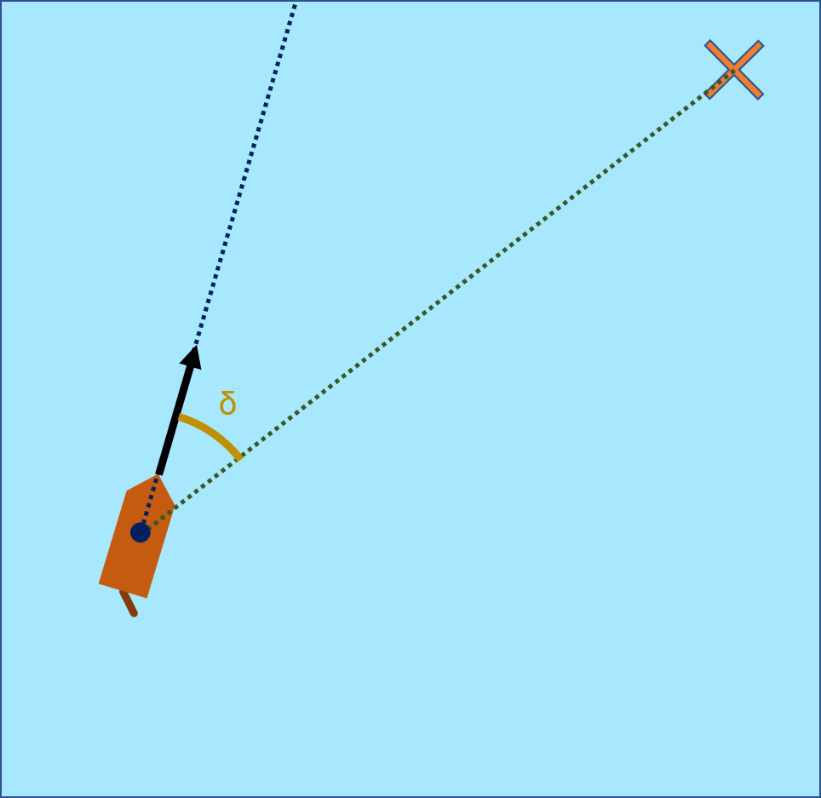this is sufficient and gives enough accuracy. For a better result, a ”PID-controller” could be implemented. In table B.3 the criteria for the decision tree are shown. Where the relative angle is the angle between the current course and the angle to from the current position to the waypoint.

Relative angle (0) Rudder angle (0)

25-180

10-25

0-10

35

25

0.8 x Relative angle

Table B.3: Rudder angle based on relative angle Figure B.1: Calculation of relative angle

This controller is limited due to the maximum turning rate of the rudder. This is discussed in multiple publications. Based on regulations from IMO the rudder should at least turn with 2,3 deg/second. But in reality this is often closer to 3 degrees/second [Molland and Turnock (2007)]. The value used by Artyszuk is 2,5 degrees/second [Artyszuk (2016)]. When validating the model with the sea-trials, it seems that 3 degrees/second gave the most realistic results. Thus this has been used during the evasive manoeuvers and other experiments.

### Manoeuvring

Ship manoeuvring is the ability to keep course, change course, keep track and change speed. Minimal requirements are given by IMO standard. However, shipowners may introduce additional requirements. Ship manoeuvrability is described by the following characteristics:

* + - * Initial turning ability (start turning)
      * Sustained turning ability (keep turning)
      * Yaw checking ability (stop turning motion)
      * Stopping ability (in rather short distance and time)
      * Yaw stability (ability to move straight ahead)

During sea-trials these capabilities can be determined. However this project will aim at predicting manoeuvrability while using limited input. Thereby is there a difference between the maximum limits and what a ship is likely to do. This will eventually lead to the possible movements of the vessel.

#### IMO standard

The manoeuvrability of a ship is considered satisfactory is the following criteria are complied:

1. *Turning ability*. The advance should not exceed 4.5 ship lengths (L) and the tactical diameter should not exceed 5 ship lengths in the turning circle manoeuvre.
2. *Initial turning ability*. With the application of 100rudder angle to port or starboard, the ship should not have traveled more than 2.5 ship lengths by the time the heading has changed by 100from the original heading.
3. *Yaw-checking and course-keeping abilities*.
   1. The value of the first overshoot angle in the 100/100zig-zag test should not exceed:
      1. 100if L/V is less than 10 seconds
      2. 200if L/V is 30 seconds or more
      3. (5 + 1/2(L/V)) degrees if L/V is between 10 and 30 seconds where L and V are expressed in m and m/s, respectively.
   2. The value of the second overshoot angle in the 100/100zig-zag test should not exceed:
      1. 250if L/V is less than 10 seconds
      2. 400if L/V is 30 seconds or more
      3. (117.5 + 0.75(L/V)) degrees if L/V is between 10 and 30 seconds
   3. The value of the first overshoot angle in the 200/200zig-zag test should not exceed 250.
4. *Stopping ability*. The track reach in the full astern stopping test should not exceed 15 ship lengths. However, this value may be modified by the Administration where ships of large displacement make this criterion impracticable, but should in no case exceed 20 ship lengths.

#### Emperical model

To describe manoeuvring correctly a hydrodynamic model is needed. Using an emperical model, instead of a fully physical correct model shortens the implementation time. By validating the model with known data from sea-trials, can be determined if the accuracy of the model is sufficient for the tests. The model used is described by Artyszuk [Artyszuk (2016)].

This linear dynamic higher-order model is based on the 2*nd* order Nomoto model [Nomoto and Taguchi (1957)].

The input for this model is based on different papers and real-life comparisons, in order to be able to simulate the ships as accurately as possible. It is a numerical model. Which means the input for the manoeuvring function is a ship and a time-step.

The first step is to gather relevant ship characteristics and the current state of the vessel, as shown in table B.4

Using this information, an estimation can be made about the acceleration. An estimate of the forces is used in this case. Where two forces are calculated, propelling force and resistance. The propelling force is based on the setting of the telegraph and drift angle which determine the steady state speed. This is multiplied with a force factor to get the right results. The resistance depends on the current ship speed and a force factor. The difference between these two determine if the ship is able to accelerate and how much. Thereby is there a filter which limits the maximum acceleration due to inertia. This eventually results in a new ship speed.

Parallel to this calculation, a new course and heading is calculated. Based on the course, heading, manoeuvring characteristics and rudder angle. Different dimensionless factors are used, these are given in table B.5. When more information on the hydrodynamics of a vessel is known, these input can be adapted. These inputs are validated for some of the used vessels, the resulting values did not differ significantly. This was most notable when running the different sea-trials with variable inputs. The ship characteristics had a much bigger influence. Although the impact of extreme changes in the rudder configuration have been looked into. The full calculation is discussed by Artyszuk [Artyszuk (2016)].

### Numerical settings

The simulation environment uses a numerical model. This means that the results are highly influenced by the input values. Two of these inputs are the time-step during the simulations and the moment the rudder is changed to limit the overshoot in the critical evasive manoeuvrer.

#### Time-step for simulation

The time-step has a big influence on the quality of the simulation and runtime. When the time-step is too large, the results of the calculations are wrong. But when the timestep is too small, the runtime becomes too large. This trade-off must be made, to do this in a substantiated way, different tests are done for different time-steps. The key performance indicator is the error of the final position and maximum course for an evasive manoeuvrer.

Angle between course and heading

|  |  |  |
| --- | --- | --- |
| Input | Unit | Description |
| Length | meter | Length of the vessel |
| Width | meter | Width of the vessel |
| Cb  Drift | -  degrees | Block coefficient (*displacement/L · B · T* ) |
| Inertia turning | radians/second2 | Inertia due to rotational movements |
| Speed | knots | Current speed |
| Telegraph speed | % | Speed-setting at bridge |
| Rudder angle | degrees | Angle of rudder from straight |

Table B.4: Input for manoeuvring model

Propeller wake fraction

|  |  |  |
| --- | --- | --- |
| Name | Value | Description |
| *k*11 | 1.004 | Sway added mass coefficient |
| *rz* | 0.247 | Ship’s gyration dimensionless radius |
| *r*66 | 0.225 | Added gyration dimensionless radius |
| *Yb* | 0.0043 | Hull hydrodynamic derivatives |
| *Yw* | 0.0260 | Hull hydrodynamic derivatives |
| *Nb* | 0.0024 | Hull hydrodynamic derivative including Munk moment contribution |
| *Nw* | -0.0630 | Hull hydrodynamic derivatives for moment |
| *AR*  *w* | 0.0177  0.326 | Dimensionless rudder ratio (*Ar/*(*L ∗ T* )) |
| *cT h*  *∂CL/∂a* | 2.127  0.0385 | Thrust coefficient propeller  Rudder lift coefficient derivative, which depends on *α* and *cT h* |
| *aH* | 2.5 | Empirical factor for rudder force due to hull-rudder interaction |
| *cRy* | 1.0 | Empirical multiplier to the rudder geometric local drift angle |
| *xRef f* | -0.5 | Effective rudder longitudinal position |

Table B.5: Dimensionless coefficients based on Artyszuk

This is determined by calculating the difference between a time-step and a very small time- step (0.00001 second per step). This is done for different ship types. The error in passing distance varied from 0.002 when using 0.001 seconds, to 20 meters when using 1 second as time-step. Being within 0.5 meter gives a result where other factors, such as the quality of the hydrodynamic model, will have a much larger impact on the results. This is the case for a time-step below 0,01 seconds. Therefor is this used during the simulations. The error in the resulting overshoot for a time-step of 0.01 seconds, for all ships below 0.02%.

#### Change time for critical evasive manoeuvrer

The change time determines when commands should be given. The optimal change time is when the least time is needed to increase the closest point of approach as much as possible. As this is most relevant for critical situations. To evaluate this criteria the change time has been tested for multiple vessels. The used criteria is the distance to the side (Y), divided by the advanced distance (X) (as shown in figure 6.3a). This is plotted against the time it took to make the manoeuvrer. From left to right a 140-meter container vessel, a 250-meter Tanker and a 400-meter cargo vessel are used. The results are shown in figure B.2.

The optimal change time should be at the upper left corner. As this means the increase of the passing distance and thereby the CPA is as big as possible, in the shortest time and traveled distance. When looking at the figure can be seen that this is the case around 18 seconds. Where should be noted that larger vessels have a larger optimal change time. This can be explained by the larger inertia of these vessels. A higher speed has a similar result. The effect of these larger change times is however very small compared to other factors. Examples of these factors are the maximum turning rate of the rudder or rudder-hull interaction coefficient. Therefore is chosen to use a single change time for the evasive manoeuvrer tests. The chosen change time is 18 seconds.

## Build

In this section the final tool will be discussed. Thereby showing what outputs can be generated and how the simulation environment can be viewed. Thereby also discussing shortly how the simulation can be controlled by the user and what the simulation does by itself.

### User interface

The simulation environment uses a tkinter GUI. This GUI has three parts. A big block which shows the map with vessel, speed vector, safety domains, land masses and forbidden zones. Using the buttons in the bottom left the map can be changed, this means moving around and zooming. At the bottom is an information bar which gives information on the current status of the simulation and possible actions. At the right of the screen is the control panel. Here can the user select if he want to modify the simulation or sail around. When in modify mode, the ships can be added, removed or edited. When sailing, only the rudder angle and RPM of the engine can be changed. Thereby is it also possible to add waypoints, so the ship will sail automatically. Further some basic information is shown, such as the speed [knots], course [degrees] and rudder angle [degrees]. This can be seen in figure B.3.

### Output

Besided simulations within this GUI, it is also possible to execute them without showing the map. This will limit the computational time. To visualize these results, different outputs are stored. These are logged during the simulation. The outputs are stored in a dictionary, so they can be labeled easily. Table B.6 shows the different outputs for the simulation. These outputs can be plotted as scatter, path or line plots. These are shown in chapter 6. This makes it possible to test manoeuvers many times with small variances. The configured tests are described in table B.7.

### Level of implementation

Currently is a hydro model implemented based on [Artyszuk (2016)]. This makes it possible to have realistic behavior of the vessels in flat water. Thereby is it possible to steer the ship in a similar manner to current bridge operation. Thus by setting the RPM of the engine(s) and changing the rudder angle.

Thereby is there also an automated way, which helps to steer the ship automatically via predefined waypoints. Thereby does it not take into account where other vessel sail, or how the map looks like. The distance between vessels is calculated continuously, which gives warnings when ships are too close. This will however not lead to an actual crash, nor does a crash happen when getting to close to land masses in the map.

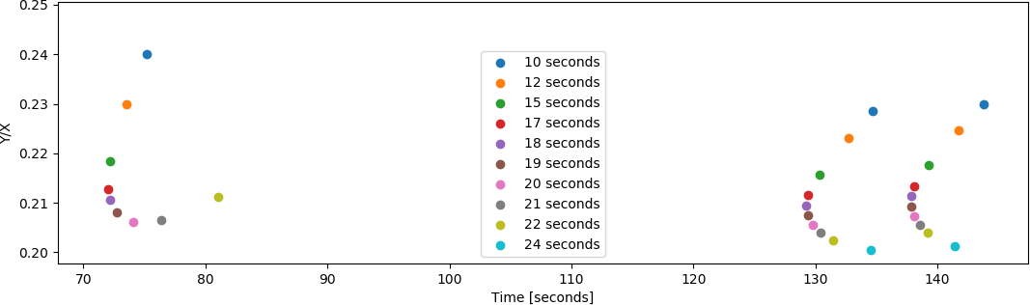

Figure B.2: Change time during evasive manoeuvrer for different ship types



Figure B.3: Simulation environment

|  |  |  |
| --- | --- | --- |
| Label | Type | Description |
| Shipname | string | Name of ship which is subject of test |
| Testname | string | Exectued test with details about input |
| Start speed | float | Initial speed of vessel before manoeuvrer |
| Time | integer | Variable which stores the simulated time |
| Timestep | float | Time per numerical step |
| Location | list | X and Y location of vessel in environment |
| Speed | list | Speed of vessel at every time-step |
| Acceleration | list | Acceleration of vessel at every time-step |
| Course | list | Course of vessel at every time-step |
| Heading | list | Heading of vessel at every time-step |
| Drift | list | Course - heading of vessel at every time-step |
| Set rudder angle | list | Set rudder-angle of vessel at every time-step |
| Real rudder angle | list | Real angle of rudder at every time-step |
| Manoeuvrer specific | - | Resulting passing distance, max angle, overshoot, |
|  |  | calculated passing distance, speed other vessel, turning |
|  |  | circle, advance distance, etc. |

Table B.6: Different manoeuvring tests

Name Goal

Sea-trial Execute zig-zag and turning circle test

Rudder test Test performance of rudder and how it responds Evasive manoeuvrer Compare behavior for different angles

Change time Test correct moment to start rotating rudder

Timestep Compare the quality of simulation using different time-steps Random Determine effectives of evasive manoeuvrer to increase the

crossing distance and CPA

Table B.7: Different manoeuvring tests

# *|* Accidents

In the last centuries much have changed to improve the safety of vessel and decrease the risk for collision. Some were reactions to major accidents which occurred. Such as the disaster with the TITANIC in April 1912, which triggered the development of SOLAS. But also new innovations, such as the introduction of Global Positioning System (GPS), ARPA and AIS. But still accidents occur. To get insight what could result in hazardous situations. Four accidents are discussed, showing the importance of proper communication on different levels. The accidents which will be discussed are:

* Collision between MV AL ORAIQ and MV FLINTERSTAR
* Collision between MV ARTADI and MV ST-GERMAIN
* Collision between USS FITZGERALD and MV ACX CRYSTAL
* Collision between USS JOHN S MCCAIN and MV ALNIC MC
* Collision between MV CONTI PERIDOT and MV CARLA MAERSK

141

## MV AL ORAIQ and MV FLINTERSTAR

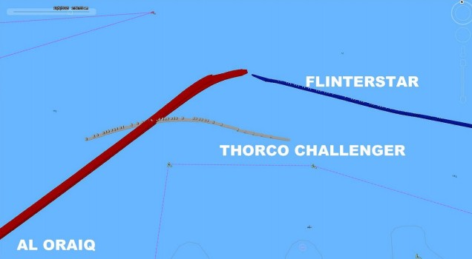During the night between 5th and 6th of October 2015 at the Northsea near Zeebrugge, a collision occurred between the LNG tanker AL ORAIQ and Dutch cargo ship FLINTERSTAR. The FLINTERSTAR sank almost immediately as a result of the collision, an illustration of the accident is shown in Figure C.1. The captain of the FLINTERSTAR was badly injured in the incident, the other ten people on board and the pilot were rescued out of the water unharmed.

Figure C.1: Illustration of collision MV AL ORAIQ and MV FLINTERSTAR

The collision occurred because the bridge team on board of the AL ORAIQ wrongly assessed the traffic situation, vessel’s speed and distance from the S3 buoy, prior to contacting the nearby vessel Thorco Challenger. After informing the Thorco Challenger, did they pass on the starboard side. On board of AL ORAIQ were coastal pilots which did not receive feedback from the watch keepers, nor was there feedback from other vessels via VHF radio. The communication via VHF radio was mostly in dutch, the officer on duty at AL ORAIQ did not request the Coastal pilots to translate. Also did the bridge watch team not assess the situation properly, leading to very little situational awareness. On board of the FLINTERSTAR there was insufficient attention for watch keeping duties. As several VHF radio communications between Traffic Centre Zeebrugge and other participants within the area monitored by Traffic Centre Zeebrugge, concerning or involving the presence of an inbound LNG carrier were missed by the Pilot and other crew at the bridge on board the FLINTERSTAR.

The pilot on board of AL ORAIQ did not attempt to work together with the crew. Thereby making decisions without consulting the crew, such as overtaking other vessels. The sea pilot on board of the FLINTERSTAR got engaged in a casual conversation with the officer of the watch, drawing his attention away from monitoring the traffic situation. The Sea Pilot was advising the officer of the watch from what appeared to be routine. [Backer (2015)]

## MV ARTADI and MV ST-GERMAIN

An example where the COLREGs were followed but still resulted in two persons killed is the collision between MV ARTADI and MV ST-GERMAIN on February 21st, 1979. The Liberian bulk carrier ARTADI collided with the passenger ferry ST-GERMAIN in the Dover Strait, killing two people and injuring four more. An illustration of the accident is shown in figure

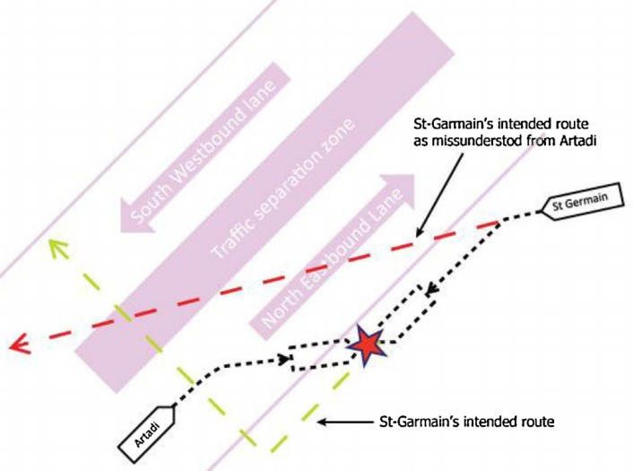C.2. Both ships followed COLREGs according to the accident report. Due to a lack of communication and wrong presumptions on the intentions, did the accident occur.

Figure C.2: Illustration of collision between MV ARTADI and MV ST-GERMAIN

The ferry was spotted in good time on the radar of the ARTADI. Coming from starboard, ST-GERMAIN was the stand-on ship according to rule 15 of the COLREGs. The pilot and master of the ARTADI expected her to keep speed and course and started to make a starboard turn to give way. However, on-board the ST-GERMAIN the intention was not at all to cross the traffic separation scheme diagonally in front of ARTADI, but instead to turn port and follow outside the boarder of the NE going traffic lane until the traffic cleared and she could make the crossing at a right angle (according to rule 10c) [Porathe et al. (2013)].

## USS FITZGERALD and MV ACX CRYSTAL

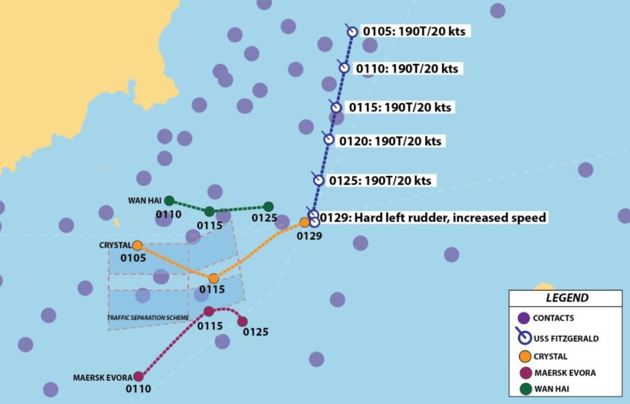A more recent collision was between the USS FITZGERALD and ACX CRYSTAL on June 17, 2017. The US destroyer hit the Philippines container vessel, resulting in the death of 7 US Sailors. An illustration of the accident is shown in figure C.3. According to the accident report did failures occur on the part of leadership and watch-standers. There were failures in planning for safety, adhere basic navigational practice, execute basic watchstanding practice, proper use of available navigation tools and wrong responses.

Figure C.3: Approximate collision location USS FITZGERALD and MV ACX CRYSTAL

In accordance with international rules, the USS FITZGERALD was obligated to manoeuvrer to remain clear from the other crossing ships. The officer of the deck responsible for navigation and other crew discussed whether to take action but choose not to, till it was too late. While other crew members also failed to provide more situational awareness and input to the officer of the deck. Did the officer of the deck, exhibit poor seamanship by failing to manoeuvrer as required, failing to sound the danger signal and failing to attempt to contact CRYSTAL on Bridge to Bridge radio. In addition, the Officer of the Deck did not call the Commanding Officer as appropriate and prescribed by Navy procedures to allow him to exercise more senior oversight and judgment of the situation. This was prescribed to an unsatisfactory level of knowledge of the international rules of the nautical road by USS FITZGERALD officers. Thereby were watch team members not familiar with basic radar fundamentals, impeding effective use. Thereby were key supervisors not aware of existing traffic separation schemes and the expected flow of traffic, as the approved navigation track did not account, nor follow the Vessel Traffic Separation Scheme. Secondary was the automated identification system not used properly. [US Navy (2017)]

## USS JOHN S MCCAIN and MV ALNIC MC

Even more recent is the collision between the USS JOHN S MCCAIN and ALNIC MC on August 21st, 2017. The US Destroyer hit the Liberia flagged oil and chemical tanker. Resulting in the death of 10 US Sailors. An illustration of the accident is shown in figure C.4. According to the accident report did the US Navy identify the following causes for the collision: Loss of situational awareness in response to mistakes in the operation of the USS JOHN S MCCAIN’s steering and propulsion system, while in the presence of a high density of maritime traffic. Failure to follow the international nautical rules of the road, which govern the manoeuvring of vessels when risk of collision is present.

Leading up to the accident did the commanding officer notice that the helmsman had difficulties maintaining course, while also maintaining control over speed. In response, he ordered the watch team to divide the duties of steering and speed control. This unplanned shift caused confusion within the watch team, which led to wrong transfers of control, where the crew was not aware of. Watchstanders failed to recognize the configuration. The steering control transfer caused the rudder to go amidships (centerline). Since the Helmsman had been steering less than 4 degrees of right rudder to maintain course before the transfer, the amidships rudder deviated the ship’s course to the left. Additionally, when the Helmsman reported a loss of steering, the Commanding Officer slowed the ship to 10 knots and eventually to 5 knots. Due to the wrong transfer did only one shaft slow down, causing an un-commanded turn to the left (port). The commanding officer and others on the ship’s bridge lost situational awareness. They did not understand the forces acting on the ship, nor did the understand the ALNIC’s course and speed relative to USS JOHN S MCCAIN. Three minutes after the reported loss of steering, was it regained, but already too late to avoid a collision. No signals of warning were send by neither ship, which are required by international rules of the nautical road. Nor was there an attempt to make contact via VHF bridge-to-bridge communication. Many of the decisions made that led to the accident were the result of poor judgment and decision making of the commanding officer. That said, no single person bears full responsibility for this incident. The crew was unprepared for the situation in which they found themselves through a lack of preparation and ineffective command and control. Deficiencies in training and preparations for navigation were at the base of this. [US Navy (2017)]

## MV CONTI PERIDOT and MV CARLA MAERSK

The last accident which will be discussed is the collision between MV CONTI PERIDOT and MV CARLA MAERSK on 9th March 2015. At 12:30 central daylight time, the the inbound bulk carrier CONTI PERIDOT collided with the outbound tanker CARLA MAERSK in the Houston Ship Channel near Morgan’s Point, Texas. The collision occurred in restricted visibility after the pilot on the CONTI PERIDOT was unable to control the heading fluctuations that the bulk carrier was experiencing during the transit. As a result, the CONTI PERIDOT crossed the channel into the path of the CARLA MAERSK. No one on board either ship was injured in the collision, but an estimated 2,100 barrels (88,200 gallons) of methyl tert-butyl ether spilled from the CARLA MAERSK, and the two vessels sustained about $8.2 million in total damage. In figure C.5 the fluctuations in heading can be seen of the CONTI PERIDOT.

Several safety issues were identified by the National Transportation Safety Board. Inadequate bridge resource management: Despite the pilot’s difficulty controlling the CONTI PERIDOT’s heading leading up to the collision, he and the master did not work together to solve the problem. The pilot did not involve the master because he was unsure whether the master could do anything to help; the master said nothing because he was likely unaware of the vessel’s heading fluctuations and may have been generally reluctant to question the pilot. Insufficient pilot communications: Although the pilot on the CONTI PERIDOT was having difficulty controlling the vessel and had an earlier near-miss meeting with an oncoming ship, he did not alert the pilots on subsequent oncoming vessels, including the CARLA MAERSK. Lack of predetermined ship movement strategies during restricted visibility in the Houston Ship Channel: On the day of the accident, local pilot associations determined that the increasing fog was significant enough to suspend pilot boardings of inbound ships. However, piloted vessels already under way continued the transit in the fog. Investigators found no existing predetermined ship movement strategy for piloted vessels already under way at the onset of hazardous weather conditions.

The National Transportation Safety Board determines that the probable cause of the collision between bulk carrier Conti Peridot and tanker Carla Maersk in the Houston Ship Channel was the inability of the pilot on the Conti Peridot to respond appropriately to hydrodynamic forces after meeting another vessel during restricted visibility, and his lack of communication with other vessels about this handling difficulty. Contributing to the circumstances that resulted in the collision was the inadequate bridge resource management between the master and the pilot on the Conti Peridot. [NTSB (2016a)][NTSB (2016b)]

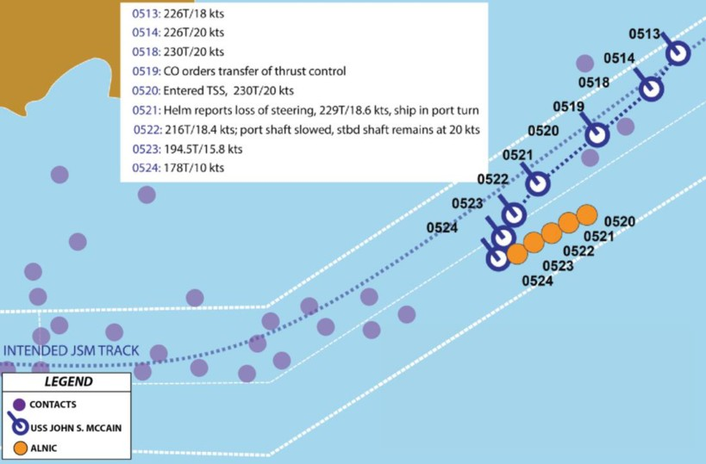

Figure C.4: Approximate collision location USS JOHN S MCCAIN and MV ALNIC MC

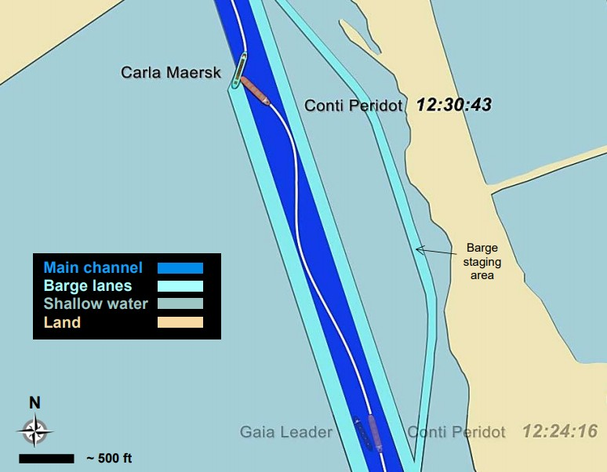

Figure C.5: Illustration of collision MV CONTI PERIDOT and MV CARLA MAERSK

## Lessons learned

In all of the above described accidents, mistakes were made. But in all cases was there not sufficient communication, to warn the other vessel. If this would have happened, they could have taken actions to avoid the collision. In order to achieve effective communication, there should be an universal protocol. This protocol should be used under all circumstances. Thereby is it important that all seafarers understand this protocol, and are able to work with it. Communication with this protocol should be engaged in all cases when there is any doubt if intentions are understood, or if full control over the situation is lost. This is also part of proper bridge resource management. Where a good balance of crew should be at the bridge, to avoid overload. But more importantly also avoid the bystander effect in cases there are too many [Fischer et al. (2011)]. The crew that is available at the bridge should be aware of forces acting on the vessel, the effect of these forces and notice when the ship does not act as expected. In these situations an emergency protocol or strategy should be executed, which is known by all active crew members.

*C.6. LESSONS LEARNED* 149

# Bibliography

[Adamson (2003)] Peter Adamson. *Review: Epictetus: A Stoic and Socratic Guide to Life*.

2003. ISBN 0199245568 (alk. paper). doi: 10.1093/mind/112.446.363.

[Arimura et al. (2001)] Hiroki Arimura, Hiroshi Sakamoto, and Setsuo Arikawa. *Lecture Notes in Artificial Intelligence*, volume 2225. 2001. ISBN 3540679154. doi: 10.1007/ 978-3-642-29066-4*{ }*11.

[Artyszuk (2016)] Jaroslaw Artyszuk. Inherent Properties of Ship Manoeuvring Linear Models in View of the Full-mission Model Adjustment. *TransNav, the International Journal on Marine Navigation and Safety of Sea Transportation*, 10(4):595–604, 2016. ISSN 2083-6473. doi: 10.12716/1001.10.04.08. URL [http://www.transnav.eu/](http://www.transnav.eu/Article%7B_%7DInherent%7B_%7DProperties%7B_%7Dof%7B_%7DShip%7B_%7DManoeuvring%7B_%7DArtyszuk%2C40%2C683.html) [Article{_}Inherent{_}Properties{_}of{_}Ship{_}Manoeuvring{_}Artyszuk,](http://www.transnav.eu/Article%7B_%7DInherent%7B_%7DProperties%7B_%7Dof%7B_%7DShip%7B_%7DManoeuvring%7B_%7DArtyszuk%2C40%2C683.html) [40,683.html](http://www.transnav.eu/Article%7B_%7DInherent%7B_%7DProperties%7B_%7Dof%7B_%7DShip%7B_%7DManoeuvring%7B_%7DArtyszuk%2C40%2C683.html).

[Austin (1975)] J.L. Austin. *How to Do Things with Words*. Harvard University Press, Cambridge, MA, 2nd edition, 1975.

[Backer (2015)] Philippe D E Backer. Report on the joint investigation of the collision between the LNG Carrier mts AL ORAIQ and the mv FLINTERSTAR. Technical Report October, 2015.

[Bernard Marr (2017)] Bernard Marr. Rolls-Royce And Google Partner To Create Smarter, Autonomous Ships Based On AI And Machine Learning, 2017. URL [https://www.](https://www.forbes.com/sites/bernardmarr) [forbes.com/sites/bernardmarr](https://www.forbes.com/sites/bernardmarr).

[Blanke et al. (2017)] Mogens Blanke, Michael Henrique, and Jakob Bang. A pre-analysis on autonomous ships. pages 1–27, 2017. URL [https://www.dma.dk/Documents/](https://www.dma.dk/Documents/Publikationer/Autonome%20skibe%7B_%7DDTU%7B_%7Drapport%7B_%7DUK.pdf) [Publikationer/Autonomeskibe{_}DTU{_}rapport{_}UK.pdf](https://www.dma.dk/Documents/Publikationer/Autonome%20skibe%7B_%7DDTU%7B_%7Drapport%7B_%7DUK.pdf).

[Bradshaw et al. (2003)] Jeffrey M. Bradshaw, Maarten Sierhuis, Alessandro Acquisti, Paul Feltovich, Robert Hoffman, Renia Jeffers, Debbie Prescott, Niranjan Suri, Andrzej Uszok, and Ron Van Hoof. Adjustable Autonomy and Human-Agent Teamwork in Practice: An Interim Report on Space Applications. pages 243–280, 2003. ISSN 978-1-4613-4833- 7. doi: 10.1007/978-1-4419-9198-0 11. URL [http://link.springer.com/10.1007/](http://link.springer.com/10.1007/978-1-4419-9198-0%7B_%7D11) [978-1-4419-9198-0{_}11](http://link.springer.com/10.1007/978-1-4419-9198-0%7B_%7D11).

[Cahoon et al. (2014)] S. Cahoon, L. Caesar, and J. Fei. Human resource practices in seafaring: Opportunities for improving retention. *Contemporary Marine and Maritime Policy*, (June 2017), 2014.

151

[Cappelle et al. (2018)] L.E. Cappelle, L. Chen, and R.R. Negenborn. Survey on ASV technology developments and readiness levels for autonomous shipping. In *9th International Conference on Computational Logistics (ICCL 2018)*, Vietri sul Mare, Italy, 2018.

[Carver and Turoff (2007)] Liz Carver and Murray Turoff. Human-computer interaction: The human and computer as a team in emergency management information systems. *Communications of the ACM*, 50(3):33–38, 2007. ISSN 00010782. doi: 10.1145/ 1226736.1226761.

[Coldwell (1983)] T. G. Coldwell. Marine Traffic Behaviour in Restricted Waters. *Journal of Navigation*, 36(3):430–444, 1983. ISSN 14697785. doi: 10.1017/S0373463300039783.

[Davis (1989)] Fred D. Davis. Perceived Usefulness , Perceived Ease of Use , and User Acceptance of. *Management Information System Research Center*, 13(3):319–340, 1989.

[Demir et al. (2017)] Mustafa Demir, Nathan J. McNeese, and Nancy J. Cooke. Team situation awareness within the context of human-autonomy teaming. *Cognitive Systems Research*, 46:3–12, 2017. ISSN 13890417. doi: 10.1016/j.cogsys.2016.11.003. URL

<http://dx.doi.org/10.1016/j.cogsys.2016.11.003>.

[DNV GL (2011)] DNV GL. Special equipment and systems - nautical safety. *Rules and regulations*, 2011. ISSN 0028-0836. doi: 10.1038/147264c0.

[Eriksen (2017)] Remi Eriksen. Technology Outlook 2025, 2017. URL [https://to2025.](https://to2025.dnvgl.com/) [dnvgl.com/](https://to2025.dnvgl.com/).

[Finnsg˚ard et al. (2018)] Christian Finnsg˚ard, Joakim Kalantari, Zeeshan Raza, Violeta Roso, and Johan Woxenius. Swedish shippers’ strategies for coping with slow-steaming in deep sea container shipping. *Journal of Shipping and Trade*, 3(1):8, 2018. ISSN 2364-4575. doi: 10.1186/s41072-018-0033-2. URL [https://jshippingandtrade.](https://jshippingandtrade.springeropen.com/articles/10.1186/s41072-018-0033-2) [springeropen.com/articles/10.1186/s41072-018-0033-2](https://jshippingandtrade.springeropen.com/articles/10.1186/s41072-018-0033-2).

[Fischer et al. (2011)] Peter Fischer, Joachim I. Krueger, Tobias Greitemeyer, Claudia Vogrincic, Andreas Kastenmu¨ller, Dieter Frey, Moritz Heene, Magdalena Wicher, and Martina Kainbacher. The bystander-effect: A meta-analytic review on bystander intervention in dangerous and non-dangerous emergencies. *Psychological Bulletin*, 137 (4):517–537, 2011. ISSN 00332909. doi: 10.1037/a0023304.

[Galilei (1632)] Galileo Galilei. *Dialogue concerning the two chief world systems*. 1632. ISBN 9780520004504. doi: 10.1126/science.119.3095.546-b.

[Gregory and Shanahan (2010)] Dik Gregory and Paul Shanahan. *The Human Element*, volume 60. The Stationery Office, 2010. ISBN 9780115531200.

[Harari (2016)] Y N Harari. *Homo Deus: A Brief History of Tomorrow*. Random House, 2016. ISBN 9781473545373. URL <https://books.google.nl/books?id=dWYyCwAAQBAJ>.

[Hetherington et al. (2006)] Catherine Hetherington, Rhona Flin, and Kathryn Mearns. Safety in shipping: The human element. *Journal of Safety Research*, 37(4):401–411, 2006. ISSN 00224375. doi: 10.1016/j.jsr.2006.04.007.

[Hoffman (2018)] Ryan W Hoffman. Sensitivity Analyses of Optimized Attitude Estimators Using Sensor Fusion Solutions for Low- Cost MEMS Configurations. 2018.

[IMO (1972)] IMO. Convention on the International Regulations for Preventing Collisions at Sea, 1972 (COLREGs), 1972. URL [http://www.imo.org/en/About/conventions/](http://www.imo.org/en/About/conventions/listofconventions/pages/colreg.aspx) [listofconventions/pages/colreg.aspx](http://www.imo.org/en/About/conventions/listofconventions/pages/colreg.aspx).

[International Maritime Organization (2000)] International Maritime Organization. Imo standard marine communication phrases (smcp). Technical report, 2000.

[Kalloniatis et al. (2017)] Alexander Kalloniatis, Irena Ali, Timothy Neville, Phuong La, Iain Macleod, Mathew Zuparic, and Elizabeth Kohn. The Situation Awareness Weighted Network (SAWN) model and method: Theory and application. *Applied Ergonomics*, 61:178–196, 2017. ISSN 18729126. doi: 10.1016/j.apergo.2017.02.002. URL [http:](http://dx.doi.org/10.1016/j.apergo.2017.02.002)

[//dx.doi.org/10.1016/j.apergo.2017.02.002](http://dx.doi.org/10.1016/j.apergo.2017.02.002).

[Kooij et al. (2018)] C Kooij, M Loonstijn, R G Hekkenberg, and K Visser. Towards autonomous shipping: operational challenges of unmanned short sea cargo vessels. *Marine Design XIII*, pages 871–880, 2018.

[Liu et al. (2015)] Jialun Liu, Frans Quadvlieg, and Robert Hekkenberg. Impacts of rudder profiles on ship manoeuvrability. *International Conference on Marine Simulation and Ship Maneuverability (MARSIM ’15)*, (September), 2015.

[Lyons and Havig (2014)] Joseph B. Lyons and Paul R. Havig. Transparency in a human- machine context: Approaches for fostering shared awareness/intent. *Lecture Notes in Computer Science (including subseries Lecture Notes in Artificial Intelligence and Lecture Notes in Bioinformatics)*, 8525 LNCS(PART 1):181–190, 2014. ISSN 16113349. doi:

10.1007/978-3-319-07458-0 18.

[MARSIM (1996)] MARSIM. *Marine simulation and ship manoeuvrability : proceedings of the international conference MARSIM ’96*. Balkema, Copenhagen, 1996. ISBN 9054108312

9789054108313. URL <https://tudelft.on.worldcat.org/oclc/905476225>.

[McMorris et al. (2018)] Terry McMorris, Martin Barwood, Beverley J. Hale, Matt Dicks, and Jo Corbett. Cognitive fatigue effects on physical performance: A systematic review and meta-analysis, 2018. ISSN 00319384. URL [http://linkinghub.elsevier.com/](http://linkinghub.elsevier.com/retrieve/pii/S0031938418300441)

[retrieve/pii/S0031938418300441](http://linkinghub.elsevier.com/retrieve/pii/S0031938418300441).

[Minsky et al. (1991)] Marvin Minsky, Ray Kurzweil, and Steve Mann. Society of mind, 1991.

ISSN 00043702.

[Molland and Turnock (2007)] Anthony Molland and Stephen Turnock. *Marine Rudders and Control Surfaces*. 2007. ISBN 9780750669443. doi: 10.1016/B978-0-7506-6944-3. X5000-8.

[Most et al. (2000)] Steven B Most, Daniel J. Simons, Brian J Scholl, and Christopher F Chabris. Sustained Inattentional Blindness. *Psyche*, 6(December):14, 2000. ISSN 1039723X. doi: 10.1068/p2952. URL [http://citeseerx.ist.psu.edu/viewdoc/](http://citeseerx.ist.psu.edu/viewdoc/download?doi=10.1.1.72.9071%7B&amp;%7Drep=rep1%7B&amp;%7Dtype=pdf) [download?doi=10.1.1.72.9071{&}rep=rep1{&}type=pdf](http://citeseerx.ist.psu.edu/viewdoc/download?doi=10.1.1.72.9071%7B&amp;%7Drep=rep1%7B&amp;%7Dtype=pdf).

[MUNIN (2016)] MUNIN. About MUNIN, 2016. URL [http://www.unmanned-ship.org/](http://www.unmanned-ship.org/munin/about/) [munin/about/](http://www.unmanned-ship.org/munin/about/).

[Naderpour et al. (2016)] Mohsen Naderpour, Jie Lu, and Guangquan Zhang. A safety-critical decision support system evaluation using situation awareness and workload measures. *Reliability Engineering and System Safety*, 150:147–159, 2016. ISSN 09518320. doi: 10. 1016/j.ress.2016.01.024. URL <http://dx.doi.org/10.1016/j.ress.2016.01.024>.

[Nedcon (2013)] Nedcon. Crew structure on board merchant vessels, 2013. URL [http://www.nedcon.ro/](http://www.nedcon.ro/crew-structure-board-merchant-vessels-engine-department/) [crew-structure-board-merchant-vessels-engine-department/](http://www.nedcon.ro/crew-structure-board-merchant-vessels-engine-department/).

[Neerincx (2008)] M.A. Neerincx. Situated cognitive engineering: Developing adaptive track handling support for naval command and control centers. pages 1–18, 2008.

[Neerincx and Linderberg (2012)] Mark Neerincx and Jasper Linderberg. Applying the Situated Cognitive Engineering Method - A Comprehensive Guide. 2012. URL [http:](http://scetool.nl/sce%7B_%7Dmanual%7B_%7Dv1.0.pdf)

[//scetool.nl/sce{_}manual{_}v1.0.pdf](http://scetool.nl/sce%7B_%7Dmanual%7B_%7Dv1.0.pdf).

[Nieva (2018)] Richard Nieva. Google says it’s designing Duplex with ’disclosure built-in’ - CNET, 2018. URL [https://www.cnet.com/news/](https://www.cnet.com/news/google-says-its-designing-duplex-with-disclosure-built-in/) [google-says-its-designing-duplex-with-disclosure-built-in/](https://www.cnet.com/news/google-says-its-designing-duplex-with-disclosure-built-in/).

[Nomoto and Taguchi (1957)] Kensaku Nomoto and Kenshi Taguchi. On steering qualities of ships. *Journal of Zosen Kiokai*, 1957(101):57–66, 1957. doi: https://doi.org/10.

2534/jjasnaoe1952.1957.101 57. URL [https://www.jstage.jst.go.jp/article/](https://www.jstage.jst.go.jp/article/jjasnaoe1952/1957/101/1957%7B_%7D101%7B_%7D57/%7B_%7Darticle) [jjasnaoe1952/1957/101/1957{_}101{_}57/{_}article](https://www.jstage.jst.go.jp/article/jjasnaoe1952/1957/101/1957%7B_%7D101%7B_%7D57/%7B_%7Darticle).

[NTSB (2016a)] NTSB. Executive Summary public meeting about collision between bulk carrier Conti Peridot and Tanker Carla Maersk. 2016a.

[NTSB (2016b)] NTSB. Marine Accident Report - Collision between Bulk Carrier Conti Peridot and Tanker Carla Maersk. *Marine Accident Report*, 2016b.

[Oliver Cameron (2017)] Oliver Cameron. An Introduction to LIDAR: The Key Self-Driving Car Sensor, 2017. URL [https://news.voyage.auto/](https://news.voyage.auto/an-introduction-to-lidar-the-key-self-driving-car-sensor-a7e405590cff) [an-introduction-to-lidar-the-key-self-driving-car-sensor-a7e405590cff](https://news.voyage.auto/an-introduction-to-lidar-the-key-self-driving-car-sensor-a7e405590cff).

[Ozawa and Sripad (2013)] Sachiko Ozawa and Pooja Sripad. How do you measure trust in the health system? A systematic review of the literature. *Social Science and Medicine*, 91:10–14, 2013. ISSN 02779536. doi: 10.1016/j.socscimed.2013.05.005. URL [http:](http://dx.doi.org/10.1016/j.socscimed.2013.05.005)

[//dx.doi.org/10.1016/j.socscimed.2013.05.005](http://dx.doi.org/10.1016/j.socscimed.2013.05.005).

[Palmer et al. (2007)] A. R. Palmer, D. A. Hall, C. Sumner, D. J K Barrett, S. Jones,

K. Nakamoto, and D. R. Moore. Some investigations into non-passive listening. *Hearing Research*, 229(1-2):148–157, 2007. ISSN 03785955. doi: 10.1016/j.heares.2006.12.007.

[Porathe et al. (2013)] Thomas Porathe, Margareta Lu¨tzh¨oft, and Gesa Praetorius. Communicating intended routes in ECDIS: Evaluating technological change. *Accident Analysis and Prevention*, 60:366–370, 2013. ISSN 00014575. doi: 10.1016/j.aap.2012.

12.012. URL <http://dx.doi.org/10.1016/j.aap.2012.12.012>.

[Porathe et al. (2014)] Thomas Porathe, Johannes Prison, and Y Man. Situation awareness in remote control centres for unmanned ships. *Human Factors in Ship Design & Operation*, (February):1–9, 2014.

[Prinzmetal and Gettleman (1993)] William Prinzmetal and Laurie Gettleman. Vertical- horizontal illusion: One eye is better than two. *Perception & Psychophysics*, 53(1): 81–88, 1993. ISSN 00315117. doi: 10.3758/BF03211717.

[Quadvlieg and van Coevorden (2003)] F.H.H.A. Quadvlieg and P. van Coevorden. Manoeuvring Criteria: More Than Imo A751 Requirements Alone! *International Conference on Marine Simulation and Ship Maneuverability*, pages 1–8, 2003.

[Rall and Dieckman (2005)] Marcus Rall and Peter Dieckman. Crisis Resource Management to Improve patient safety. *Euroanesthesia*, (May):107–112, 2005.

[Rolls-Royce (2015)] Rolls-Royce. Unified Bridge, 2015. URL [https://www.rolls-royce.](https://www.rolls-royce.com/innovation/unified-bridge.aspx%7B#%7Doverview) [com/innovation/unified-bridge.aspx{#}overview](https://www.rolls-royce.com/innovation/unified-bridge.aspx%7B#%7Doverview).

[Saarni et al. (2018)] Jouni Saarni, Sini Nordberg-Davis, and Antti Saurama. Outlook on the transition towards autonomous shipping. Technical report, Turun yliopisto, University of Turku, 2018.

[Sames (2017)] Pierre C Sames. Unmanned ships on the horizon - DNV GL, 2017. URL

<https://www.dnvgl.com/article/unmanned-ships-on-the-horizon-94273>.

[SMASH (2017)] SMASH. Elektrisch containerschip Gouwenaar 2, 2017. URL [https://smartshippingchallenge.nl/initiatieven-en-innovaties/](https://smartshippingchallenge.nl/initiatieven-en-innovaties/electrisch-containerschip-gouwenaar) [electrisch-containerschip-gouwenaar](https://smartshippingchallenge.nl/initiatieven-en-innovaties/electrisch-containerschip-gouwenaar).

[Speier et al. (1999)] Cheri Speier, Joseph S Valacich, and Iris Vessey. The Influence of Task Interruption on Individual Decision Making : An Information Overload Perspective. *Decision Sciences*, 30(2):337–360, 1999.

[Szlapczynski and Szlapczynska (2017a)] Rafal Szlapczynski and Joanna Szlapczynska. A method of determining and visualizing safe motion parameters of a ship navigating in restricted waters. *Ocean Engineering*, 129(September 2016):363–373, 2017a. ISSN 00298018. doi: 10.1016/j.oceaneng.2016.11.044. URL [http://dx.doi.org/10.1016/](http://dx.doi.org/10.1016/j.oceaneng.2016.11.044) [j.oceaneng.2016.11.044](http://dx.doi.org/10.1016/j.oceaneng.2016.11.044).

[Szlapczynski and Szlapczynska (2017b)] Rafal Szlapczynski and Joanna Szlapczynska. Review of ship safety domains: Models and applications. *Ocean Engineering*, 145 (August):277–289, 2017b. ISSN 00298018. doi: 10.1016/j.oceaneng.2017.09.020. URL

<https://doi.org/10.1016/j.oceaneng.2017.09.020>.

[Taams (2018)] Hugo Taams. Guidance, Navigation and Control of Autonomous Vessels.

Technical report, TU Delft, Delft, 2018.

[Tjøswold (2012)] Sissel Tjøswold. Verifying and Validation of a Manoeuvring Model for NTNU ’ s Research Vessel R / V Gunnerus. Technical Report June, 2012.

[Underwood et al. (2013)] Geoffrey Underwood, Athy Ngai, and Jean Underwood. Driving experience and situation awareness in hazard detection. *Safety Science*, 56:29–35, 2013. ISSN 09257535. doi: 10.1016/j.ssci.2012.05.025. URL [http://dx.doi.org/10.1016/](http://dx.doi.org/10.1016/j.ssci.2012.05.025) [j.ssci.2012.05.025](http://dx.doi.org/10.1016/j.ssci.2012.05.025).

[US Coast Guard (2018)] US Coast Guard. AIS Messages, 2018. URL [https://www.](https://www.navcen.uscg.gov/?pageName=AISMessages) [navcen.uscg.gov/?pageName=AISMessages](https://www.navcen.uscg.gov/?pageName=AISMessages).

[US Navy (2017)] US Navy. Report on the collision between USS Fitzgerald and motor vessel ACX Crystal. Technical report, 2017.

[Walliser (2011)] James Walliser. *Trust in automated systems the effect of automation level on trust calibration*. PhD thesis, 2011.

[Washburn and Putney (2001)] David A. Washburn and R. Thompson Putney. Attention and task difficulty: When is performance facilitated? *Learning and Motivation*, 32(1):36–47, 2001. ISSN 00239690. doi: 10.1006/lmot.2000.1065.

[Waterborne (2016)] Waterborne. Waterborne Vision 2030. 2016.

[Wilson (2017)] Jonathan Wilson. Rolls-Royce Marine unveils ‘Electric Blue’ modular smart shipping concept, 2017. URL [https://eandt.theiet.org/content/articles/2017/02/](https://eandt.theiet.org/content/articles/2017/02/rolls-royce-marine-unveils-electric-blue-modular-smart-shipping-concept/)

[rolls-royce-marine-unveils-electric-blue-modular-smart-shipping-concept/](https://eandt.theiet.org/content/articles/2017/02/rolls-royce-marine-unveils-electric-blue-modular-smart-shipping-concept/).

[Zaky et al. (2018)] Mochammad Zaky, Masaaki Sano, and Hironori Yasukawa. Improvement of maneuverability in a VLCC by a high lift rudder. *Ocean Engineering*, 165(July): 438–449, 2018. ISSN 00298018. doi: 10.1016/j.oceaneng.2018.07.030. URL [https:](https://doi.org/10.1016/j.oceaneng.2018.07.030)

[//doi.org/10.1016/j.oceaneng.2018.07.030](https://doi.org/10.1016/j.oceaneng.2018.07.030).